Early Medical Assessment

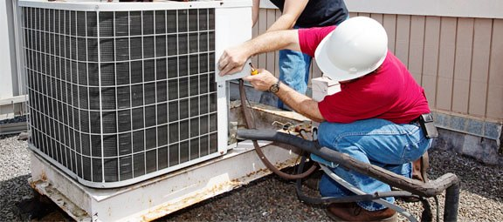

Domestic Appliance Retailing
Refrigeration Mechanic, Installation Technician

Domestic Appliance Retailing
Refrigeration Mechanic, Installation Technician
Dear Doctor: This form will take up to 5 minutes to complete. Please review each task the worker undertakes (both picture and written description) and tick whether or not the worker can complete this task. If modification required, please leave comments. Space at the end of this document is available for final comments and recommendations.
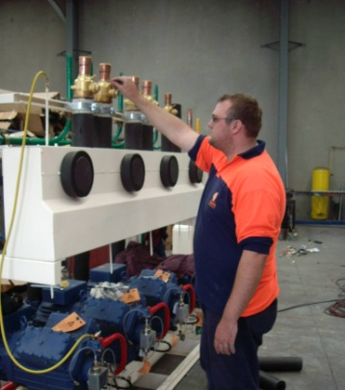  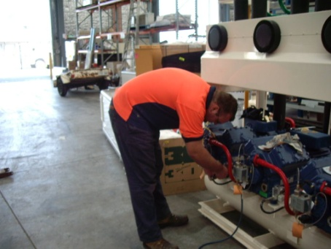 | Assembly  - Pre-fitting motors, piping and wiring onto a cooling unit whilst at the workshop.  - Lifting and carrying of equipment and parts and fitting them to the units.  - Frequent handling of power tools; testing tools and gauges.  - Working at knee to waist height and from floor height in a squatting position.  - Bending and twisting and working above shoulder heights as per requiring bilateral shoulder flexion and abduction above 100°. | Doctor Approval  Yes No  Comments:
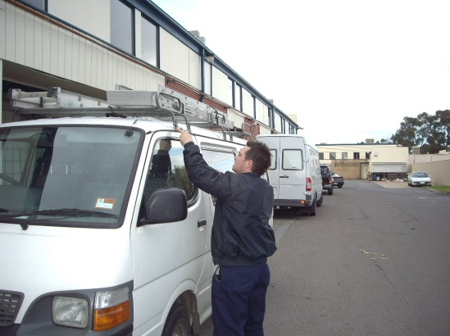  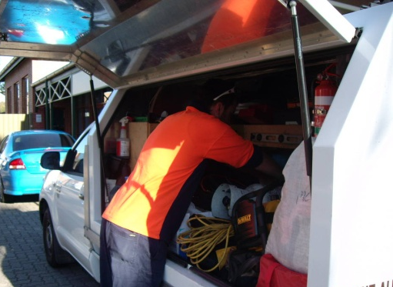 | Installation  - Occasional lifting in excess of 35kg, often while in awkward positions  - Frequent handling of power tools; testing tools and gauges.  - Frequent handling of small parts.  - Gathering ladders from the top of the work vehicle conducted in a standing position requiring shoulder flexion greater than 90°.  - Gathering items from the rear of the vehicle requiring some stooping and bending.
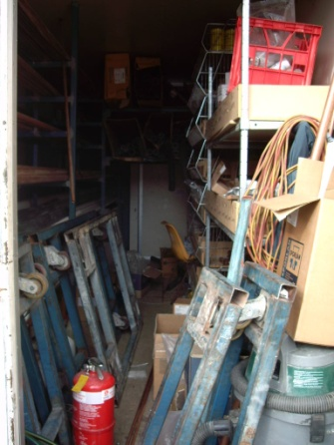 | Installation  - Tools, plant and equipment are generally stored in a secure container. May require the technician to access items weighing greater than 25kg from floor to above head heights.
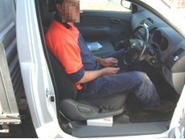 | Working Conditions  - Sitting/driving for prolonged periods when travelling to remote areas  - Conducting work in freezers at below -5°C and fridges at 0°-4°C  - Conducting work on roof tops with temperatures above 50°C  - Conducting work in confined spaces, often requiring crawling. | Doctor Approval  Yes No  Comments:
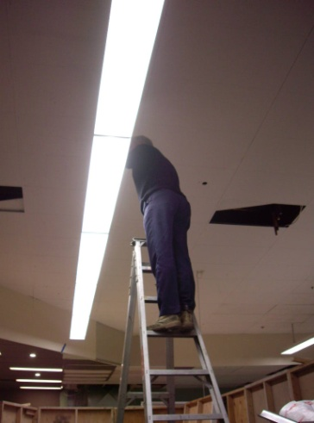  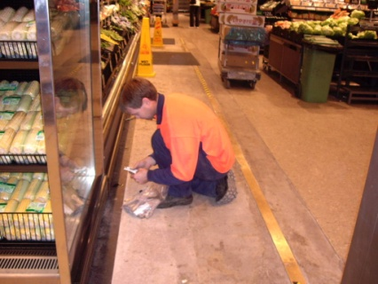  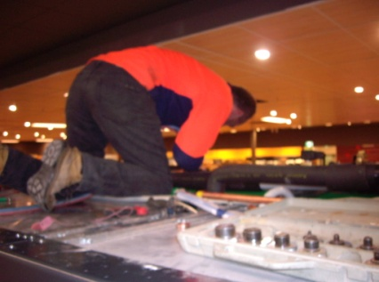 | Physical Requirements  - Repetitive and prolonged periods of either climbing ladders, squatting, kneeling or crawling, involving bilateral lower limbs and knees.  - Crawling is generally conducted in a stooped position, in order to access motor units and wiring on the top of refrigeration units.  - Reaches are generally within the body ranges however occasional reaching outside of the body, sometimes in awkward positions.  - Reaching floor level to above head heights as well as climbing and working on ladders, platforms and boom or scissor lifts.  - Moderate to high muscle strain when stooped leaning into fridges and with sustained ladder climbing.  - Bilateral upper and lower limb coordination to get in/out of Utility vehicle and to operate the foot pedals and hand controls when driving. | Doctor Approval  Yes No  Comments:
Work Capacity Form
Doctor Review (include final comments)

I confirm that in my view, subject to the above comments, the worker is able to perform certain duties detailed in this Early Medical Assessment.
These duties should be reassessed on: |  | Date:

Signature : |  | Date:

Employers Declaration:
I confirm that I/we have reviewed the Doctor’s recommendations and comments. I/we will make suitable changes to make allowances for the Dr’s recommendations.
Signature : |  | Date:

Employees Declaration
My Doctor has discussed their recommendations with me. I have been given the opportunity to participate in this process.
Signature : |  | Date:
For information on completing this form, please contact Business SA on 08 8300 0000.
Disclaimer: This document is published by Business SA with funding from ReturnToWorkSA. All workplaces and circumstances are different and this document should be used as a guide only. It is not diagnostic and should not replace consultation, evaluation, or personal services including examination and an agreed course of action by a licensed practitioner. Business SA and ReturnToWorkSA and their affiliates and their respective agents do not accept any liability for injury, loss or damage arising from the use or reliance on this document. The copyright owner provides permission to reproduce and adapt this document for the purposes indicated and to tailor it (as intended) for individual circumstances. (C) 2016 ReturnToWorkSA

