Early Medical Assessment

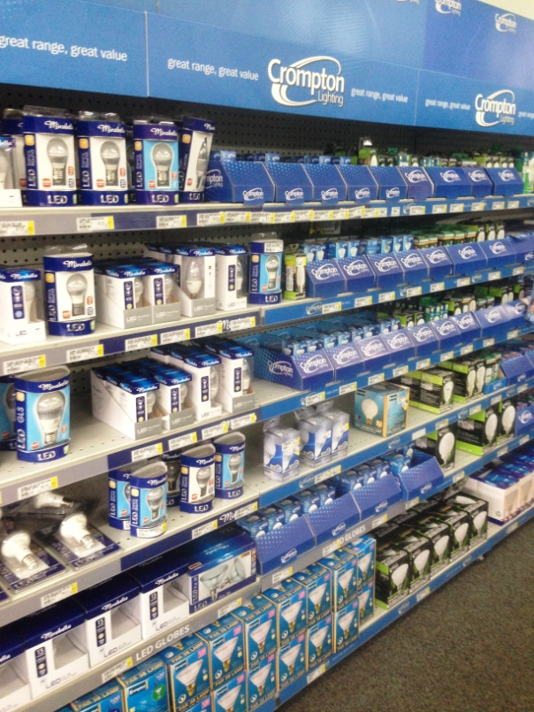

Domestic Appliance Retailing
Plumbing and Electrical

Domestic Appliance Retail
Plumbing and Electrical
Dear Doctor: This form will take up to 5 minutes to complete. Please review each task the worker undertakes (both picture and written description) and tick whether or not the worker can complete this task. If modification required, please leave comments. Space at the end of this document is available for final comments and recommendations.
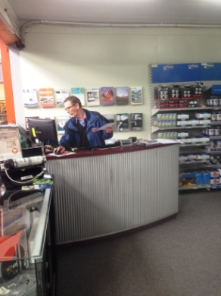  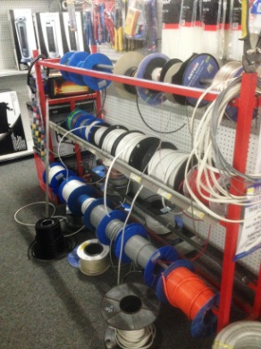 | Customer Service  - Constant standing whilst discussing / demonstrating product.  - Pulling products from shelves as required (<8kg). Repetitive reaching and grasping.  - Moving heavier floor stock as per below for customer using two person lift or sack truck.  - Pulling electrical cord from reels and cutting.  - Using computer at counter to process sales. | Doctor Approval  Yes No  Comments:
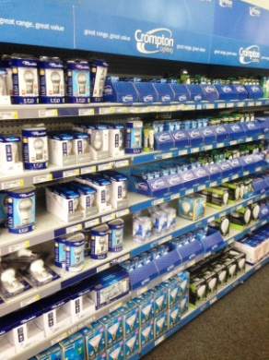  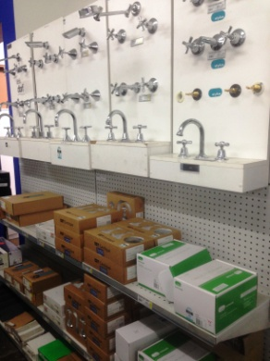  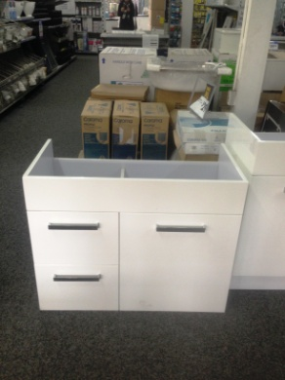 | Stocking Shelves  - Collecting produce from “Goods Inwards” and carrying/pushing them to Plumbing and Electrical area. Sack truck and trolley jack available to be used to move heavy items.  - Shelving between floor and 1600mm requiring reaching and low level postures to access.  - Heavier items located on lower shelves.  - Many light objects available. Occasionally electrical goods such as heaters, fans are purchased and carried to counter in a box <10kg. Both arms used to carry due to size of boxes.  - Toilets and dryers, bar fridges, dishwashers, washing machines are stored in boxes on pallets on floor or one for display. These are all moved with sack trucks (pushing/pulling required) | Doctor Approval  Yes No  Comments:
Work Capacity Form
Doctor Review (include final comments)

I confirm that in my view, subject to the above comments, the worker is able to perform certain duties detailed in this Early Medical Assessment.
These duties should be reassessed on: |  | Date:

Signature : |  | Date:

Employers Declaration:
I confirm that I/we have reviewed the Doctor’s recommendations and comments. I/we will make suitable changes to make allowances for the Dr’s recommendations.
Signature : |  | Date:

Employees Declaration
My Doctor has discussed their recommendations with me. I have been given the opportunity to participate in this process.
Signature : |  | Date:
For information on completing this form, please contact Business SA on 08 8300 0000.
Disclaimer: This document is published by Business SA with funding from ReturnToWorkSA. All workplaces and circumstances are different and this document should be used as a guide only. It is not diagnostic and should not replace consultation, evaluation, or personal services including examination and an agreed course of action by a licensed practitioner. Business SA and ReturnToWorkSA and their affiliates and their respective agents do not accept any liability for injury, loss or damage arising from the use or reliance on this document. The copyright owner provides permission to reproduce and adapt this document for the purposes indicated and to tailor it (as intended) for individual circumstances. (C) 2016 ReturnToWorkSA

