Early Medical Assessment

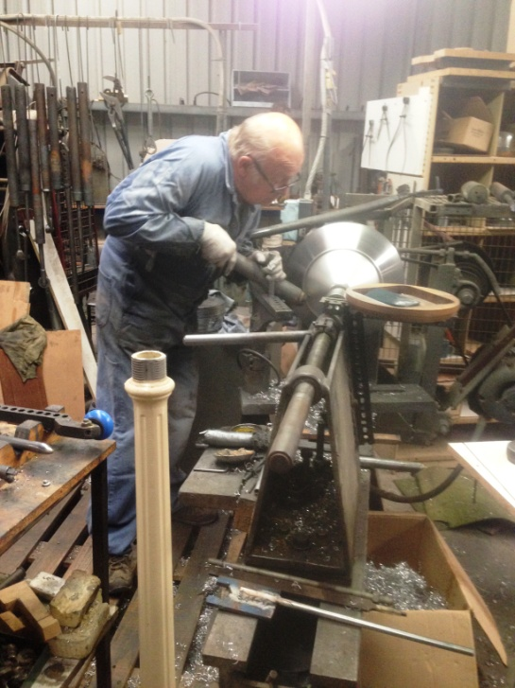

Domestic Appliance Retailing
Manufacturing

Domestic Appliance Retailing
Manufacturing
Dear Doctor: This form will take up to 5 minutes to complete. Please review each task the worker undertakes (both picture and written description) and tick whether or not the worker can complete this task. If modification required, please leave comments. Space at the end of this document is available for final comments and recommendations.
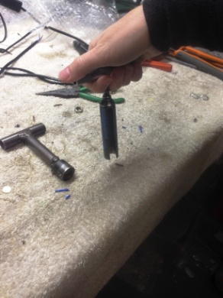  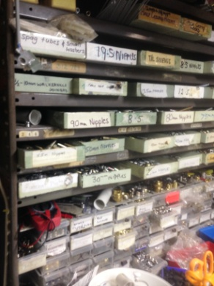  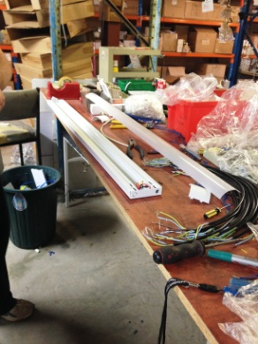 | Assembly  - Constant standing at bench.  - Small parts kept on shelving to both sides of the bench within easy reach.  - Use of tools and drill. Specialized tools have been created such as T for tightening nuts and washers. Held in dominant hand.  - Very fine motor skills required. Handling of very small objects.  - Repetitive work performed as time allows therefore it is not an all day task. | Doctor Approval  Yes No  Comments:
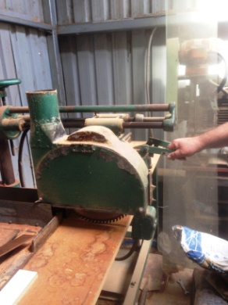  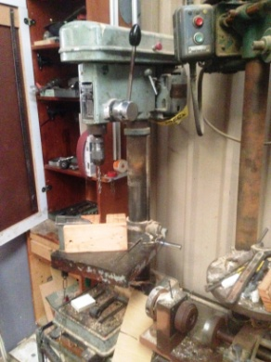  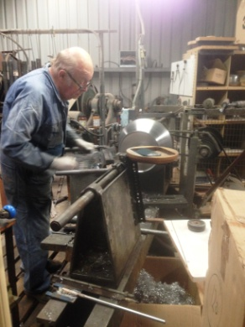  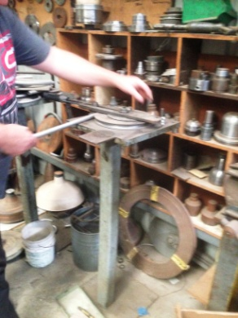  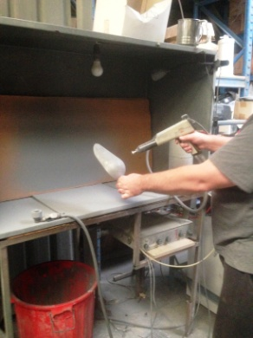 | Manufacturing of Light Fittings  - A large variety of machinery used to make light fittings.  - Constant standing and walking required whilst operating machinery. Each used for a period of time (not all day) .  - Timber work - timber turning machine, lathes, sanders, spindle moulder, inverted router and copy lathe.  - Metal Work – Spinner, lathes, benching machine, powder coater used.  - Repetitive gripping and grasping, light push/pull force, forward reaching required. Many are bilateral tasks. Some bending may be required when performing precision work.  - Variety of tools are used within the machines requiring training. | Doctor Approval  Yes No  Comments:
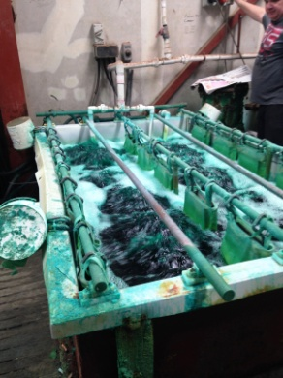  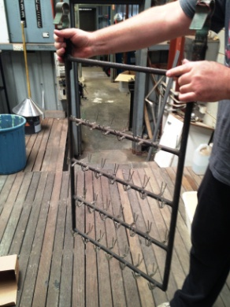 | Plating  - Used to turn aluminum and steel into gold, nickel, brass and bronze finishes.  - Hanging fittings off racks (up to 10kg loaded).  - Holding bilaterally from the top dunking rack into solution and taking it out when necessary (time varies). | Doctor Approval  Yes No  Comments:
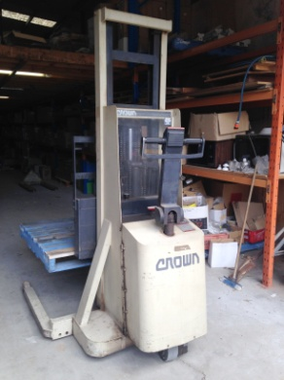  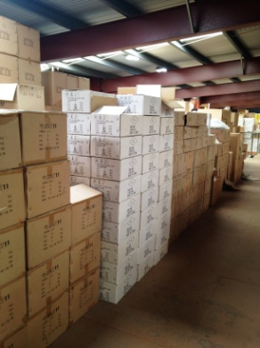 | Stores  - Sack truck and hand driven forklift available for use to move products.  - Storage area is in upstairs rafter. Forklift used to lift pallets up to rafter. Then unpacked by hand from upstairs.  - Infrequent large deliveries received due to the large amount of stock held and manufacturing side of the business.  - Orders are picked upstairs and put on pallets which are lifted down using forklift.  - Upstairs stock is stacked on top of each other. Most boxes <5kg, there may be some boxes up to 10kg. Items can be taken out individually to reduce load.  - Customer service workers can access upstairs stock as required throughout the day. | Doctor Approval  Yes No  Comments:
Work Capacity Form
Doctor Review (include final comments)

I confirm that in my view, subject to the above comments, the worker is able to perform certain duties detailed in this Early Medical Assessment.
These duties should be reassessed on: |  | Date:

Signature : |  | Date:

Employers Declaration:
I confirm that I/we have reviewed the Doctor’s recommendations and comments. I/we will make suitable changes to make allowances for the Dr’s recommendations.
Signature : |  | Date:

Employees Declaration
My Doctor has discussed their recommendations with me. I have been given the opportunity to participate in this process.
Signature : |  | Date:
For information on completing this form, please contact Business SA on 08 8300 0000.
Disclaimer: This document is published by Business SA with funding from ReturnToWorkSA. All workplaces and circumstances are different and this document should be used as a guide only. It is not diagnostic and should not replace consultation, evaluation, or personal services including examination and an agreed course of action by a licensed practitioner. Business SA and ReturnToWorkSA and their affiliates and their respective agents do not accept any liability for injury, loss or damage arising from the use or reliance on this document. The copyright owner provides permission to reproduce and adapt this document for the purposes indicated and to tailor it (as intended) for individual circumstances. (C) 2016 ReturnToWorkSA

