Early Medical Assessment

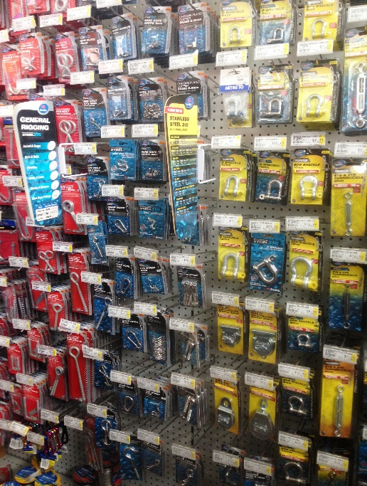

Domestic Appliance Retailing
Goods Inwards and Hardware

Domestic Appliance Retailing
Goods Inwards and Hardware
Dear Doctor: This form will take up to 5 minutes to complete. Please review each task the worker undertakes (both picture and written description) and tick whether or not the worker can complete this task. If modification required, please leave comments. Space at the end of this document is available for final comments and recommendations.
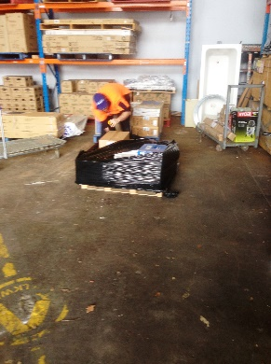  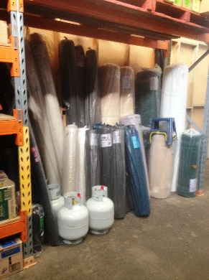  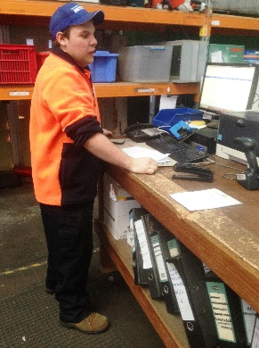 | Receiving Goods  - Hardware products are delivered to the door on pallets.  - Tearing plastic wrap with fingers and unwrapping goods. Bending required.  - Moving goods from pallet to receiving area by carrying or lifting onto a flat bed trolley or sack truck and pushing.  - Entering details into computer whilst standing at bench.  - Moving goods to holding area for hardware staff to collect.  - Empty boxes are kept on shelving (floor to overhead) for display items. | Doctor Approval  Yes No  Comments:
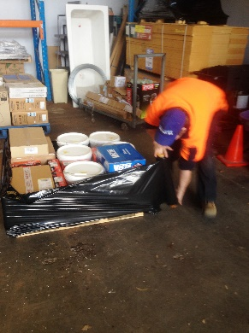  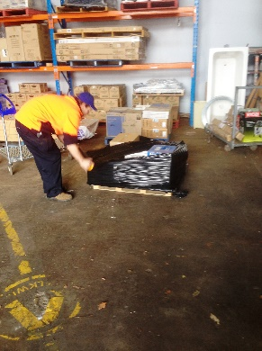 | Wrapping Pallets  - Breaking up orders from other stores and re-palletising correctly involving some low level postures, lifting and carrying boxes of varying weights and sizes to different pallets on the floor.  - Wrapping pallets with shrink wrap involving prolonged bending, whilst walking around pallet. Both hands are used to grip wrap at either end to allow it to run out. Pulling required. | Doctor Approval  Yes No  Comments:
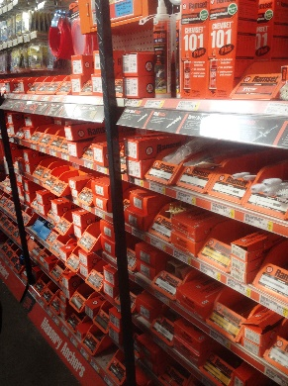  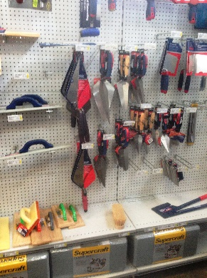 | Hardware Customer Service  - Constant standing whilst assisting customers.  - Smaller hardware items such as nuts and bolts sold in this section. Customers tend to help themselves but may ask for assistance.  - Shelving between floor to overhead with light items stored higher.  - Chains may need to be cut involving pulling chain to desired length and using long handled bolt cutters (bilateral power grip) to cut chain.  - Stocking shelves with goods when not serving customers ie. carrying or pushing items on flat bed trolley from goods inwards are to shelving and placing in correct shelf. Repetitive reaching to place multiple items. | Doctor Approval  Yes No  Comments:
Work Capacity Form
Doctor Review (include final comments)

I confirm that in my view, subject to the above comments, the worker is able to perform certain duties detailed in this Early Medical Assessment.
These duties should be reassessed on: |  | Date:

Signature : |  | Date:

Employers Declaration:
I confirm that I/we have reviewed the Doctor’s recommendations and comments. I/we will make suitable changes to make allowances for the Dr’s recommendations.
Signature : |  | Date:

Employees Declaration
My Doctor has discussed their recommendations with me. I have been given the opportunity to participate in this process.
Signature : |  | Date:
For information on completing this form, please contact Business SA on 08 8300 0000.
Disclaimer: This document is published by Business SA with funding from ReturnToWorkSA. All workplaces and circumstances are different and this document should be used as a guide only. It is not diagnostic and should not replace consultation, evaluation, or personal services including examination and an agreed course of action by a licensed practitioner. Business SA and ReturnToWorkSA and their affiliates and their respective agents do not accept any liability for injury, loss or damage arising from the use or reliance on this document. The copyright owner provides permission to reproduce and adapt this document for the purposes indicated and to tailor it (as intended) for individual circumstances. (C) 2016 ReturnToWorkSA

