Early Medical Assessment

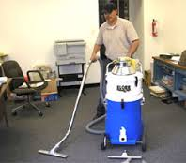

Domestic Appliance Retailing
General Cleaner

Domestic Appliance Retailing
General Cleaner
Dear Doctor: This form will take up to 5 minutes to complete. Please review each task the worker undertakes (both picture and written description) and tick whether or not the worker can complete this task. If modification required, please leave comments. Space at the end of this document is available for final comments and recommendations.
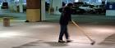  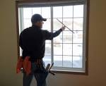  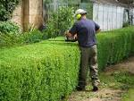 | Outdoor Areas  - Sweeping daily (pushing/pulling motion).  - Picking up rubbish from the ground; walking, bending and grasping.  - Pruning shrubs using a hedge trimmer.  - Cleaning windows weekly; forward reaching at all heights whilst grasping squeegee. | Doctor Approval  Yes No  Comments:
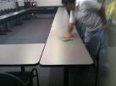  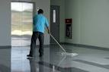 | Cleaning  - Emptying 2-3 office waste paper bins per day. Confidential bins are emptied every 3 weeks.  - Pulling general bin to office weekly so that other staff can empty their bins into it. Pulling into lift and taking it downstairs to loading dock.  - Sweeping, mopping, vacuuming.  - Wiping desks and surfaces.  - Cleaning fridges and microwaves by removing food and wiping.  - Replacing bin liners requiring some bending. | Doctor Approval  Yes No  Comments:
 | - Constant standing and walking, frequent pushing/pulling, occasional / frequent bending and twisting, constant forward reaching, constant lifting of light items such as the broom and cleaning products, occasional lifting of bins <15kg , constant grasping of objects.
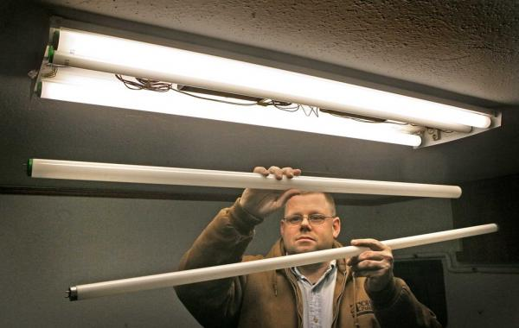  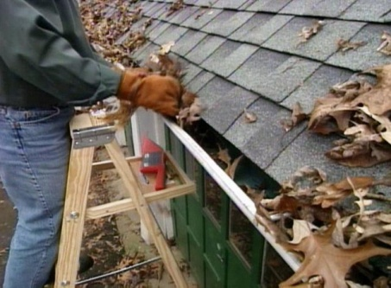 | Maintenance  - Wide variety of tasks including but not limited to changing light bulbs, cleaning gutters, painting over graffiti on the outside walls and assisting in moving furniture.  - Undertaken as required.  - Requiring constant standing and walking. May require bending and twisting, low level postures, ladder climbing, reaching between floor and overhead height and occasional pushing. | Doctor Approval  Yes No  Comments:
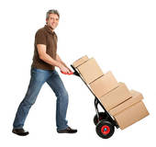 | Deliveries  - Delivering items such as paper, milk, newspapers and bathroom supplies to various departments.  - Storing archive boxes.  - Constant standing and walking; carrying and or pushing sack truck with items to be delivered. Heaviest item is box of paper <15kg. | Doctor Approval  Yes No  Comments:
Work Capacity Form
Doctor Review (include final comments)

I confirm that in my view, subject to the above comments, the worker is able to perform certain duties detailed in this Early Medical Assessment.
These duties should be reassessed on: |  | Date:

Signature : |  | Date:

Employers Declaration:
I confirm that I/we have reviewed the Doctor’s recommendations and comments. I/we will make suitable changes to make allowances for the Dr’s recommendations.
Signature : |  | Date:

Employees Declaration
My Doctor has discussed their recommendations with me. I have been given the opportunity to participate in this process.
Signature : |  | Date:
For information on completing this form, please contact Business SA on 08 8300 0000.
Disclaimer: This document is published by Business SA with funding from ReturnToWorkSA. All workplaces and circumstances are different and this document should be used as a guide only. It is not diagnostic and should not replace consultation, evaluation, or personal services including examination and an agreed course of action by a licensed practitioner. Business SA and ReturnToWorkSA and their affiliates and their respective agents do not accept any liability for injury, loss or damage arising from the use or reliance on this document. The copyright owner provides permission to reproduce and adapt this document for the purposes indicated and to tailor it (as intended) for individual circumstances. (C) 2016 ReturnToWorkSA

