Early Medical Assessment

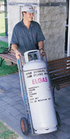

Domestic Appliance Retailing
Gas Bottle Deliveries

Domestic Appliance Retailing
Gas Bottle Deliveries
Dear Doctor: This form will take up to 5 minutes to complete. Please review each task the worker undertakes (both picture and written description) and tick whether or not the worker can complete this task. If modification required, please leave comments. Space at the end of this document is available for final comments and recommendations.
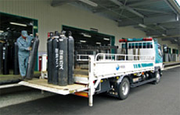  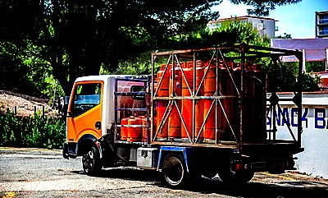 | Collection of Gas Bottles from  Shop  - Reversing truck (neck and back rotation) up to loading dock and using controller to operate tail lift until in line with dock.  - Manoeuvring 45kg tank (90kg when full) onto truck (pushing/pulling/twisting a very short distance) or using sack truck to place on truck. | Doctor Approval  Yes No  Comments:
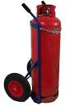 | Delivery of Gas Bottles to  Customer  - Driving to customer’s home.  - Manoeuvring gas bottle onto sack truck (push/pull/twist).  - Automatically lowering truck lifter.  - Pushing sack truck into position at customers home (flat ground negotiated only).  - Manoeuvring bottle off sack truck  - Frequent climbing in/out of truck  - Pushing of sacktruck | Doctor Approval  Yes No  Comments:
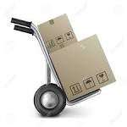  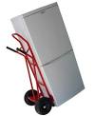 | Other Deliveries  - Deliveries of whitegoods as required using automatic lift on truck and sack truck for moving into customers home. | Doctor Approval  Yes No  Comments:
Work Capacity Form
Doctor Review (include final comments)

I confirm that in my view, subject to the above comments, the worker is able to perform certain duties detailed in this Early Medical Assessment.
These duties should be reassessed on: |  | Date:

Signature : |  | Date:

Employers Declaration:
I confirm that I/we have reviewed the Doctor’s recommendations and comments. I/we will make suitable changes to make allowances for the Dr’s recommendations.
Signature : |  | Date:

Employees Declaration
My Doctor has discussed their recommendations with me. I have been given the opportunity to participate in this process.
Signature : |  | Date:
For information on completing this form, please contact Business SA on 08 8300 0000.
Disclaimer: This document is published by Business SA with funding from ReturnToWorkSA. All workplaces and circumstances are different and this document should be used as a guide only. It is not diagnostic and should not replace consultation, evaluation, or personal services including examination and an agreed course of action by a licensed practitioner. Business SA and ReturnToWorkSA and their affiliates and their respective agents do not accept any liability for injury, loss or damage arising from the use or reliance on this document. The copyright owner provides permission to reproduce and adapt this document for the purposes indicated and to tailor it (as intended) for individual circumstances. (C) 2016 ReturnToWorkSA

