Early Medical Assessment

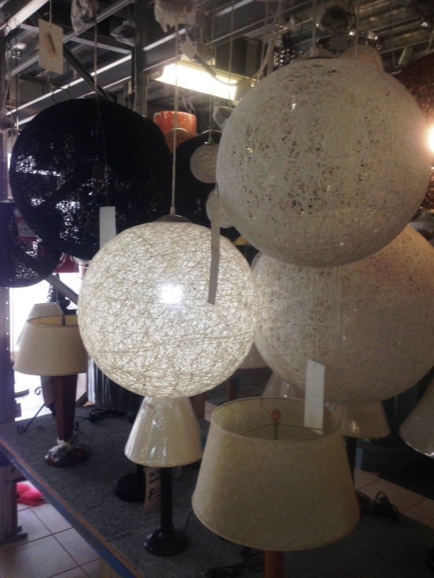

Domestic Appliance Retailing
Customer Service

Domestic Appliance Retailing
Customer Service
Dear Doctor: This form will take up to 5 minutes to complete. Please review each task the worker undertakes (both picture and written description) and tick whether or not the worker can complete this task. If modification required, please leave comments. Space at the end of this document is available for final comments and recommendations.
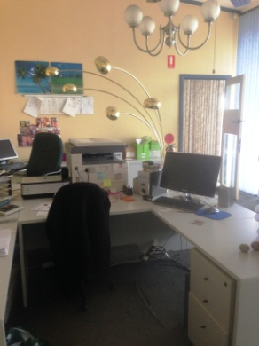 | Administration  - Constant sitting whilst using computer and telephone for orders etc.  - Filing in drawers. | Doctor Approval  Yes No  Comments:
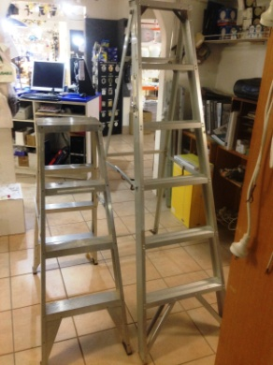  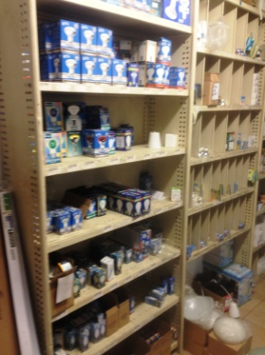 | Assisting Customers  - Constant standing and walking to assist customers as required throughout day.  - Occasional ladder climbing to access lights hanging from hooks on the roof.  - Readying orders.  - Handling stock (as below) during customer enquiry. | Doctor Approval  Yes No  Comments:
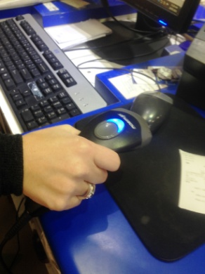 | Cash Handling  - Computer system and POS equipment set up at standing bench.  - Hand held scanner used to enter item into system for sale. | Doctor Approval  Yes No  Comments:
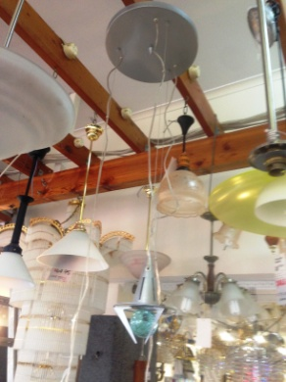  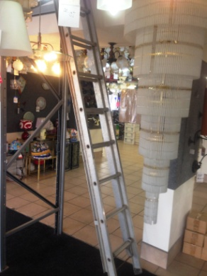  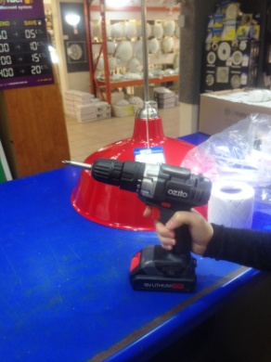  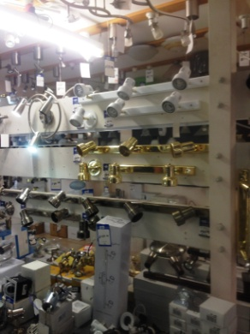  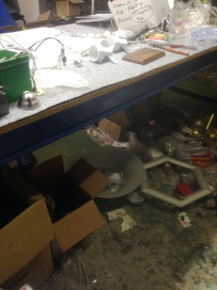 | Stock Handling  - Storeroom to showroom display area. Weights handled vary with majority <5kg.  - Hanging lights on existing hooks or off beams on roof. Overhead reach required and lifting with the dominant arm.  - Occasional ladder climbing.  - Use of battery operated drill to install some light displays.  - Vertical display set up using screw driver or drill in dominant hand and steadying/holding light in non dominant hand.  - Assembly of lamps at bench using fine hand movements and drill /tools if required.  - A few fittings are located on the floor therefore infrequent squatting required.  - Bulbs located on shelving floor to overhead height. Ladders available to reduce reaching.  - Large chandeliers are the heaviest lift at approx 50kg however ‘floor’ staff are not required to move these.  - Re-stocking of displays and shelved as required.  - Stock kept out back in shelving and upstairs in rafter storage area. Stair climbing required if this stock is needed. | Doctor Approval  Yes No  Comments:
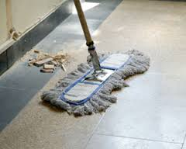 | Cleaning  - Sweeping and mopping as required.  - Dusting at varying heights. | Doctor Approval  Yes No  Comments:
Work Capacity Form
Doctor Review (include final comments)

I confirm that in my view, subject to the above comments, the worker is able to perform certain duties detailed in this Early Medical Assessment.
These duties should be reassessed on: |  | Date:

Signature : |  | Date:

Employers Declaration:
I confirm that I/we have reviewed the Doctor’s recommendations and comments. I/we will make suitable changes to make allowances for the Dr’s recommendations.
Signature : |  | Date:

Employees Declaration
My Doctor has discussed their recommendations with me. I have been given the opportunity to participate in this process.
Signature : |  | Date:
For information on completing this form, please contact Business SA on 08 8300 0000.
Disclaimer: This document is published by Business SA with funding from ReturnToWorkSA. All workplaces and circumstances are different and this document should be used as a guide only. It is not diagnostic and should not replace consultation, evaluation, or personal services including examination and an agreed course of action by a licensed practitioner. Business SA and ReturnToWorkSA and their affiliates and their respective agents do not accept any liability for injury, loss or damage arising from the use or reliance on this document. The copyright owner provides permission to reproduce and adapt this document for the purposes indicated and to tailor it (as intended) for individual circumstances. (C) 2016 ReturnToWorkSA

