Early Medical Assessment

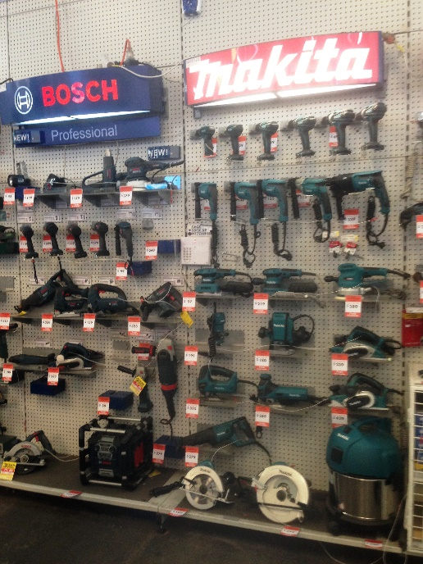

Domestic Appliance Retailing
Customer Service - Tools and Power Tools

Domestic Appliance Retailing
Customer Service Tools and Power Tools
Dear Doctor: This form will take up to 5 minutes to complete. Please review each task the worker undertakes (both picture and written description) and tick whether or not the worker can complete this task. If modification required, please leave comments. Space at the end of this document is available for final comments and recommendations.
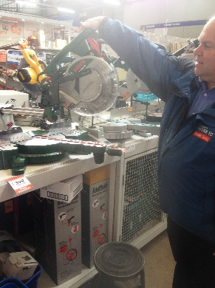  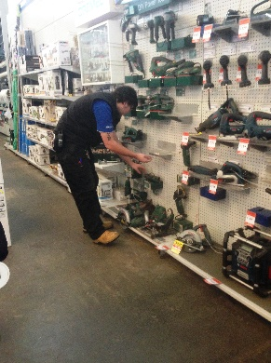  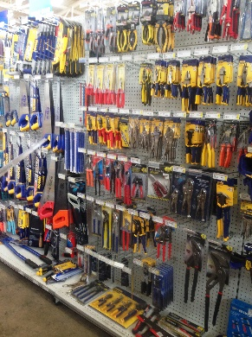 | Customer Service  - Constant standing and walking whilst assisting customers.  - Shelving is between floor to overhead height. Customers are able to help themselves but some may require assistance to locate items. Low level postures to high reaching may be required to access items.  - Demonstration of power tools either attached to wall or on bench. Reaching and gripping / holding for demonstration. | Doctor Approval  Yes No  Comments:
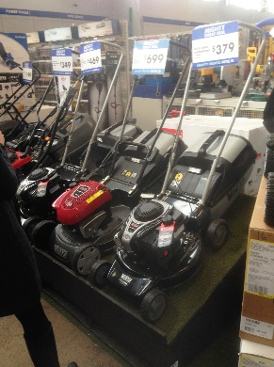 | Stocking Shelves  - Two workers lift saws from trolley when placing on bench.  - Lawn mowers are kept on raised platform. Two people lift these up / down as required.  - Larger items such as whipper snippers and chain saws are hung vertically on racking.  - Fuels are in 5L tins.  - Heavier items are stocked on lower shelves.  - Flat bed trolley and sack truck available for moving stock from Goods Inwards to shelving.  - Repetitive reaching at all heights required when restocking shelves. | Doctor Approval  Yes No  Comments:
Work Capacity Form
Doctor Review (include final comments)

I confirm that in my view, subject to the above comments, the worker is able to perform certain duties detailed in this Early Medical Assessment.
These duties should be reassessed on: |  | Date:

Signature : |  | Date:

Employers Declaration:
I confirm that I/we have reviewed the Doctor’s recommendations and comments. I/we will make suitable changes to make allowances for the Dr’s recommendations.
Signature : |  | Date:

Employees Declaration
My Doctor has discussed their recommendations with me. I have been given the opportunity to participate in this process.
Signature : |  | Date:
For information on completing this form, please contact Business SA on 08 8300 0000.
Disclaimer: This document is published by Business SA with funding from ReturnToWorkSA. All workplaces and circumstances are different and this document should be used as a guide only. It is not diagnostic and should not replace consultation, evaluation, or personal services including examination and an agreed course of action by a licensed practitioner. Business SA and ReturnToWorkSA and their affiliates and their respective agents do not accept any liability for injury, loss or damage arising from the use or reliance on this document. The copyright owner provides permission to reproduce and adapt this document for the purposes indicated and to tailor it (as intended) for individual circumstances. (C) 2016 ReturnToWorkSA

