Early Medical Assessment

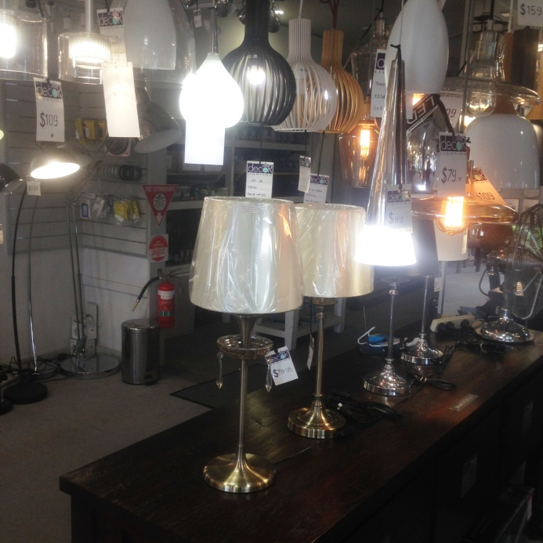

Domestic Appliance Retailing
Customer Service

Domestic Appliance Retailing
Customer Service
Dear Doctor: This form will take up to 5 minutes to complete. Please review each task the worker undertakes (both picture and written description) and tick whether or not the worker can complete this task. If modification required, please leave comments. Space at the end of this document is available for final comments and recommendations.
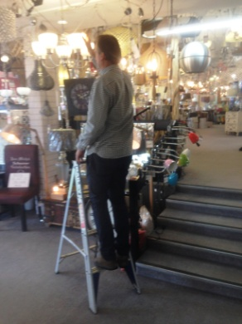  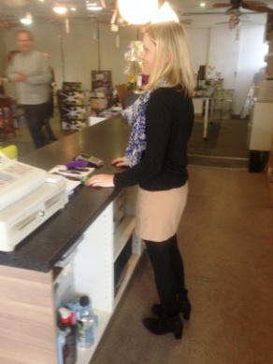  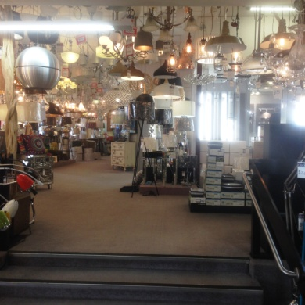 | Customer Service  - Constant standing and interacting with customers.  - Stock is located from floor to above head height ie. hanging light fittings. Step ladders available if required.  - Occasionally fitting a globe into a wired display light. Climbing step ladder to access globe and overhead reaching and fingering to screw globe in.  - Writing paper invoices whist standing at customer service desk.  - Use of till / POS equipment at customer service bench. | Doctor Approval  Yes No  Comments:
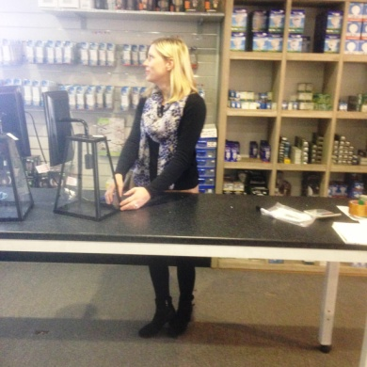 | Assembly of Fittings  - Undertaken whist standing at bench when there are no customers to serve.  - Fine gripping and fingering bilaterally required to assemble lamps and light fittings / chandeliers. | Doctor Approval  Yes No  Comments:
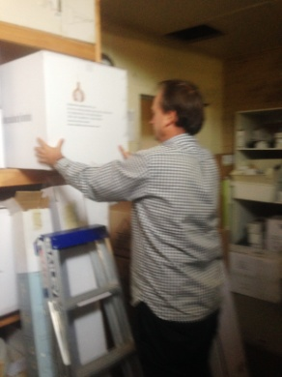 | Receipt of Deliveries  - Deliveries are unloaded by truck driver or owner.  - Placing stock in shelving in stockroom. Floor to head height. | Doctor Approval  Yes No  Comments:
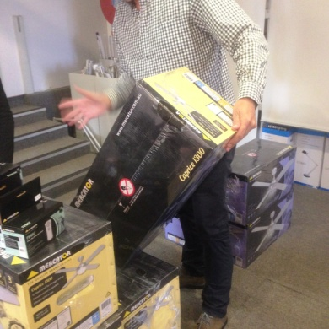  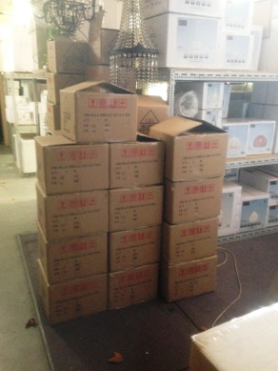  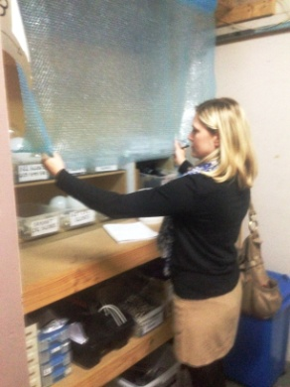 | Stock Handling  - Maximum weight of items in shop 7kg.  - Shelving in shop and store room (heights may vary).  - Sack truck available to move more than one box if required.  - Wrapping required for some lights/globes. Bilateral reaching above head to grasp bubble wrap from roller. Wrapping undertaken on bench requiring forward reaching and fine gripping. | Doctor Approval  Yes No  Comments:
Work Capacity Form
Doctor Review (include final comments)

I confirm that in my view, subject to the above comments, the worker is able to perform certain duties detailed in this Early Medical Assessment.
These duties should be reassessed on: |  | Date:

Signature : |  | Date:

Employers Declaration:
I confirm that I/we have reviewed the Doctor’s recommendations and comments. I/we will make suitable changes to make allowances for the Dr’s recommendations.
Signature : |  | Date:

Employees Declaration
My Doctor has discussed their recommendations with me. I have been given the opportunity to participate in this process.
Signature : |  | Date:
For information on completing this form, please contact Business SA on 08 8300 0000.
Disclaimer: This document is published by Business SA with funding from ReturnToWorkSA. All workplaces and circumstances are different and this document should be used as a guide only. It is not diagnostic and should not replace consultation, evaluation, or personal services including examination and an agreed course of action by a licensed practitioner. Business SA and ReturnToWorkSA and their affiliates and their respective agents do not accept any liability for injury, loss or damage arising from the use or reliance on this document. The copyright owner provides permission to reproduce and adapt this document for the purposes indicated and to tailor it (as intended) for individual circumstances. (C) 2016 ReturnToWorkSA

