Early Medical Assessment

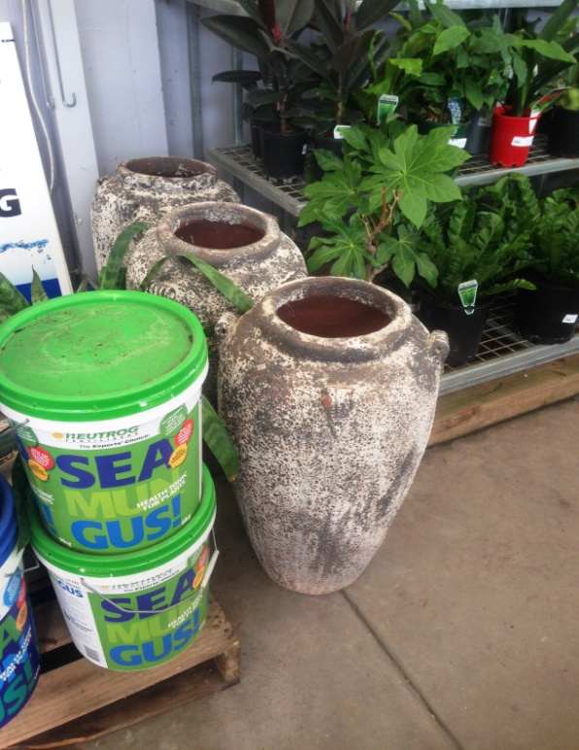

Domestic Appliance Retailing
Customer Service – Garden

Domestic Appliance Retailing
Customer Service – Garden
Dear Doctor: This form will take up to 5 minutes to complete. Please review each task the worker undertakes (both picture and written description) and tick whether or not the worker can complete this task. If modification required, please leave comments. Space at the end of this document is available for final comments and recommendations.
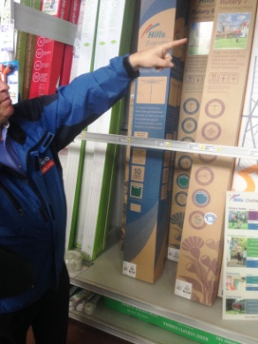  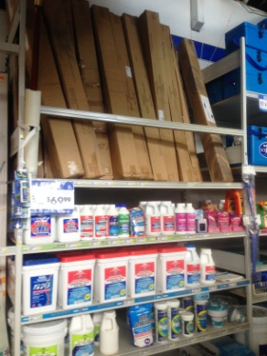 | Customer Service – Outdoor Items  - Constant standing and walking whilst assisting customers.  - Often customers will obtain items by themselves but sometimes worker will need to access and carry items for customer. Shelving between floor and overhead height.  - Platform ladder used to access stock on higher shelves eg empty tubs and eskys.  - Outdoor furniture carried by two staff members where it is wrapped and delivered by truck. BBQs shifted by 4 workers due to weight.  - Umbrella boxes up to 15kg are stacked upright behind a safety bar so they do not tumble on anyone. Two workers lift over and carry. Bending, lifting, carrying between 2. | Doctor Approval  Yes No  Comments:
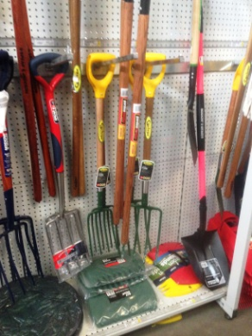  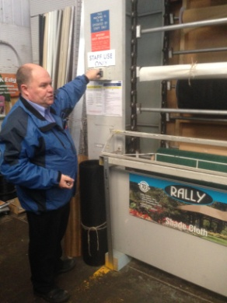 | Customer Service – Inside Garden  Section  - Constant standing and walking whilst assisting customers.  - Accessing items on shelves for demonstration or sale. Shelving between floor and overhead height. Step stool available to reduce reaching.  - Long handled gardening tools hung upright on shelving within easy forward reach.  - Fertilisers and heavier items on lower shelves requiring some low level postures and lifting. 15kg max.  - Mesh and flexible wires are kept on rolls on an automatic turner. Control is at approx head height and is used to put the required roll in front of the worker. Worker pulls out desired length between waist and chest height and uses scissors or Stanley knife in dominant hand to cut. Worker then re-rolls for customer using both hands. | Doctor Approval  Yes No  Comments:
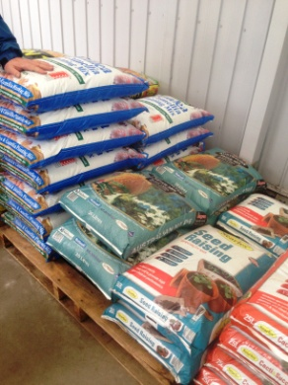  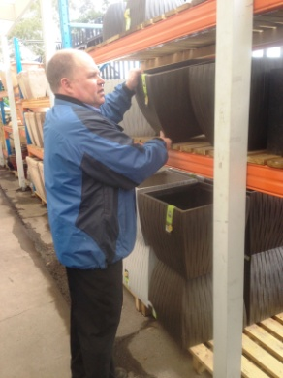 | Customer Service – Outside Garden  Section  - Constant standing to assist customer. Occasionally will help customer to their car with product either carrying or pushing sack truck.  - Shelving from floor up to chest height. Heavy sand and soil kept in bags on pallets (moved by forklift) mainly around 25-30kg. If moving more than one bag at a time a sack truck is used to take out to customer’s car. Heaviest bag 56kg is handled by 2 people.  - Plants are located between floor and chest height. Customers usually pick themselves.  - Pots on floor or shelving up to overhead. Heavier pots on lower shelves. Two person lift for larger pots. | Doctor Approval  Yes No  Comments:
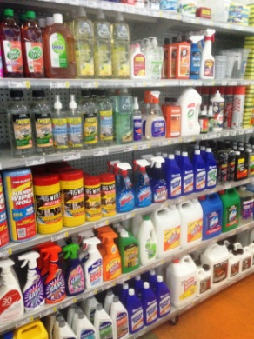 | Stocking Shelves  - When not assisting customers, shelves are restocked.  - Products obtained with trolley from Goods Inwards.  - Repetitive bending and reaching to access stock from trolley and place on shelving. Shelving heights vary. Climbing if step stool is being used to reach higher shelves. | Doctor Approval  Yes No  Comments:
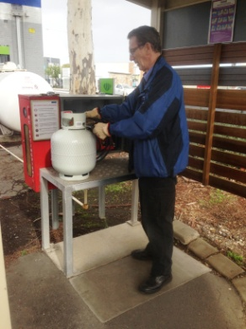 | Filling Gas Bottles  - Following strict procedure, placing empty bottle on shelf and gripping to clip hose on. Continual grasping required whilst bottle is filling. Gloves worn.  - Bottle heavier when full. Lifting and carrying bottle back inside to shop or to customer car. | Doctor Approval  Yes No  Comments:
Work Capacity Form
Doctor Review (include final comments)

I confirm that in my view, subject to the above comments, the worker is able to perform certain duties detailed in this Early Medical Assessment.
These duties should be reassessed on: |  | Date:

Signature : |  | Date:

Employers Declaration:
I confirm that I/we have reviewed the Doctor’s recommendations and comments. I/we will make suitable changes to make allowances for the Dr’s recommendations.
Signature : |  | Date:

Employees Declaration
My Doctor has discussed their recommendations with me. I have been given the opportunity to participate in this process.
Signature : |  | Date:
For information on completing this form, please contact Business SA on 08 8300 0000.
Disclaimer: This document is published by Business SA with funding from ReturnToWorkSA. All workplaces and circumstances are different and this document should be used as a guide only. It is not diagnostic and should not replace consultation, evaluation, or personal services including examination and an agreed course of action by a licensed practitioner. Business SA and ReturnToWorkSA and their affiliates and their respective agents do not accept any liability for injury, loss or damage arising from the use or reliance on this document. The copyright owner provides permission to reproduce and adapt this document for the purposes indicated and to tailor it (as intended) for individual circumstances. (C) 2016 ReturnToWorkSA

