Early Medical Assessment

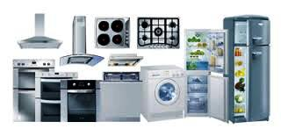

Domestic Appliance Retailing
Cashier

Domestic Appliance Retailing
Cashier
Dear Doctor: This form will take up to 5 minutes to complete. Please review each task the worker undertakes (both picture and written description) and tick whether or not the worker can complete this task. If modification required, please leave comments. Space at the end of this document is available for final comments and recommendations.
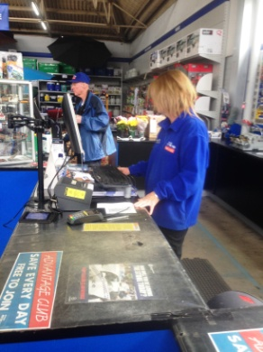  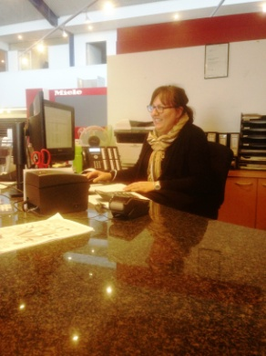 | Processing Payments  - Undertaken either sitting at desk or standing at bench.  - Cash handling or EFTPOS use.  - Forward reaching to customer and use of computer, constant handling and gripping. | Doctor Approval  Yes No  Comments:
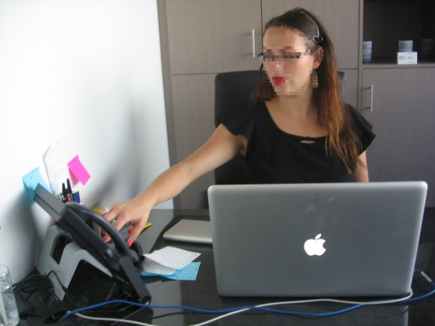 | General Administration  - Undertaken seated at desk.  - Use of computer, telephone and photocopier. | Doctor Approval  Yes No  Comments:
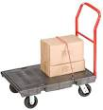 | Stock Returns  - Placing returned item on trolley and returning to appropriate area.  - Placing back on shelf below shoulder height.  - Cashiers handle a maximum of 9kg otherwise a Sales Person is called.  - Pushing lightweight trolley, forward reaching to replace item between floor and shoulder height, occasional low level postures, gripping / handling. | Doctor Approval  Yes No  Comments:
 | Sales Tickets  - Handwriting tickets for current sales seated.  - Walking to and placing ticket on product on display floor / shelving. Reach required will vary depending on product placing. | Doctor Approval  Yes No  Comments:
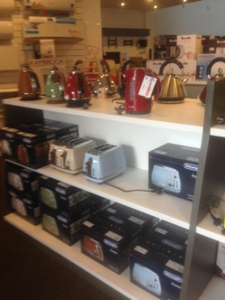 | Merchandising – Kitchen Department  - General presentation of stock on shelving. Restocking as required. Trolley used to move multiple items to department .  - All items <9kg and below shoulder height. | Doctor Approval  Yes No  Comments:  +
Work Capacity Form
Doctor Review (include final comments)

I confirm that in my view, subject to the above comments, the worker is able to perform certain duties detailed in this Early Medical Assessment.
These duties should be reassessed on: |  | Date:

Signature : |  | Date:

Employers Declaration:
I confirm that I/we have reviewed the Doctor’s recommendations and comments. I/we will make suitable changes to make allowances for the Dr’s recommendations.
Signature : |  | Date:

Employees Declaration
My Doctor has discussed their recommendations with me. I have been given the opportunity to participate in this process.
Signature : |  | Date:
For information on completing this form, please contact Business SA on 08 8300 0000.
Disclaimer: This document is published by Business SA with funding from ReturnToWorkSA. All workplaces and circumstances are different and this document should be used as a guide only. It is not diagnostic and should not replace consultation, evaluation, or personal services including examination and an agreed course of action by a licensed practitioner. Business SA and ReturnToWorkSA and their affiliates and their respective agents do not accept any liability for injury, loss or damage arising from the use or reliance on this document. The copyright owner provides permission to reproduce and adapt this document for the purposes indicated and to tailor it (as intended) for individual circumstances. (C) 2016 ReturnToWorkSA

