Early Medical Assessment

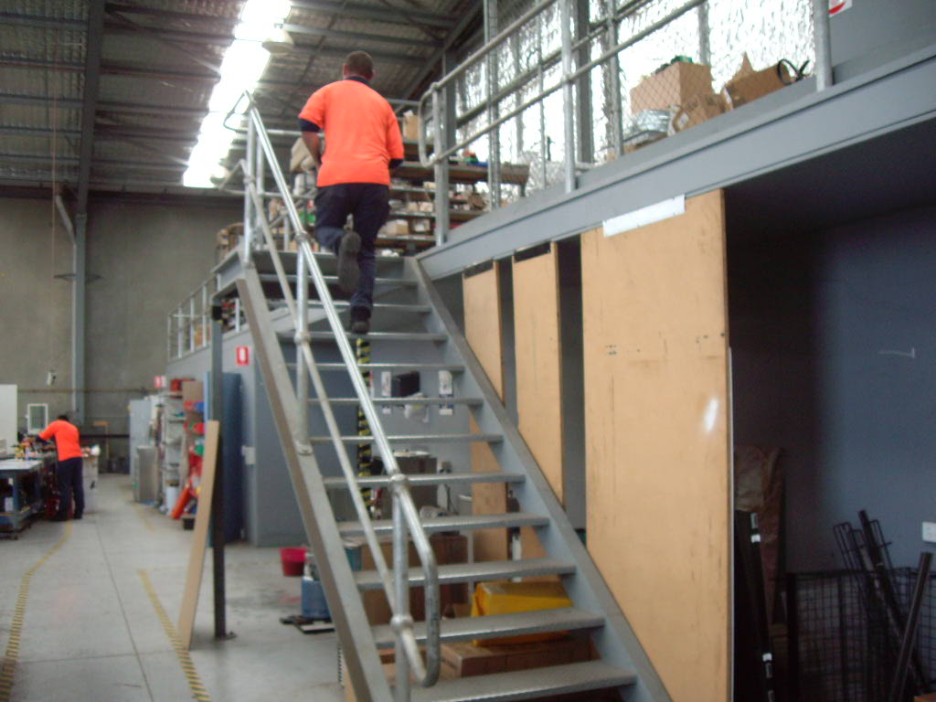

Domestic Appliance Retailing
Air Conditioning Stores/Warehouse

Domestic Appliance Retailing
Air Conditioning Stores/Warehouse
Dear Doctor: This form will take up to 5 minutes to complete. Please review each task the worker undertakes (both picture and written description) and tick whether or not the worker can complete this task. If modification required, please leave comments. Space at the end of this document is available for final comments and recommendations.
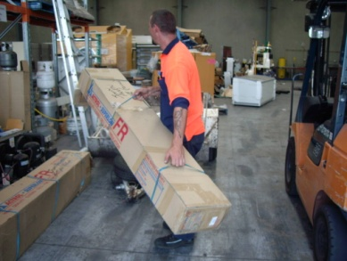  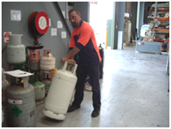 | Manual Handling  - Occasional maneuvering and lifting of items greater than 55kg.  - Frequent rolling of gas bottles, requiring claw grasping and internal/external shoulder movements.  - Frequent handling of plant/equipment.  - Frequent handling of small parts.  - Frequent handling of air-conditioning units requiring bilateral gross claw and flat palmer grasping as well as some lumbar twisting. | Doctor Approval  Yes No  Comments:
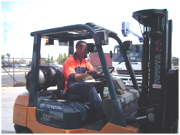 | Forklift Driving  - Bilateral upper and lower limb coordination to operate the foot and hand controls when in operation.  - Frequent cervical neck flexion, extension and rotation.  - Occasional thoracic lumbar twisting to view behind forklift when reversing. | Doctor Approval  Yes No  Comments:
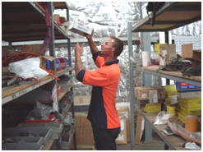 | Physical Requirements  - Occasional stair climbing is required involving bilateral lower limbs.  - Accessing items from floor to above head heights requiring squatting/kneeling, lumbar stooping and overhead reaching with shoulders flexed to greater than 160°. | Doctor Approval  Yes No  Comments:
Work Capacity Form
Doctor Review (include final comments)

I confirm that in my view, subject to the above comments, the worker is able to perform certain duties detailed in this Early Medical Assessment.
These duties should be reassessed on: |  | Date:

Signature : |  | Date:

Employers Declaration:
I confirm that I/we have reviewed the Doctor’s recommendations and comments. I/we will make suitable changes to make allowances for the Dr’s recommendations.
Signature : |  | Date:

Employees Declaration
My Doctor has discussed their recommendations with me. I have been given the opportunity to participate in this process.
Signature : |  | Date:
For information on completing this form, please contact Business SA on 08 8300 0000.
Disclaimer: This document is published by Business SA with funding from ReturnToWorkSA. All workplaces and circumstances are different and this document should be used as a guide only. It is not diagnostic and should not replace consultation, evaluation, or personal services including examination and an agreed course of action by a licensed practitioner. Business SA and ReturnToWorkSA and their affiliates and their respective agents do not accept any liability for injury, loss or damage arising from the use or reliance on this document. The copyright owner provides permission to reproduce and adapt this document for the purposes indicated and to tailor it (as intended) for individual circumstances. (C) 2016 ReturnToWorkSA

