Early Medical Assessment

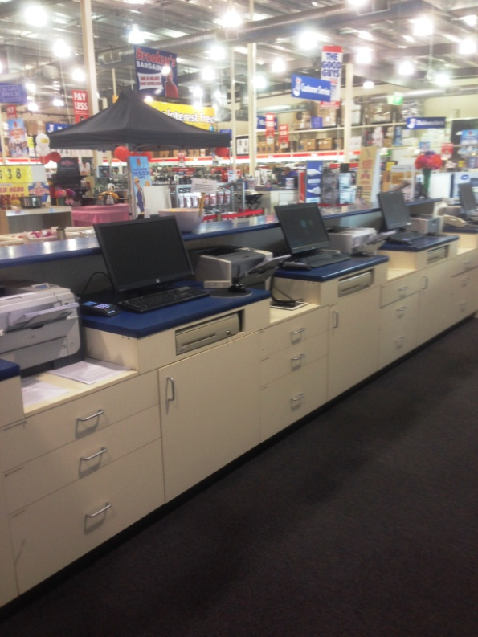

Domestic Appliance Retailing
Administrator

Domestic Appliance Retailing
Administrator
Dear Doctor: This form will take up to 5 minutes to complete. Please review each task the worker undertakes (both picture and written description) and tick whether or not the worker can complete this task. If modification required, please leave comments. Space at the end of this document is available for final comments and recommendations.
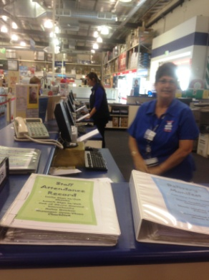 | Administrator  - Constant standing at counter.  - Forward reaching within range to used computer and telephone.  - Cash handling / POS equipment.  - Occasionally handling smaller products brought to bench by customer.  - Larger items are handled by putting in product code for payment. Sales role has already entered item in computer, Administrator accepts payment for product but does not handle it.  - Sitting can be required for other administration duties which are not directly involved in service customers. | Doctor Approval  Yes No  Comments:
Work Capacity Form
Doctor Review (include final comments)

I confirm that in my view, subject to the above comments, the worker is able to perform certain duties detailed in this Early Medical Assessment.
These duties should be reassessed on: |  | Date:

Signature : |  | Date:

Employers Declaration:
I confirm that I/we have reviewed the Doctor’s recommendations and comments. I/we will make suitable changes to make allowances for the Dr’s recommendations.
Signature : |  | Date:

Employees Declaration
My Doctor has discussed their recommendations with me. I have been given the opportunity to participate in this process.
Signature : |  | Date:
For information on completing this form, please contact Business SA on 08 8300 0000.
Disclaimer: This document is published by Business SA with funding from ReturnToWorkSA. All workplaces and circumstances are different and this document should be used as a guide only. It is not diagnostic and should not replace consultation, evaluation, or personal services including examination and an agreed course of action by a licensed practitioner. Business SA and ReturnToWorkSA and their affiliates and their respective agents do not accept any liability for injury, loss or damage arising from the use or reliance on this document. The copyright owner provides permission to reproduce and adapt this document for the purposes indicated and to tailor it (as intended) for individual circumstances. (C) 2016 ReturnToWorkSA

