Early Medical Assessment

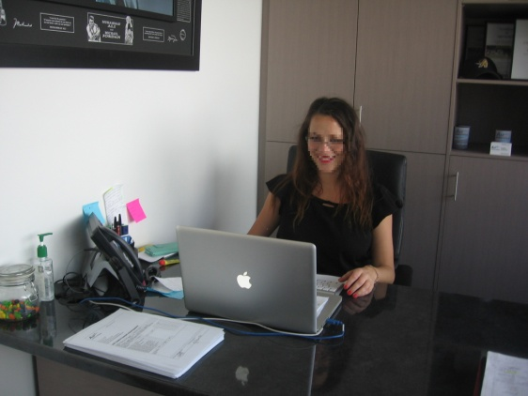

Domestic Appliance Retailing
Administration Assistant

Domestic Appliance Retailing
Administration Assistant
Dear Doctor: This form will take up to 5 minutes to complete. Please review each task the worker undertakes (both picture and written description) and tick whether or not the worker can complete this task. If modification required, please leave comments. Space at the end of this document is available for final comments and recommendations.
 | Workstation Duties  - Constant sitting at a workstation, using computer for 95% of the workday.  - Answering phones with the use of a headset and the handset positioned within arm’s length. | Doctor Approval  Yes No  Comments:
 | Administrative Duties  - Archiving and filing required.  - Printing and / or photocopying. | Doctor Approval  Yes No  Comments:
 | Customer Service  - Standing to meet and greet visitors.  - Accepting and signing for deliveries.  - Occasional lifting and carrying of small loads (max weight 5kg). | Doctor Approval  Yes No  Comments:
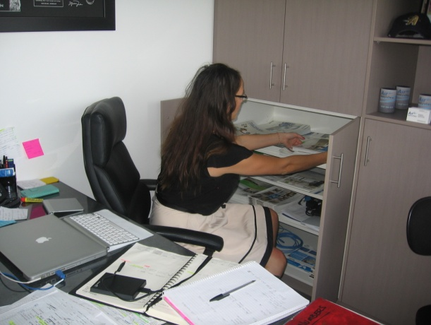 | Stationary  - Tidying, cleaning and replenishment of items in cupboards  - some stretching above head height;  - some bending to floor;  - lifting small loads, max 1kg.  (step stool and ladder available) | Doctor Approval  Yes No  Comments:
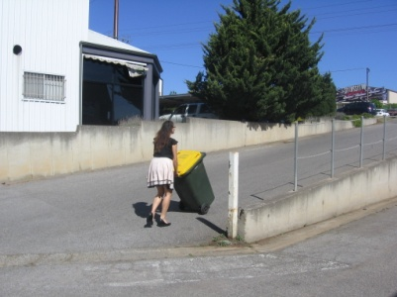  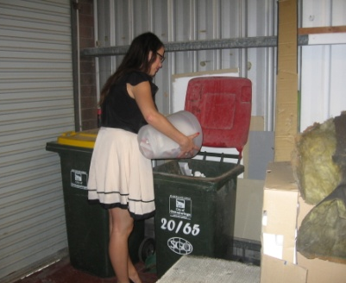 | Rubbish Bins  - Emptying wastepaper bins  - Bending to floor level;  - Carrying (max weight of 1.5kg).  - Taking out the garbage and recycling bins. Pushing a weight of approximately 20kg. | Doctor Approval  Yes No  Comments:
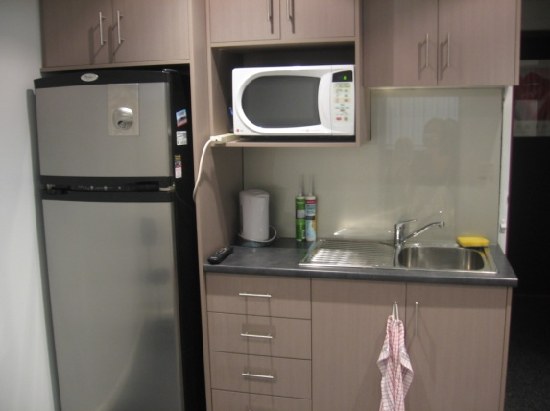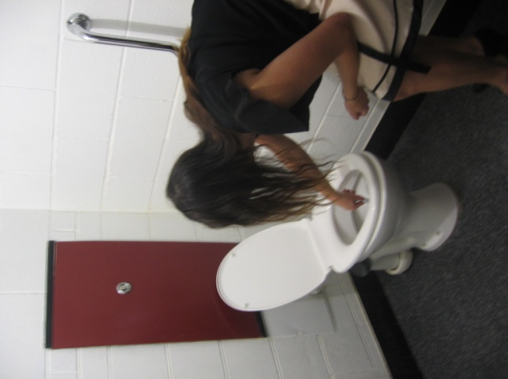 | Cleaning  - Kitchen cleaning duties  - Stretching to reach above head height ;  - Occasional bending to floor;  - Lifting small loads (max 1kg);  - Washing and drying dishes.  - Cleaning of bathrooms  - Wiping down of handbasin (no bending required);  - Cleaning toilets (bending and reaching required).  - Vacuuming the floors  - Some bending and twisting required;  - Pulling/pushing. | Doctor Approval  Yes No  Comments:
Work Capacity Form
Doctor Review (include final comments)

I confirm that in my view, subject to the above comments, the worker is able to perform certain duties detailed in this Early Medical Assessment.
These duties should be reassessed on: |  | Date:

Signature : |  | Date:

Employers Declaration:
I confirm that I/we have reviewed the Doctor’s recommendations and comments. I/we will make suitable changes to make allowances for the Dr’s recommendations.
Signature : |  | Date:

Employees Declaration
My Doctor has discussed their recommendations with me. I have been given the opportunity to participate in this process.
Signature : |  | Date:
For information on completing this form, please contact Business SA on 08 8300 0000.
Disclaimer: This document is published by Business SA with funding from ReturnToWorkSA. All workplaces and circumstances are different and this document should be used as a guide only. It is not diagnostic and should not replace consultation, evaluation, or personal services including examination and an agreed course of action by a licensed practitioner. Business SA and ReturnToWorkSA and their affiliates and their respective agents do not accept any liability for injury, loss or damage arising from the use or reliance on this document. The copyright owner provides permission to reproduce and adapt this document for the purposes indicated and to tailor it (as intended) for individual circumstances. (C) 2016 ReturnToWorkSA

