Early Medical Assessment

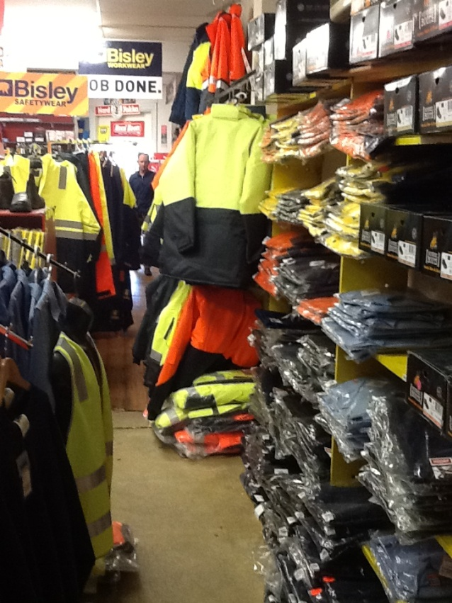
Clothing and Clothing
Accessories
Work and Safetywear Sales Assistant

Clothing and Clothing Accessories
Work and Safetywear Sales Assistant
Dear Doctor: This form will take up to 5 minutes to complete. Please review each task the worker undertakes (both picture and written description) and tick whether or not the worker can complete this task. If modification required, please leave comments. Space at the end of this document is available for final comments and recommendations.
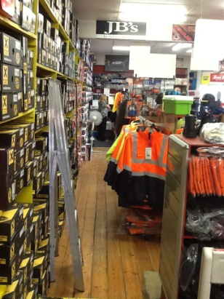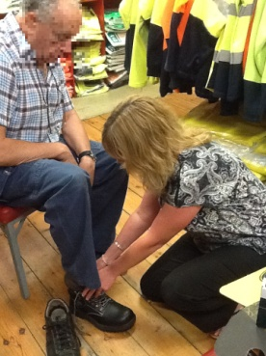 | Customer Service  - Standing and discussing product with customer  - Assisting customer (e.g. with shoe fitting)  - Repeated squatting, bending, getting up and climbing steps/ladders in order to fetch other alternatives for the customer (as appropriate) | Doctor Approval  Yes No  Comments:
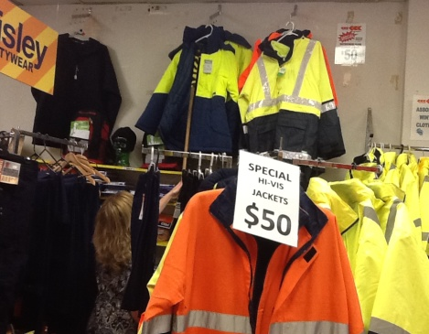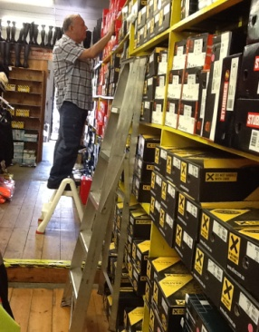 | Handling Stock  - Handling stock (⅓ - 3kg), eg. clothing and footwear  - Wall hangers are situated at various heights  - Free-standing hangers optional (various heights)  - Handling stock on shelves (floor level to 2.2m high)  Step stool and ladder may be  available | Doctor Approval  Yes No  Comments:
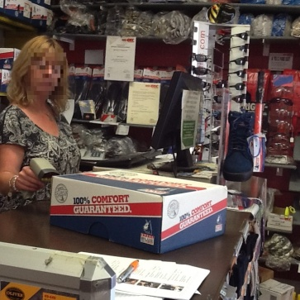 | Processing Transaction  - Walking to and standing at front counter  - Scanning item(s)  - Handling cash or EFT  - Wrapping and bagging item(s) at counter; fine dexterity and forward reaching required | Doctor Approval  Yes No  Comments:
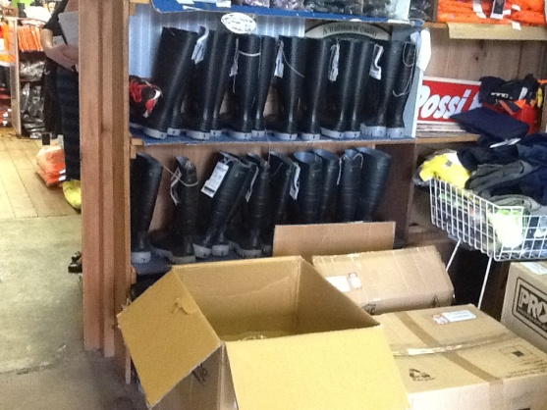 | Processing Bulk Stock and Orders  - Receiving goods at back of shop (max. weight of boxes is 15kg)  - Carrying smaller boxes (approx. 4kg) through shop  - Unpacking boxes and shelving / hanging stock (approx. 10-15 minutes, 2x / day) | Doctor Approval  Yes No  Comments:
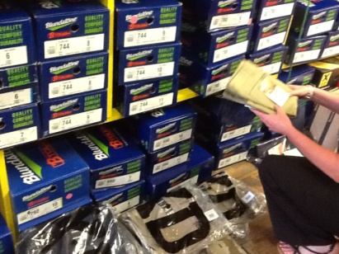 | Daily Tasks  - Replacing stock on shelves and on hangers  - Tidying up  - Vacuuming / sweeping the floor using a push/pull motion | Doctor Approval  Yes No  Comments:
Work Capacity Form
Doctor Review (include final comments)

I confirm that in my view, subject to the above comments, the worker is able to perform certain duties detailed in this Early Medical Assessment.
These duties should be reassessed on: |  | Date:

Signature : |  | Date:

Employers Declaration:
I confirm that I/we have reviewed the Doctor’s recommendations and comments. I/we will make suitable changes to make allowances for the Dr’s recommendations.
Signature : |  | Date:

Employees Declaration
My Doctor has discussed their recommendations with me. I have been given the opportunity to participate in this process.
Signature : |  | Date:
For information on completing this form, please contact Business SA on 08 8300 0000.
Disclaimer: This document is published by Business SA with funding from ReturnToWorkSA. All workplaces and circumstances are different and this document should be used as a guide only. It is not diagnostic and should not replace consultation, evaluation, or personal services including examination and an agreed course of action by a licensed practitioner. Business SA and ReturnToWorkSA and their affiliates and their respective agents do not accept any liability for injury, loss or damage arising from the use or reliance on this document. The copyright owner provides permission to reproduce and adapt this document for the purposes indicated and to tailor it (as intended) for individual circumstances. (C) 2016 ReturnToWorkSA

