Early Medical Assessment
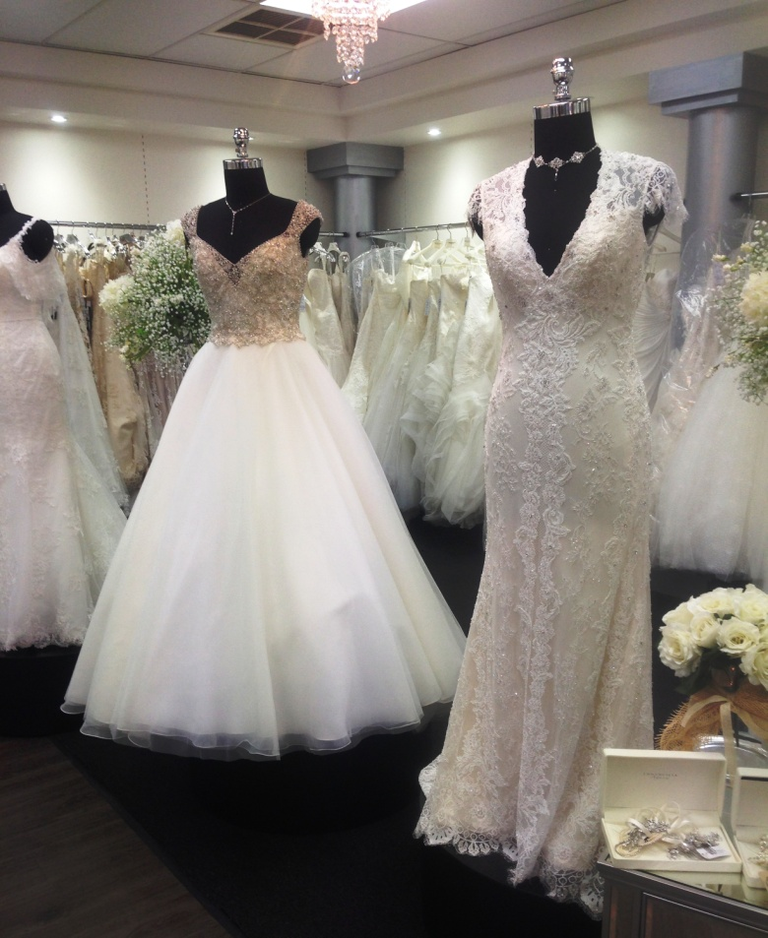

Clothing and Clothing Accessories
Bridal Sales Assistant

Bridal Sales Assistant
Dear Doctor: This form will take up to 5 minutes to complete. Please review each task the worker undertakes (both picture and written description) and tick whether or not the worker can complete this task. If modification required, please leave comments. Space at the end of this document is available for final comments and recommendations.
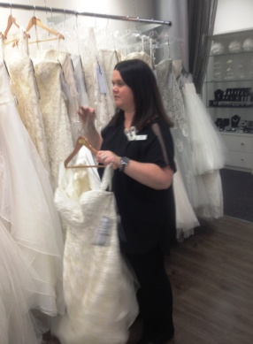 | Customer Service  - Standing and walking constantly  - Shop is located upstairs therefore climbing of 2 flights of stairs infrequently  - Standing and discussing product with customer.  - Selecting stock for bride to try on from racks (see stock handling)  - Brides have 1.5 hour appointments with sales assistant. | Doctor Approval  Yes No  Comments:
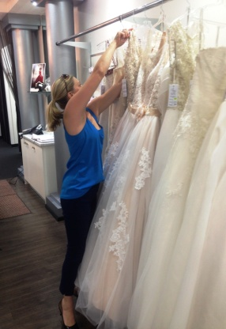  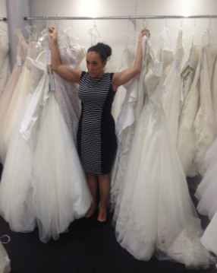  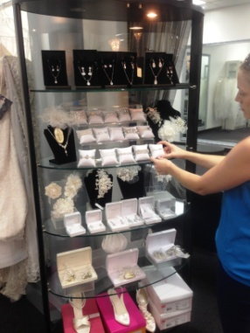 | Stock Handling  - Accessing gowns from racks at 2020mm (reaching overhead) and placing on change room rack  - Dresses range in weight up to approx. 5kg. Up to 5 dresses are carried at a time (approx 15kg). Sustained shoulder flexion, abduction and rotation required to carry above head.  - Accessories stored on shelves between 180mm-1500mm requiring forward reaching and occasionally squatting. | Doctor Approval  Yes No  Comments:
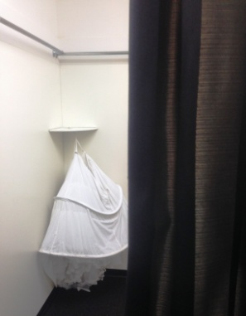  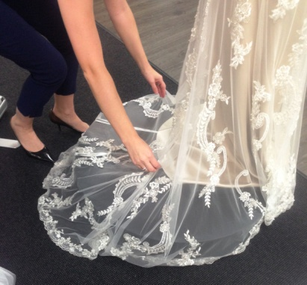  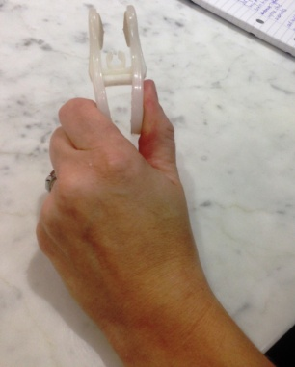  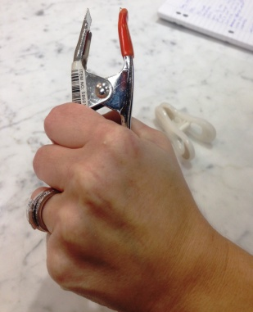 | Dressing the Bride  - Placing the dress over brides head requires overhead reach and shoulder flexion /abduction  - Squatting and bending to arrange dress around bride.  - Over head reaching to place veil/accessories  - Clamping to allow dress to ‘fit’ bride - gripping - two types of clamp used (pinch or power grip required)  - Flower girls are fitted also requiring lower postures. | Doctor Approval  Yes No  Comments:
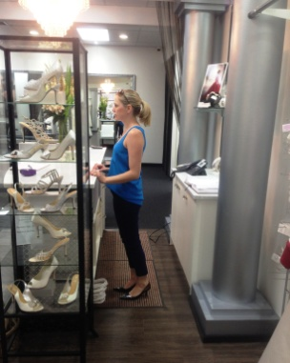 | Processing Transactions  - Standing at bench  - Handling cash or EFT  - Bagging items | Doctor Approval  Yes No  Comments:
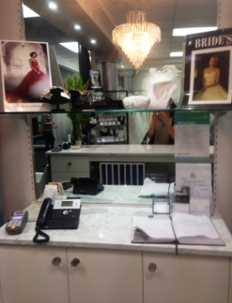
Work Capacity Form
Doctor Review (include final comments)

I confirm that in my view, subject to the above comments, the worker is able to perform certain duties detailed in this Early Medical Assessment.
These duties should be reassessed on: |  | Date:

Signature : |  | Date:

Employers Declaration:
I confirm that I/we have reviewed the Doctor’s recommendations and comments. I/we will make suitable changes to make allowances for the Dr’s recommendations.
Signature : |  | Date:

Employees Declaration
My Doctor has discussed their recommendations with me. I have been given the opportunity to participate in this process.
Signature : |  | Date:
For information on completing this form, please contact Business SA on 08 8300 0000.
Disclaimer: This document is published by Business SA with funding from ReturnToWorkSA. All workplaces and circumstances are different and this document should be used as a guide only. It is not diagnostic and should not replace consultation, evaluation, or personal services including examination and an agreed course of action by a licensed practitioner. Business SA and ReturnToWorkSA and their affiliates and their respective agents do not accept any liability for injury, loss or damage arising from the use or reliance on this document. The copyright owner provides permission to reproduce and adapt this document for the purposes indicated and to tailor it (as intended) for individual circumstances. (C) 2016 ReturnToWorkSA

