Early Medical Assessment

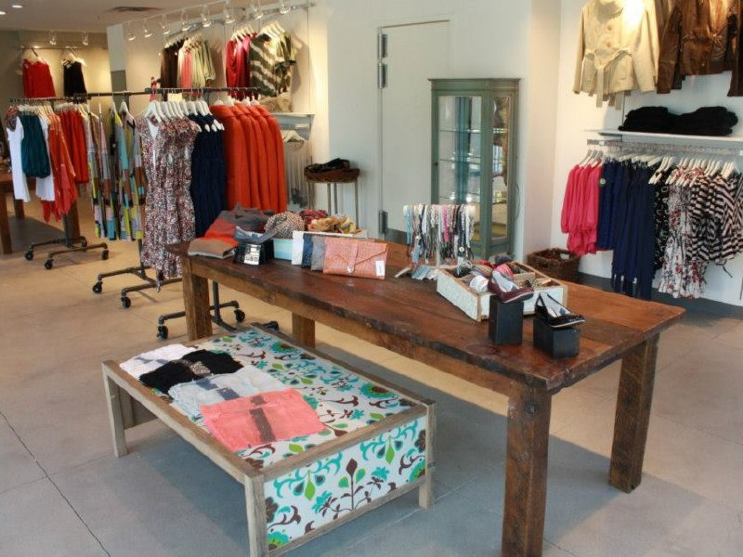

Clothing and Clothing Accessories

Retail Sales Assistant Womenswear

1. Clothing and Clothing Accessories
2. Retail Sales Assistant Womenswear

Dear Doctor: This form will take up to 5 minutes to complete. Please review each task the worker undertakes (both picture and written description) and tick whether or not the worker can complete this task. If modification required, please leave comments. Space at the end of this document is available for final comments and recommendations.

|  |  |  |
| --- | --- | --- |
| cid:3011bd5a101d3a3c231a51508e7eae35.jpeg | **Customer Service**   * Standing and discussing product with customer. * Handling garments ( ½ kg) on hangers. Display heights can vary | Doctor Approval  Yes  No  Comments: |
| C:\Users\DirectOT\AppData\Local\Microsoft\Windows\Temporary Internet Files\Content.Outlook\GI072LNI\photo 4 (13).JPG | **Customer Assistance**   * Carrying garments on hangers to change room and hanging. * Assisting with zips and buttons as requested. (Bilateral pincer grip and pull force). * Walking to retrieve other sizes and carrying back to change room. * Rehanging unwanted stock onto hangers and replacing in store. | Doctor Approval  Yes  No  Comments: |
|  | **Processing Transaction**   * Walking to and standing at front counter * Unilaterally grasping items and hand held scanner (<1kg) * Handling cash or EFT * Wrapping and bagging item(s) at counter requiring forward reaching and fine dexterity | Doctor Approval  Yes  No  Comments: |
| C:\Users\DirectOT\AppData\Local\Microsoft\Windows\Temporary Internet Files\Content.Outlook\GI072LNI\photo 1 (20).JPG | **Receiving Deliveries**   * Receiving delivered items in plastic bags (3-5kg) or cartons (up to 15kg). * Directing the delivery person to storage location – no handling of filled boxes required by staff member. * Removing bags from hanging garments | Doctor Approval  Yes  No  Comments: |
| C:\Users\DirectOT\AppData\Local\Microsoft\Windows\Temporary Internet Files\Content.Outlook\GI072LNI\photo 2 (16).JPG | **Recovery of Back Room Stock**   * Occasionally walking to retrieve stock from back room. * Squatting / stooping to retrieve shoes in box (1kg) from low stack. * Reaching to grasp hanging items and laybys / holds from rack | Doctor Approval  Yes  No  Comments: |
| C:\Users\DirectOT\AppData\Local\Microsoft\Windows\Temporary Internet Files\Content.Outlook\GI072LNI\photo 3 (13).JPG C:\Users\DirectOT\AppData\Local\Microsoft\Windows\Temporary Internet Files\Content.Outlook\GI072LNI\photo 2 (15).JPG   * + - * 1. (b)   C:\Users\DirectOT\AppData\Local\Microsoft\Windows\Temporary Internet Files\Content.Outlook\GI072LNI\photo (11).JPG (c) | **Processing Deliveries /**  **Stocking hangers**   * Removing individual items from carton e.g. shirt or jewellery (<1.5kg) * Tearing plastic wrappers from clothing * Cutting strapping on multiple hangers (a) * Applying security tags (b) * Applying printed labels to swing tag (c). * Fine dexterity required for these tasks. Repeated gripping and grasping. | Doctor Approval  Yes  No  Comments: |
| C:\Users\DirectOT\AppData\Local\Microsoft\Windows\Temporary Internet Files\Content.Outlook\GI072LNI\photo 3 (14).JPG | **Daily Cleaning**   * Cleaning glass counter display with cloth, forward reaching and circular movements. * Vacuuming and mopping hard floors each morning (20 min). * Dusting shelves (varying heights) | Doctor Approval  Yes  No  Comments: |
| C:\Users\DirectOT\AppData\Local\Microsoft\Windows\Temporary Internet Files\Content.Outlook\GI072LNI\photo 5 (13).JPG  1.58mm | **Merchandising**   * Usually performed by manager twice weekly * Removing garments off rack * Grasping and pushing upwards (light force) to lift hangers off mounts and replace. * Replacing garments * Repeated forward reaching at varying heights | Doctor Approval  Yes  No  Comments: |
| C:\Users\DirectOT\AppData\Local\Microsoft\Windows\Temporary Internet Files\Content.Outlook\GI072LNI\photo 4 (14).JPG | **Altering Window Display**   * Applying clothing to mannequin – use of pincer action to pin garment * Forward reaching, bending, over shoulder reaching required arrange clothes on mannequin * Lifting 5kg mannequin and placing in window display | Doctor Approval  Yes  No  Comments: |

1. Work Capacity Form

**Doctor Review (include final comments)**

|  |
| --- |
|  |
|  |
|  |
|  |
|  |
|  |
|  |
|  |
|  |
|  |

I confirm that in my view, subject to the above comments, the worker is able to perform certain duties detailed in this Early Medical Assessment.

|  |  |  |
| --- | --- | --- |
| These duties should be reassessed on: |  | Date: |

|  |  |  |
| --- | --- | --- |
| Signature : |  | Date: |

**Employers Declaration:**

I confirm that I/we have reviewed the Doctor’s recommendations and comments. I/we will make suitable changes to make allowances for the Dr’s recommendations.

|  |  |  |
| --- | --- | --- |
| Signature : |  | Date: |

**Employees Declaration**

My Doctor has discussed their recommendations with me. I have been given the opportunity to participate in this process.

|  |  |  |
| --- | --- | --- |
| Signature : |  | Date: |

For information on completing this form, please contact Business SA on 08 8300 0000.

***Disclaimer:*** *This document is published by Business SA with funding from ReturnToWorkSA. All workplaces and circumstances are different and this document should be used as a guide only. It is not diagnostic and should not replace consultation, evaluation, or personal services including examination and an agreed course of action by a licensed practitioner. Business SA and ReturnToWorkSA and their affiliates and their respective agents do not accept any liability for injury, loss or damage arising from the use or reliance on this document. The copyright owner provides permission to reproduce and adapt this document for the purposes indicated and to tailor it (as intended) for individual circumstances*. (C) 2016 ReturnToWorkSA