Early Medical Assessment

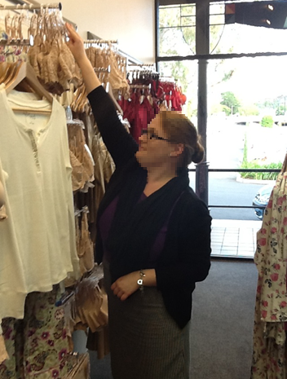

Clothing and Clothing

1. Accessories
2. Lingerie Retail Sales Assistant
3. Clothing and Clothing Accessories

Lingerie Sales Assistant

Dear Doctor: This form will take up to 5 minutes to complete. Please review each task the worker undertakes (both picture and written description) and tick whether or not the worker can complete this task. If modification required, please leave comments. Space at the end of this document is available for final comments and recommendations.

|  |  |  |
| --- | --- | --- |
| cid:c3a8f8727fe7b54fdf8d1e9a3c7db446.jpeg | **Customer Service**   * Standing and discussing product with customer * Handle stock (⅓ - 1kg) as per below | Doctor Approval  Yes  No  Comments: |
| cid:d0632d7b612aa450867c6bcff37178f6.jpeg | **Handling Stock**   * Wall hangers up to 2.5m * Free-standing hanging racks approx. 0.56 - 1.65m * Reaching at varying heights required to access racks * Step stool may be available | Doctor Approval  Yes  No  Comments: |
| cid:e79ca90cd3855190ef99636cbd948470.jpeg | **Recovery of Back up Stock**   * Occasionally retrieve stock from rear storeroom. * Reaching to remove folded items from hangers up to 2.2m and folded items from shelves 0.2-1.8m * Handling and climbing step ladder | Doctor Approval  Yes  No  Comments: |
| **cid:3011bd5a101d3a3c231a51508e7eae35.jpeg** | **Processing Transaction**   * Walking to and standing at front counter * Bilaterally grasping item(s) and moving under fixed scanner * Handling cash or EFT * Wrapping and bagging item(s) at counter. Fine dexterity required. | Doctor Approval  Yes  No  Comments: |
| cid:27e7d842be03902297b4862439073b80.jpeg | **Bra Fittings**   * Average 10 fittings per day * Removing stock from hangers * Applying tape measure around chest requiring shoulder flexion, rotation and abduction and grasping * Bilateral pincer grip and pull force to attach clasps and adjust straps. * Assisting customer to apply bra | Doctor Approval  Yes  No  Comments: |
| photo2.JPG | **Daily Cleaning**   * Cleaning glass counter display with cloth. * Using turbo vacuum cleaner on carpet floors each morning (15 min). – push / pull force * Dusting shelf tops | Doctor Approval  Yes  No  Comments: |
| cid:1a7c2a7f875531523fc2bbfbd08695b0.jpeg | **Processing Bulk Stock and Orders**   * Receiving goods at front counter (average 5-6kg). * Occasionally lifting cartons to floor, squatting required * Unpacking items on counter * Applying hangers to lingerie (pincer grasp) * Hanging stock on store displays | Doctor Approval  Yes  No  Comments: |
| cid:d0632d7b612aa450867c6bcff37178f6.jpeg | **Re-Merchandising**   * Small scale 1-2 x p/week * Larger scale 1-2 x p/month * Removing stock off display * Grasping and lifting hangers off mounts and replacing * Replacing stock as needed | Doctor Approval  Yes  No  Comments: |
| cid:b0c7f0f6406d46b6852609da9d8be83f.jpeg | **Altering Window Display**   * Usually performed by manager every 2-3 weeks * Remove arms, legs, wrists and feet from static mannequin * Apply product * Replace limbs | Doctor Approval  Yes  No  Comments: |

1. Work Capacity Form

**Doctor Review (include final comments)**

|  |
| --- |
|  |
|  |
|  |
|  |
|  |
|  |
|  |
|  |
|  |
|  |

I confirm that in my view, subject to the above comments, the worker is able to perform certain duties detailed in this Early Medical Assessment.

|  |  |  |
| --- | --- | --- |
| These duties should be reassessed on: |  | Date: |

|  |  |  |
| --- | --- | --- |
| Signature : |  | Date: |

**Employers Declaration:**

I confirm that I/we have reviewed the Doctor’s recommendations and comments. I/we will make suitable changes to make allowances for the Dr’s recommendations.

|  |  |  |
| --- | --- | --- |
| Signature : |  | Date: |

**Employees Declaration**

My Doctor has discussed their recommendations with me. I have been given the opportunity to participate in this process.

|  |  |  |
| --- | --- | --- |
| Signature : |  | Date: |

For information on completing this form, please contact Business SA on 08 8300 0000.

***Disclaimer:*** *This document is published by Business SA with funding from ReturnToWorkSA. All workplaces and circumstances are different and this document should be used as a guide only. It is not diagnostic and should not replace consultation, evaluation, or personal services including examination and an agreed course of action by a licensed practitioner. Business SA and ReturnToWorkSA and their affiliates and their respective agents do not accept any liability for injury, loss or damage arising from the use or reliance on this document. The copyright owner provides permission to reproduce and adapt this document for the purposes indicated and to tailor it (as intended) for individual circumstances*. (C) 2016 ReturnToWorkSA