Early Medical Assessment
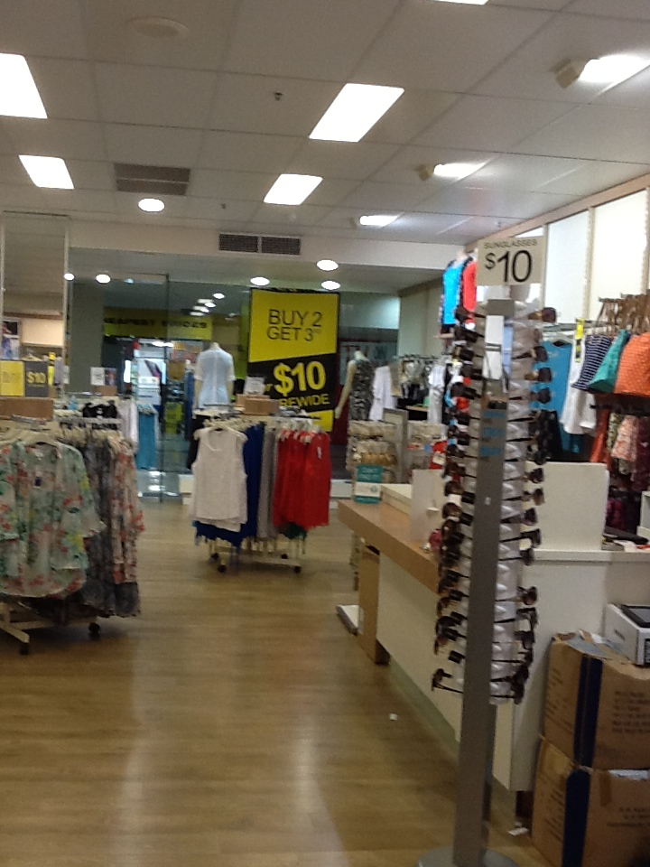
Clothing and Clothing
Accessories
Ladies Fashion Sales Assistant
Clothing and Clothing Accessories
Ladies Fashion Sales Assistant
Dear Doctor: This form will take up to 5 minutes to complete. Please review each task the worker undertakes (both picture and written description) and tick whether or not the worker can complete this task. If modification required, please leave comments. Space at the end of this document is available for final comments and recommendations.
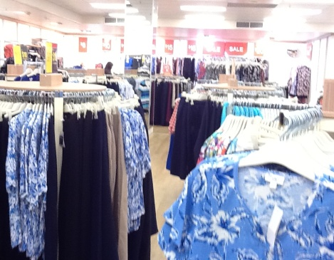 | Customer Service  - Standing and discussing product with customer  - Handling stock (⅓ - 1kg) as per below | Doctor Approval  Yes No  Comments:
 | Handling Stock  - Handling stock (⅓ - 1kg)  - Hanging hangers on free-standing displays or on wall hangers (varying heights). Repetitive reaching required.  - Safety step / ladder / reaching rod may be available. | Doctor Approval  Yes No  Comments:
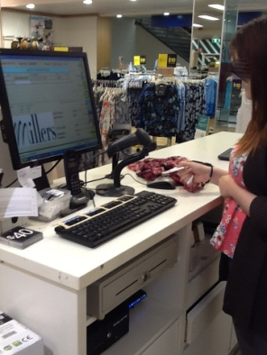 | Processing Transactions  - Walking to and standing at front counter  - Bilaterally grasping item(s) and moving under fixed scanner  - Handling cash or EFT  - Wrapping and bagging item(s) whilst standingat counter. Fine dexterity required. | Doctor Approval  Yes No  Comments:
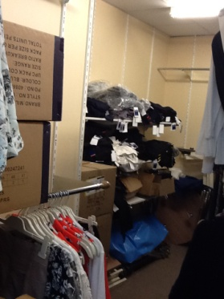 | Recovery of Back up Stock  - Occasionally retrieve stock from rear storeroom.  - Reaching to remove items from hangers and shelves (max. height: 2.15m)  - Handling and climbing step ladder | Doctor Approval  Yes No  Comments:

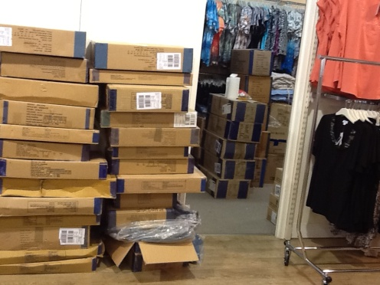 | Processing Bulk Stock and Orders  - Receiving goods from delivery man (max. weight of boxes 12kg).  - Occasionally lifting boxes  - Unpacking items  - Applying hangers requiring grasping  - Hanging stock on store displays at varying heights | Doctor Approval  Yes No  Comments:
 | Re-Merchandising  - Moving merchandise  - Grasping and lifting hangers off mounts and replacing at varying heights  - Replacing stock as required | Doctor Approval  Yes No  Comments:
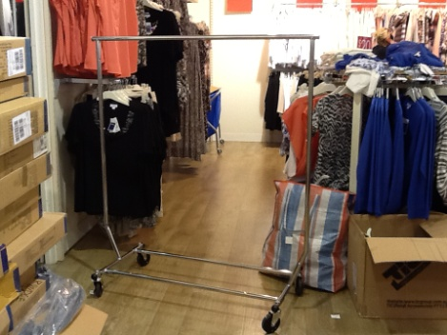 | Daily Cleaning  - Cleaning surfaces, mirrors and glass  - Using (push/pull) industrial vacuum cleaner on floating boards | Doctor Approval  Yes No  Comments:
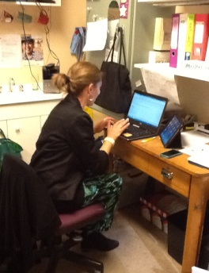 | Administration  - Administrative tasks usually performed by store manager (daily)  - Using computer  - Responding to phone calls and emails  - Undertaken in a seated position. | Doctor Approval  Yes No  Comments:
Work Capacity Form
Doctor Review (include final comments)

I confirm that in my view, subject to the above comments, the worker is able to perform certain duties detailed in this Early Medical Assessment.
These duties should be reassessed on: |  | Date:

Signature : |  | Date:

Employers Declaration:
I confirm that I/we have reviewed the Doctor’s recommendations and comments. I/we will make suitable changes to make allowances for the Dr’s recommendations.
Signature : |  | Date:

Employees Declaration
My Doctor has discussed their recommendations with me. I have been given the opportunity to participate in this process.
Signature : |  | Date:
For information on completing this form, please contact Business SA on 08 8300 0000.
Disclaimer: This document is published by Business SA with funding from ReturnToWorkSA. All workplaces and circumstances are different and this document should be used as a guide only. It is not diagnostic and should not replace consultation, evaluation, or personal services including examination and an agreed course of action by a licensed practitioner. Business SA and ReturnToWorkSA and their affiliates and their respective agents do not accept any liability for injury, loss or damage arising from the use or reliance on this document. The copyright owner provides permission to reproduce and adapt this document for the purposes indicated and to tailor it (as intended) for individual circumstances. (C) 2016 ReturnToWorkSA

