Early Medical Assessment
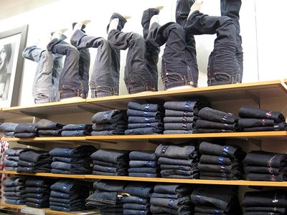

Clothing and Clothing
Accessories
Jeans Retailer – Customer Service
SAWIC Code 484001

Clothing and Clothing Accessories
Jeans Retailer
Dear Doctor: This form will take up to 5 minutes to complete. Please review each task the worker undertakes (both picture and written description) and tick whether or not the worker can complete this task. If modification required, please leave comments. Space at the end of this document is available for final comments and recommendations.
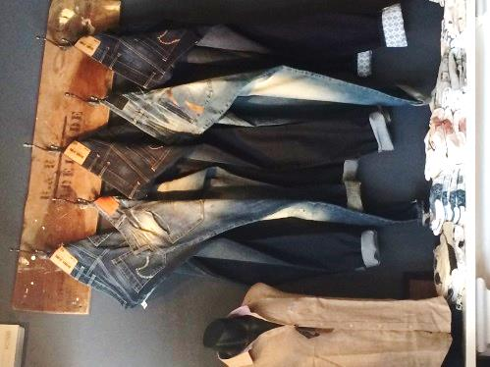 | Customer Service  - Standing and discussing product with customer.  - Handling garments (½ -1 kg) folded or on hangers at varying heights.  - Standing momentarily to check fit of jeans using mid range forward reach +/-stooping.  - Measuring customer for jeans alterations or customised jeans (squatting and / or stooping.) | Doctor Approval  Yes No  Comments:
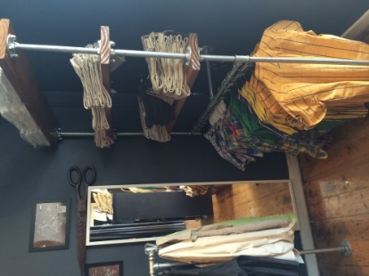 | Customer Assistance  - Folding unwanted items and returning to shelves. Primarily performed at bench height.  - Re-hanging unwanted stock onto hangers.  - A step stool / ladder may be available for use to reach high shelves. | Doctor Approval  Yes No  Comments:
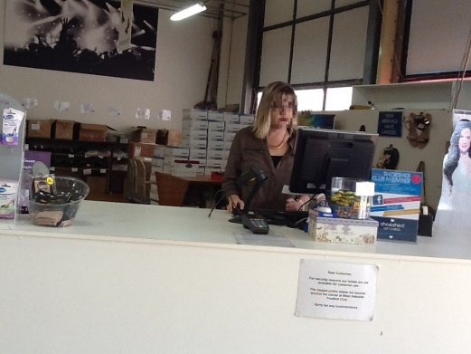 | Processing Transaction  - Standing at counter.  - Handwriting docket.  - Inputting data into a computer.  - Cash handling or EFT.  - Wrapping and bagging item and passing to customer. Forward reaching and grasping required. | Doctor Approval  Yes No  Comments:
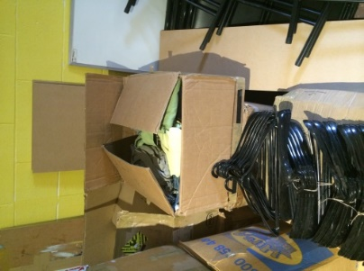 | Receiving Stock  - Stock is delivered in cartons (15kg-25kg). Individual items weigh <1kg.  - Unpacking stock and applying stock to hangers or folding for shelving.  - Lifting, bending, reaching, grasping required. | Doctor Approval  Yes No  Comments:
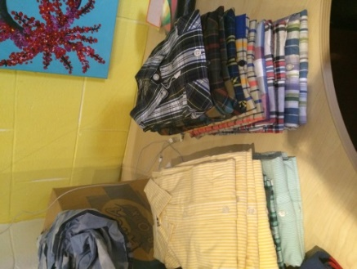 | Stocking Displays  - Carrying items from the rear to the front of shop (weight dependent upon tolerance).  - Hanging items on hangers or looping belt loop over hooks requiring reaching at varying heights.  - Folding T-shirts and shirts and placing in a stack on shelf. | Doctor Approval  Yes No  Comments:
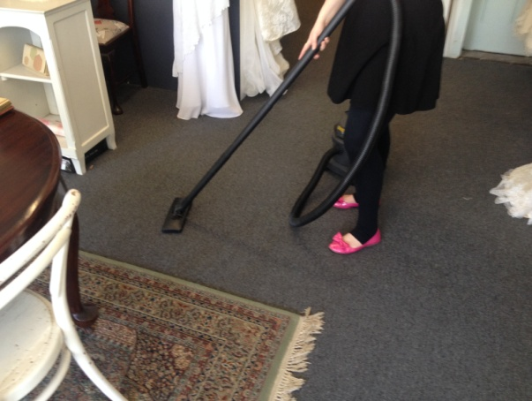 | Daily Cleaning  - Cleaning surfaces with a damp cloth.  - Vacuuming (push/pull forces) timber floor each morning (5min). | Doctor Approval  Yes No  Comments:
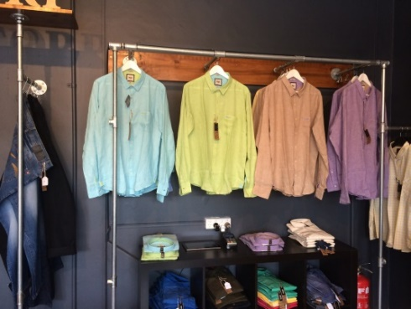 | Merchandising  - Performed 1-2 weekly.  - Removing garments off racks and shelves (heights vary).  - Altering orientation.  - Replacing garments.  - Repetitive reaching and grasping required | Doctor Approval  Yes No  Comments:
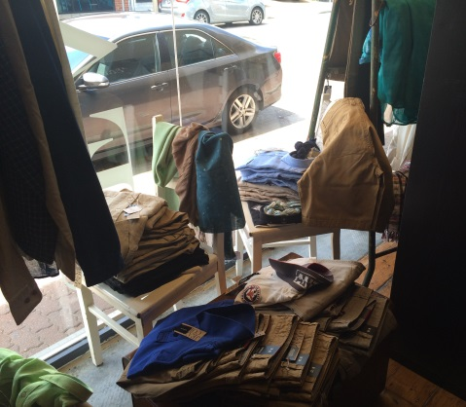 | Altering Window Display  - Folding garments  - Arranging garments on shelf and furniture in window display. | Doctor Approval  Yes No  Comments:
Work Capacity Form
Doctor Review (include final comments)

I confirm that in my view, subject to the above comments, the worker is able to perform certain duties detailed in this Early Medical Assessment.
These duties should be reassessed on: |  | Date:

Signature : |  | Date:

Employers Declaration:
I confirm that I/we have reviewed the Doctor’s recommendations and comments. I/we will make suitable changes to make allowances for the Dr’s recommendations.
Signature : |  | Date:

Employees Declaration
My Doctor has discussed their recommendations with me. I have been given the opportunity to participate in this process.
Signature : |  | Date:
For information on completing this form, please contact Business SA on 08 8300 0000.
Disclaimer: This document is published by Business SA with funding from ReturnToWorkSA. All workplaces and circumstances are different and this document should be used as a guide only. It is not diagnostic and should not replace consultation, evaluation, or personal services including examination and an agreed course of action by a licensed practitioner. Business SA and ReturnToWorkSA and their affiliates and their respective agents do not accept any liability for injury, loss or damage arising from the use or reliance on this document. The copyright owner provides permission to reproduce and adapt this document for the purposes indicated and to tailor it (as intended) for individual circumstances. (C) 2016 ReturnToWorkSA

