Early Medical Assessment

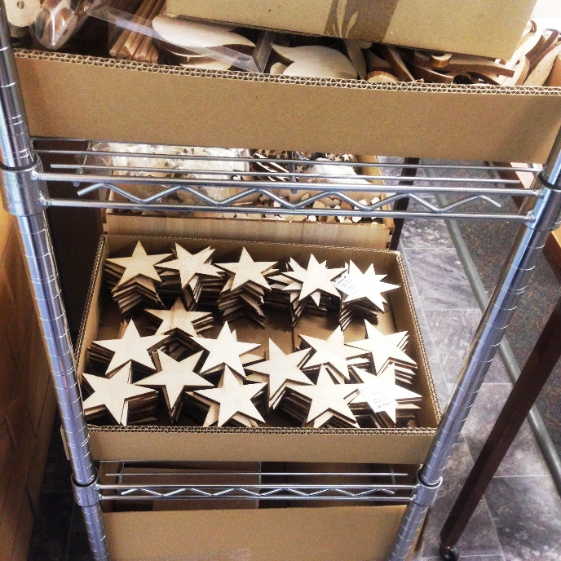

Building Supplies Wholesale
Workshop

Building Supplies Wholesale
Workshop
Dear Doctor: This form will take up to 5 minutes to complete. Please review each task the worker undertakes (both picture and written description) and tick whether or not the worker can complete this task. If modification required, please leave comments. Space at the end of this document is available for final comments and recommendations.
Workers in the workshop stand constantly and use a variety of machinery as below.
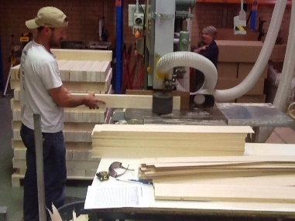  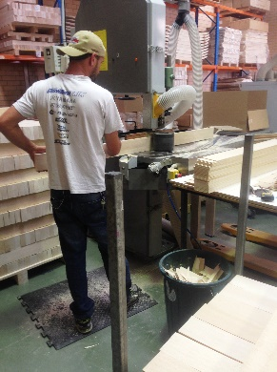 | Ban Saw  - Used to cut product to the desired width.  - Constant standing; using foot pedal to set width. Anti fatigue matting in place.  - Feeding product through saw by grasping. | Doctor Approval  Yes No  Comments:
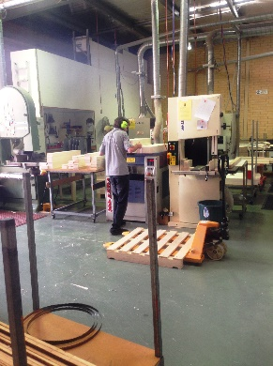  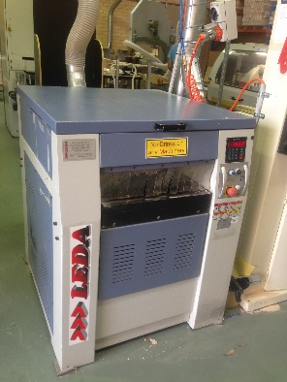 | Thicknesser  - Constant standing; two person job.  - First worker feeds timber though, second worker collects on the other side  - Button operated. | Doctor Approval  Yes No  Comments:
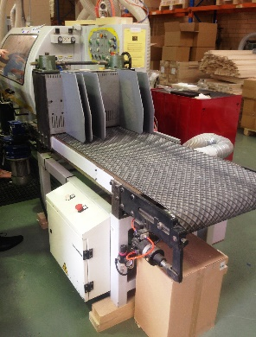  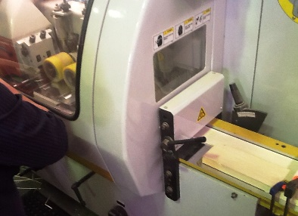 | Moulder  - Auto feed at waist height; constant standing required.  - Collecting from other end after product has been cut.  - Manually changing settings according to desired shape.  - Lifting lid;  - Turning knobs at waist height requiring fine dexterity;  - Closing lid. | Doctor Approval  Yes No  Comments:
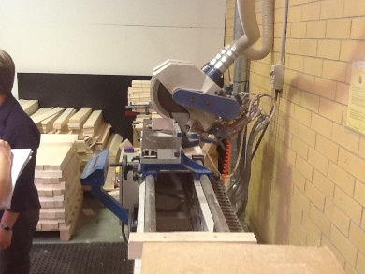 | Docking Saw  - Cutting ends off timber lengths to make clean.  - Machine is completely automatic.  - Grasping timber and reaching forward to place it in; Operating via button. | Doctor Approval  Yes No  Comments:
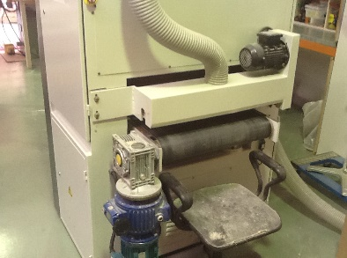  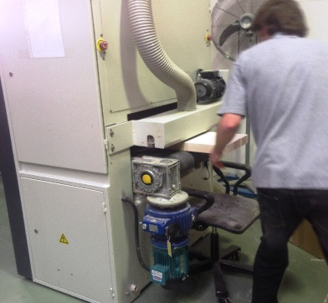  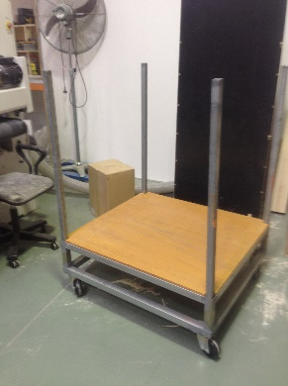 | Sander  - Feeding timber through sander.  - Catching timber on other side so it is not damaged.  - For lighter objects a tray is placed on the receiving end to catch it.  - Restacking sanded timber on a trolley.  - Constant standing, repetitive grasping of light pieces of timber. Some low level postures when trolley is low. | Doctor Approval  Yes No  Comments:
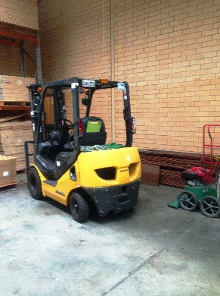  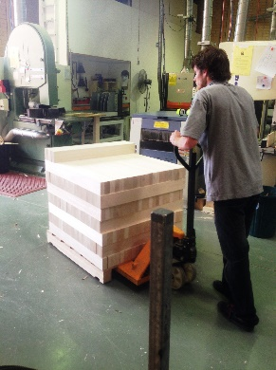  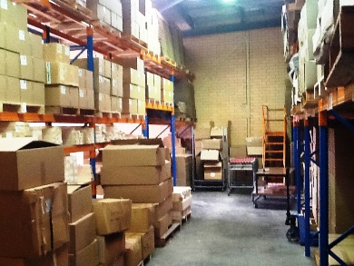  __ | Moving Stock  - Drive the forklift requires the ability to  - be able to mount the forklift repetitively;  - have unrestricted head and shoulder movement;  - demonstrate strength in arms and hands for gripping the gear stick and the steering wheel.  - Pushing / pulling trolley jack . | Doctor Approval  Yes No  Comments:
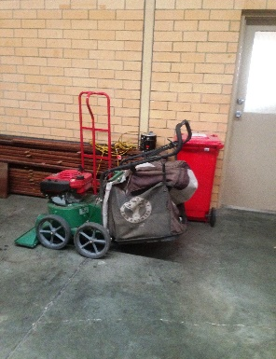  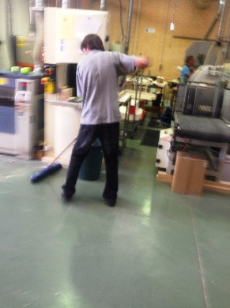 | Cleaning  - Sweeping, pushing pulling broom, may involve some twisting and bending depending on technique.  - Vacuum available to collect saw dust. | Doctor Approval  Yes No  Comments:
Work Capacity Form
Doctor Review (include final comments)

I confirm that in my view, subject to the above comments, the worker is able to perform certain duties detailed in this Early Medical Assessment.
These duties should be reassessed on: |  | Date:

Signature : |  | Date:

Employers Declaration:
I confirm that I/we have reviewed the Doctor’s recommendations and comments. I/we will make suitable changes to make allowances for the Dr’s recommendations.
Signature : |  | Date:

Employees Declaration
My Doctor has discussed their recommendations with me. I have been given the opportunity to participate in this process.
Signature : |  | Date:
For information on completing this form, please contact Business SA on 08 8300 0000.
Disclaimer: This document is published by Business SA with funding from ReturnToWorkSA. All workplaces and circumstances are different and this document should be used as a guide only. It is not diagnostic and should not replace consultation, evaluation, or personal services including examination and an agreed course of action by a licensed practitioner. Business SA and ReturnToWorkSA and their affiliates and their respective agents do not accept any liability for injury, loss or damage arising from the use or reliance on this document. The copyright owner provides permission to reproduce and adapt this document for the purposes indicated and to tailor it (as intended) for individual circumstances. (C) 2016 ReturnToWorkSA

