Early Medical Assessment

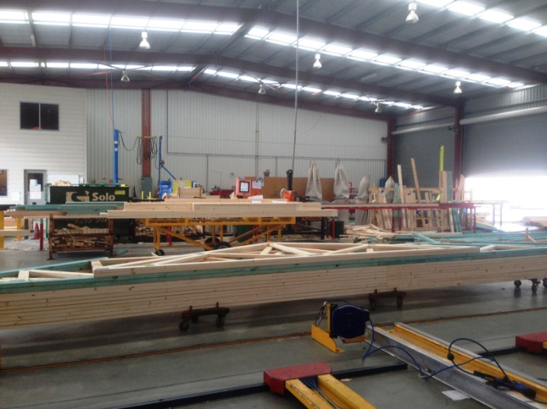

Building Supplies Wholesale
Truss Plant Worker

Building Supplies Wholesale
Truss Plant Worker
Dear Doctor: This form will take up to 5 minutes to complete. Please review each task the worker undertakes (both picture and written description) and tick whether or not the worker can complete this task. If modification required, please leave comments. Space at the end of this document is available for final comments and recommendations.
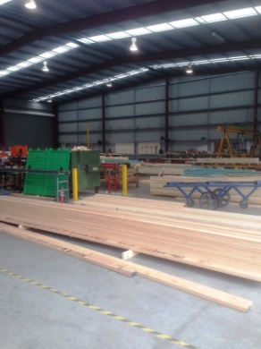 | Picking Timber Lengths  - Lengths of timber stored on trestles on the ground. 6m maximum length (weighing approx 5kg).  - Bending to grasp timber length and counteracting length to balance it and carry it to the saw.  - Alternatively a trolley can be used to move more than one piece. | Doctor Approval  Yes No  Comments:
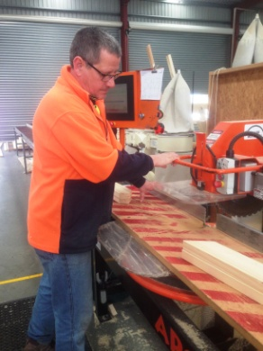  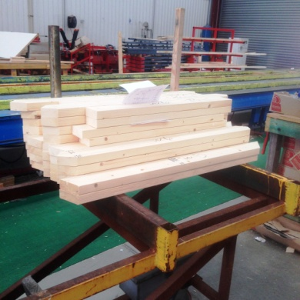 | Mango Saw  - Programming Mango Saw to cut correct angle using touch screen.  - Pulling saw handle (between waist and chest height) toward the body to make cut (light force).  - Collecting cut pieces of timber and placing on trolley nearby.  - Pushing trolley to jig area. | Doctor Approval  Yes No  Comments:
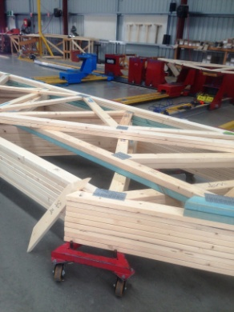  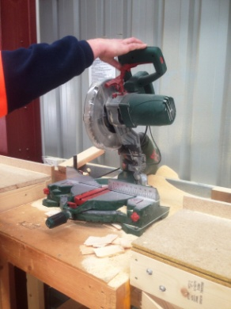  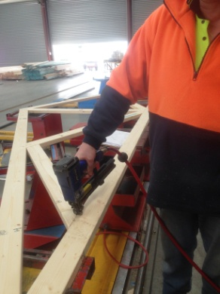  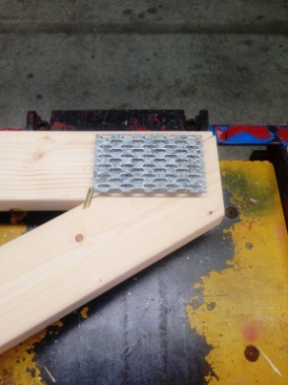  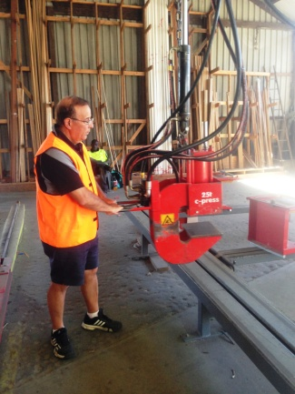 | Jig and Press  - Constant standing required.  - Placing timber in pre-set jig. Lifting and grasping each piece individually.  - If timber cuts are out by a few mm and not fitting together, carrying timber piece to drop saw and re-cutting. Pulling down handle from shoulder to waist height with dominant hand. Steadying timber with non dominant hand.  - Grasping staple gun in dominant hand and stapling timber together to hold in place for pressing (hammer grip)  - Metal plates are positioned at joins on timber. Fine dexterity required.  - Operating press with pushing/pulling motion and walking it along the roof truss. Twisting may be required. Levers used to position clamp.  - Once plates have been pressed two workers lift the truss and carry it to place on wheels on ground, bending/squatting required | Doctor Approval  Yes No  Comments:
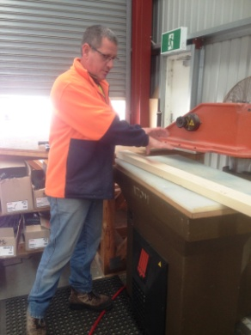  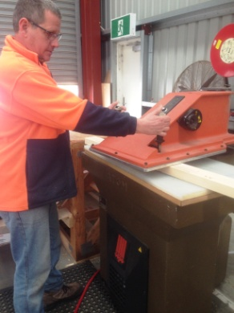 | Clicker Press  - Smaller roof trusses are joined using a clicker press.  - Grasping handles and swinging press to the right to bring controls in front of worker (light force) .  - Pressing two buttons (between waist and chest height) to operate press.  - Swinging press away to left. | Doctor Approval  Yes No  Comments:
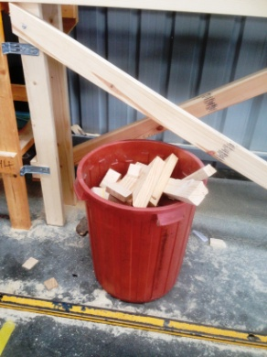 | Clean Up  - Sweeping floor.  - Emptying scraps bin as required (lifting and carrying bin). | Doctor Approval  Yes No  Comments:
Work Capacity Form
Doctor Review (include final comments)

I confirm that in my view, subject to the above comments, the worker is able to perform certain duties detailed in this Early Medical Assessment.
These duties should be reassessed on: |  | Date:

Signature : |  | Date:

Employers Declaration:
I confirm that I/we have reviewed the Doctor’s recommendations and comments. I/we will make suitable changes to make allowances for the Dr’s recommendations.
Signature : |  | Date:

Employees Declaration
My Doctor has discussed their recommendations with me. I have been given the opportunity to participate in this process.
Signature : |  | Date:
For information on completing this form, please contact Business SA on 08 8300 0000.
Disclaimer: This document is published by Business SA with funding from ReturnToWorkSA. All workplaces and circumstances are different and this document should be used as a guide only. It is not diagnostic and should not replace consultation, evaluation, or personal services including examination and an agreed course of action by a licensed practitioner. Business SA and ReturnToWorkSA and their affiliates and their respective agents do not accept any liability for injury, loss or damage arising from the use or reliance on this document. The copyright owner provides permission to reproduce and adapt this document for the purposes indicated and to tailor it (as intended) for individual circumstances. (C) 2016 ReturnToWorkSA

