Early Medical Assessment

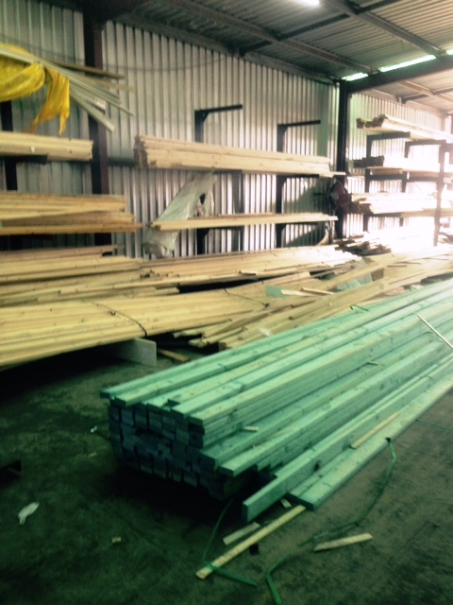

Building Supplies Wholesale
Timber Picker

Building Supplies Wholesale
Timber Picker
Dear Doctor: This form will take up to 5 minutes to complete. Please review each task the worker undertakes (both picture and written description) and tick whether or not the worker can complete this task. If modification required, please leave comments. Space at the end of this document is available for final comments and recommendations.
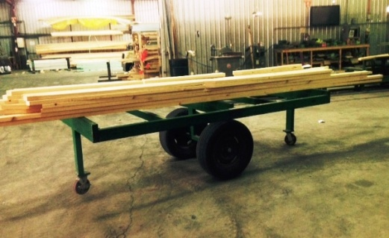  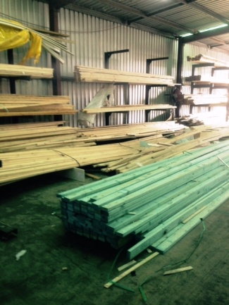  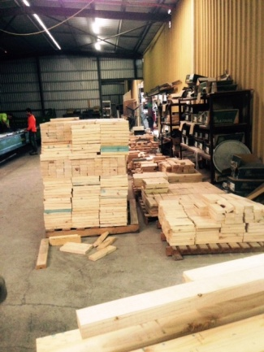  179  183 | Picking Order  - Picking order by hand or forklift (depending on size of order).  - Unwrapping stack, taking required pieces of timber out and returning stack with forklift.  - Order is packed onto trestles at approx. waist height.  - Trolleys are available for use.  - Grasping, lifting and carrying, low level postures, and constant standing / walking required. | Doctor Approval  Yes No  Comments:
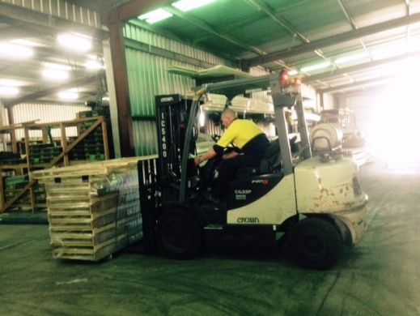 | Driving Forklift  - Frequent use of forklift requiring the driver to  - be able to mount the forklift repetitively;  - have unrestricted head and shoulder movement;  - demonstrate strength in arms and hands for gripping the gear stick and the steering wheel. | Doctor Approval  Yes No  Comments:
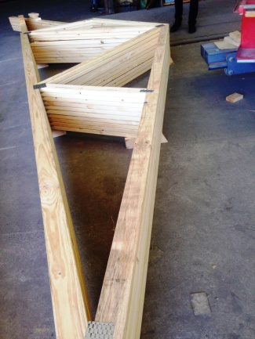  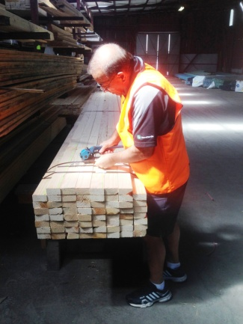  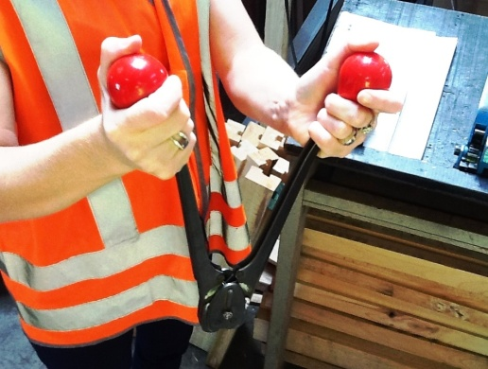  and  ‘Wrapping’, and ‘machine wrapping 1’ | Wrapping  - When complete order is picked wrapping occurs.  - Wrapping trusses using strapping machine and clipping machine  - Strapping machine – ratchet like motion required whilst gripping lever to pull strap tight. Power grip required by dominant hand. Fine gripping required by second hand to feed strap into machine;  - Clipping machine - requires bilateral hand grip to squeeze handles together to place clip on strap. | Doctor Approval  Yes No  Comments:
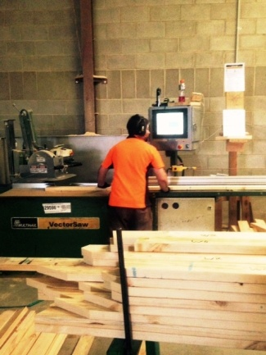 | Cutting Timber to Length  - Cutting timber to size using hand saw.  - Pulling down and pushing saw as required. Handle located between waist and chest height.  - Standing, pushing/pulling, reaching and grasping required. | Doctor Approval  Yes No  Comments:
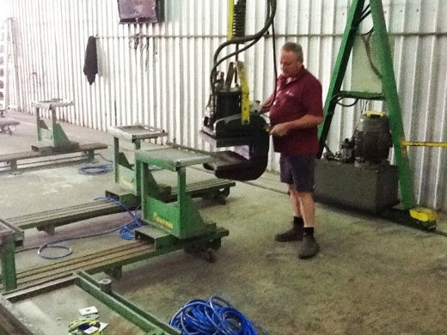 | Plating Timber  - If a length of timber greater than 6m is required, the press is used.  - Hydraulic Gantry press; walking with press and pushing/pulling it into position.  - Bilateral hands required to move and operate press. | Doctor Approval  Yes No  Comments:
Work Capacity Form
Doctor Review (include final comments)

I confirm that in my view, subject to the above comments, the worker is able to perform certain duties detailed in this Early Medical Assessment.
These duties should be reassessed on: |  | Date:

Signature : |  | Date:

Employers Declaration:
I confirm that I/we have reviewed the Doctor’s recommendations and comments. I/we will make suitable changes to make allowances for the Dr’s recommendations.
Signature : |  | Date:

Employees Declaration
My Doctor has discussed their recommendations with me. I have been given the opportunity to participate in this process.
Signature : |  | Date:
For information on completing this form, please contact Business SA on 08 8300 0000.
Disclaimer: This document is published by Business SA with funding from ReturnToWorkSA. All workplaces and circumstances are different and this document should be used as a guide only. It is not diagnostic and should not replace consultation, evaluation, or personal services including examination and an agreed course of action by a licensed practitioner. Business SA and ReturnToWorkSA and their affiliates and their respective agents do not accept any liability for injury, loss or damage arising from the use or reliance on this document. The copyright owner provides permission to reproduce and adapt this document for the purposes indicated and to tailor it (as intended) for individual circumstances. (C) 2016 ReturnToWorkSA

