Early Medical Assessment

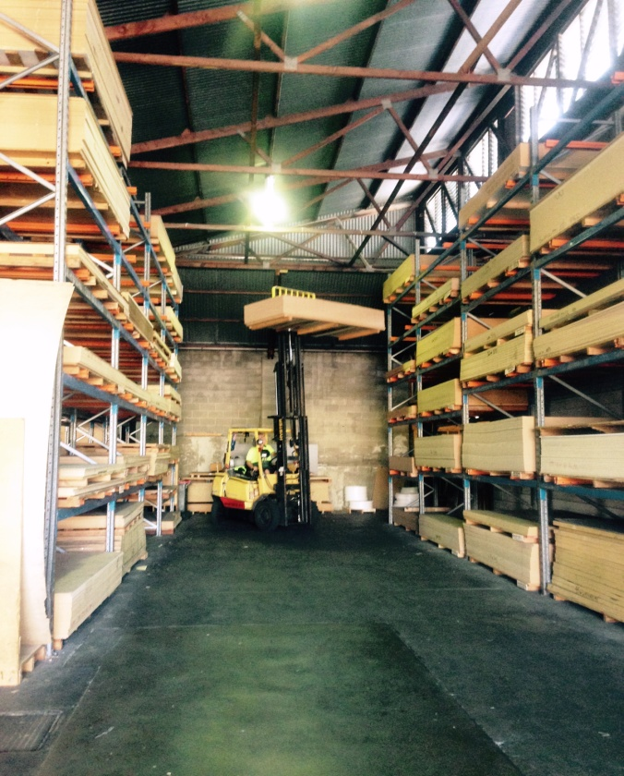

Building Supplies Wholesale
Storeman

Building Supplies Wholesale
Storeman
Dear Doctor: This form will take up to 5 minutes to complete. Please review each task the worker undertakes (both picture and written description) and tick whether or not the worker can complete this task. If modification required, please leave comments. Space at the end of this document is available for final comments and recommendations.
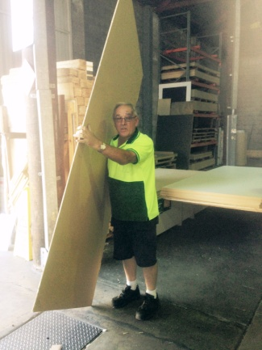  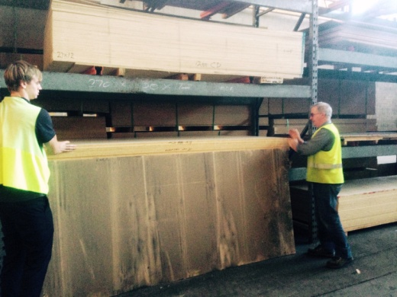  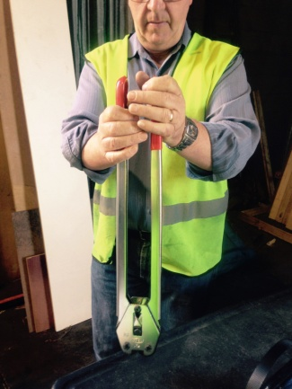  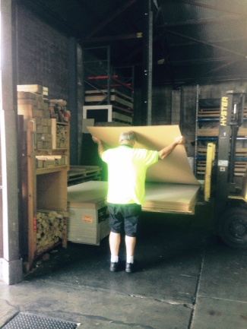 | Picking and Packing Orders /  Handling Product  - Standing and walking constantly.  - Collecting order sheet from office and sourcing product.  - Frequently getting in/out of forklift to source products from shelving.  - Splitting of packs and pulling order required.  - If hand picking boards, workers slide sheet slide off stack and stand it on ground before lifting. Two people lift heavier sheets or forklifts can be used.  - Repacking stack and securing with plastic strapping using a strapping machine (power grip and ratchet motion) and applying clip with 2 handled clamp.  - Physically demanding role with bending, squatting, twisting, lifting, reaching, carrying and gripping involved.  - Weights will vary however loads are awkward ie. sheets sizes can be 2.4m x 1.2m or 3.6m x 1.8m. Bench tops are 4.1m long and heavy. | Doctor Approval  Yes No  Comments:
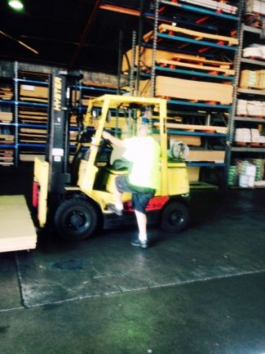  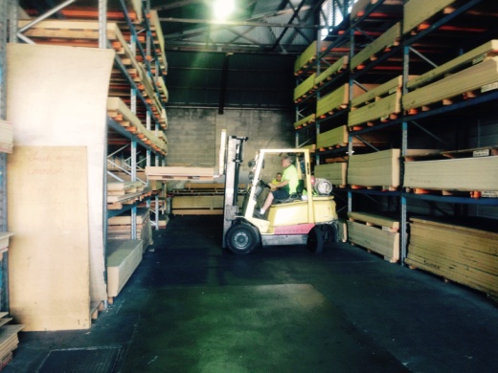 | Forklift Driving  - Frequent use of forklift requiring the driver to  - be able to mount the forklift repetitively;  - have unrestricted head and shoulder movement;  - demonstrate strength in arms and hands for gripping the gear stick and the steering wheel.  - Width of aisle allows for forklift to turn. | Doctor Approval  Yes No  Comments:
Work Capacity Form
Doctor Review (include final comments)

I confirm that in my view, subject to the above comments, the worker is able to perform certain duties detailed in this Early Medical Assessment.
These duties should be reassessed on: |  | Date:

Signature : |  | Date:

Employers Declaration:
I confirm that I/we have reviewed the Doctor’s recommendations and comments. I/we will make suitable changes to make allowances for the Dr’s recommendations.
Signature : |  | Date:

Employees Declaration
My Doctor has discussed their recommendations with me. I have been given the opportunity to participate in this process.
Signature : |  | Date:
For information on completing this form, please contact Business SA on 08 8300 0000.
Disclaimer: This document is published by Business SA with funding from ReturnToWorkSA. All workplaces and circumstances are different and this document should be used as a guide only. It is not diagnostic and should not replace consultation, evaluation, or personal services including examination and an agreed course of action by a licensed practitioner. Business SA and ReturnToWorkSA and their affiliates and their respective agents do not accept any liability for injury, loss or damage arising from the use or reliance on this document. The copyright owner provides permission to reproduce and adapt this document for the purposes indicated and to tailor it (as intended) for individual circumstances. (C) 2016 ReturnToWorkSA

