Early Medical Assessment
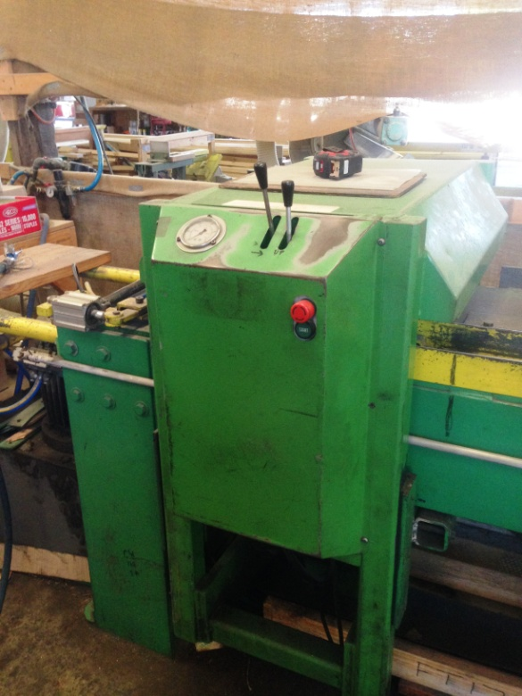

Building Supplies Wholesale
Press Operator

Building Supplies Wholesale
Press Operator
Dear Doctor: This form will take up to 5 minutes to complete. Please review each task the worker undertakes (both picture and written description) and tick whether or not the worker can complete this task. If modification required, please leave comments. Space at the end of this document is available for final comments and recommendations.
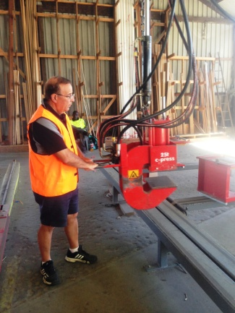  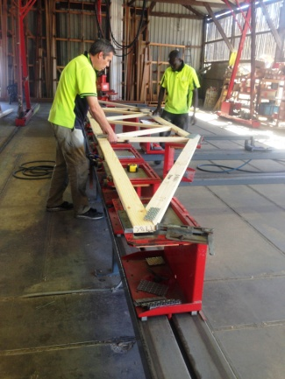  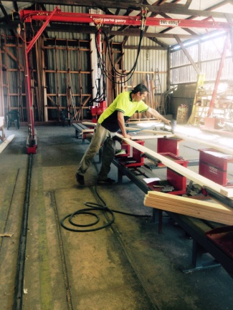  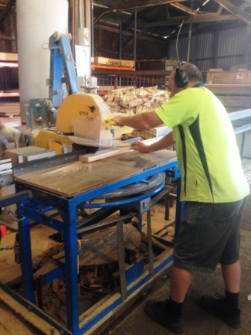  Truss press, 40, 20, 10  Handsaw 2 and 3 | Roof Truss Press  - Two workers perform this job, one on either side of the hydraulic press.  - Constant standing required.  - Timber pieces are positioned in place on plates. Lifting lengths of timber and grasping to position.  - Both workers use nail guns to secure in place (hammer grip).  - Metal plates are positioned at joins above and below timber. Fine dexterity required.  - Worker operates press with pushing/pulling motion and walks it along the roof truss. Twisting may be required. Levers used to position clamp.  - If pieces don’t fit properly, manual saw is used to cut to correct length.  - Once plates have been pressed the two workers lift the truss and carry it to place on blocks on ground, bending/squatting required | Doctor Approval  Yes No  Comments:
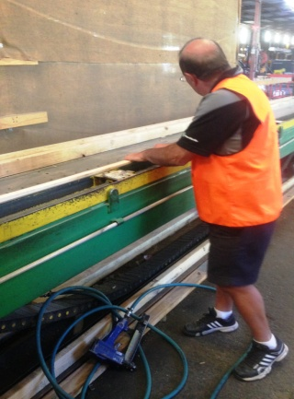  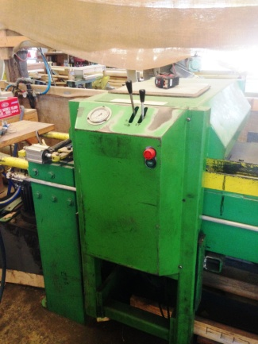 | Floor Truss Press  - Picking of timber for job conducted first so that it is all nearby.  - All straight lengths of timber used. Two pieces placed on either side and bracing pieces put in place. Grasping of timber.  - Plates are clamped on joins to secure truss. Fine dexterity required to handle and place plates.  - Levers operated to move press, pulling down toward self. | Doctor Approval  Yes No  Comments:
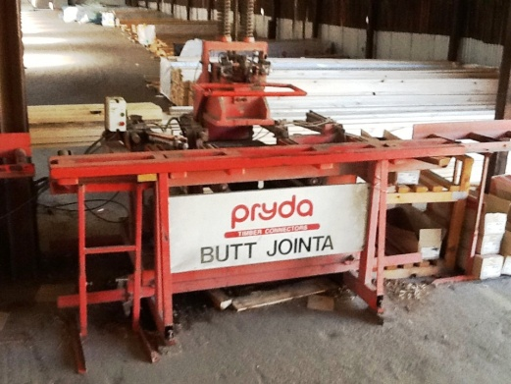  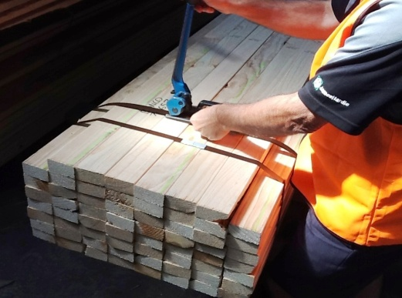  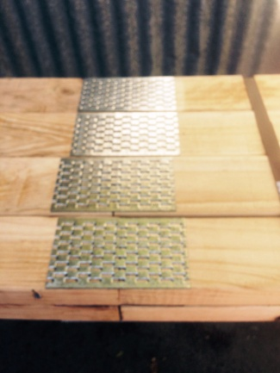 | Butt Jointa  - Used to make timber lengths longer than the standard 6m.  - Picking the 2 lengths required to make required timber length from trestles or floor.  - Push/pull force required to position clamp and pulling of lever to join. Handle to pull is positioned 1200mm and lever is above this at approx. chest height.  - Rolling/pushing joined timber length onto trestle nearby  - Strapping of timber bundle using strapping machine and clamp to secure clip. | Doctor Approval  Yes No  Comments:
Work Capacity Form
Doctor Review (include final comments)

I confirm that in my view, subject to the above comments, the worker is able to perform certain duties detailed in this Early Medical Assessment.
These duties should be reassessed on: |  | Date:

Signature : |  | Date:

Employers Declaration:
I confirm that I/we have reviewed the Doctor’s recommendations and comments. I/we will make suitable changes to make allowances for the Dr’s recommendations.
Signature : |  | Date:

Employees Declaration
My Doctor has discussed their recommendations with me. I have been given the opportunity to participate in this process.
Signature : |  | Date:
For information on completing this form, please contact Business SA on 08 8300 0000.
Disclaimer: This document is published by Business SA with funding from ReturnToWorkSA. All workplaces and circumstances are different and this document should be used as a guide only. It is not diagnostic and should not replace consultation, evaluation, or personal services including examination and an agreed course of action by a licensed practitioner. Business SA and ReturnToWorkSA and their affiliates and their respective agents do not accept any liability for injury, loss or damage arising from the use or reliance on this document. The copyright owner provides permission to reproduce and adapt this document for the purposes indicated and to tailor it (as intended) for individual circumstances. (C) 2016 ReturnToWorkSA

