Early Medical Assessment

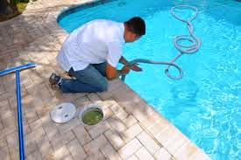

Building Supplies Wholesale
Pool Technician

Building Supplies Wholesale
Pool Technician
Dear Doctor: This form will take up to 5 minutes to complete. Please review each task the worker undertakes (both picture and written description) and tick whether or not the worker can complete this task. If modification required, please leave comments. Space at the end of this document is available for final comments and recommendations.
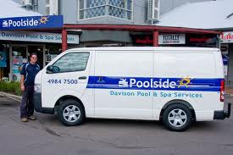 | Driving to Homes  - Sitting to drive to customers homes.  - Van has shelves inside and equipment/tools required to clean pools.  - Push/pull force to open van doors and reaching to shelving to access items required.  - Vans are driven into area very close to shop when collecting chemicals to reduce distance for lifting. | Doctor Approval  Yes No  Comments:
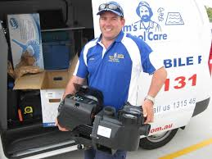 | Checking Pool Issues  - Carry equipment into pool area of home.  - Standing to use telescopic tools, some bending and twisting required.  - Low level postures to check filter box and creepy crawly.  - Accessing pool equipment eg. Pump. | Doctor Approval  Yes No  Comments:
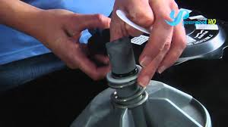  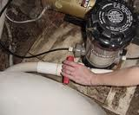 | Repairs  - Repairs are undertaken at the shop so technician removes pump and places in van. Pumps are usually <20kg.  - Bench available at shop to undertake diagnostics and repairs. Shelves are within easy reach. | Doctor Approval  Yes No  Comments:
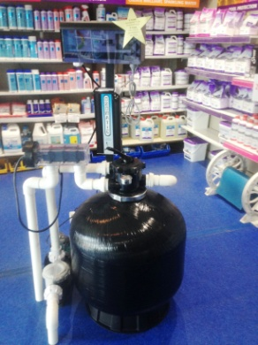 | Sand Change  - Some pools will require sand to be changed. Sand is removed and put in a bucket. Refilling is done from a 20kg bag of sand which is carried from van. | Doctor Approval  Yes No  Comments:
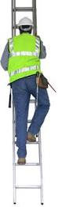 | Solar Repairs  - Occasionally a ladder is climbed to enable inspection of solar panels. | Doctor Approval  Yes No  Comments:
 | Replacing Pipes  - Excavation work with a shovel or maddock and wheelbarrow. | Doctor Approval  Yes No  Comments:
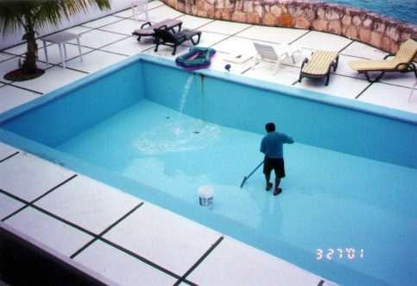 | Leaks  - If pool is leaking it needs to be drained and the hydrostatic valve at the bottom needs to be replaced, low level postures and gripping required .  - If this occurs in summer, technician may dive in to replace valve instead of draining pool. | Doctor Approval  Yes No  Comments:
Work Capacity Form
Doctor Review (include final comments)

I confirm that in my view, subject to the above comments, the worker is able to perform certain duties detailed in this Early Medical Assessment.
These duties should be reassessed on: |  | Date:

Signature : |  | Date:

Employers Declaration:
I confirm that I/we have reviewed the Doctor’s recommendations and comments. I/we will make suitable changes to make allowances for the Dr’s recommendations.
Signature : |  | Date:

Employees Declaration
My Doctor has discussed their recommendations with me. I have been given the opportunity to participate in this process.
Signature : |  | Date:
For information on completing this form, please contact Business SA on 08 8300 0000.
Disclaimer: This document is published by Business SA with funding from ReturnToWorkSA. All workplaces and circumstances are different and this document should be used as a guide only. It is not diagnostic and should not replace consultation, evaluation, or personal services including examination and an agreed course of action by a licensed practitioner. Business SA and ReturnToWorkSA and their affiliates and their respective agents do not accept any liability for injury, loss or damage arising from the use or reliance on this document. The copyright owner provides permission to reproduce and adapt this document for the purposes indicated and to tailor it (as intended) for individual circumstances. (C) 2016 ReturnToWorkSA

