Early Medical Assessment

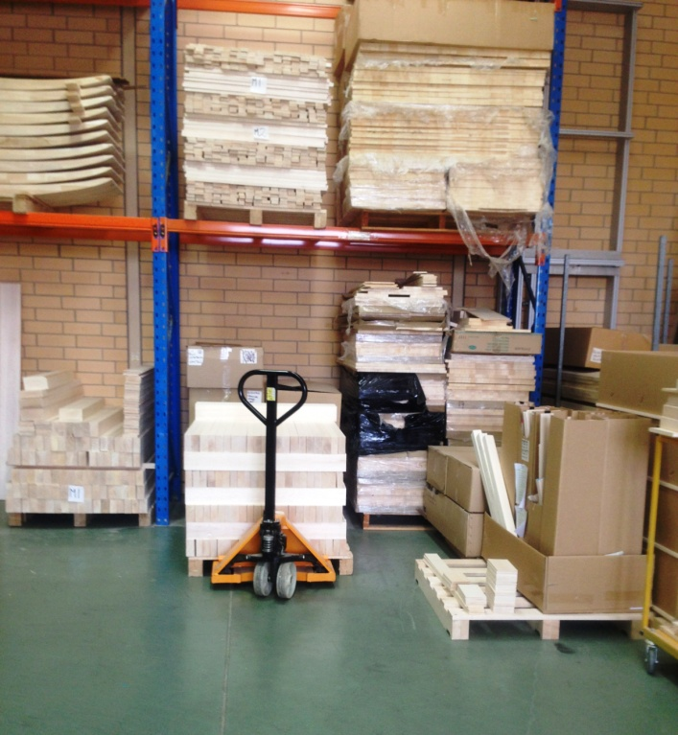

Building Supplies Wholesale
Picker / Packer

Building Supplies Wholesale
Picker / Packer
Dear Doctor: This form will take up to 5 minutes to complete. Please review each task the worker undertakes (both picture and written description) and tick whether or not the worker can complete this task. If modification required, please leave comments. Space at the end of this document is available for final comments and recommendations.
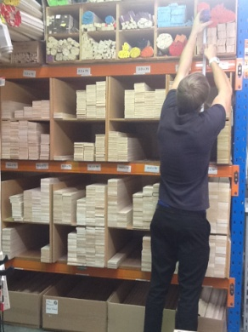  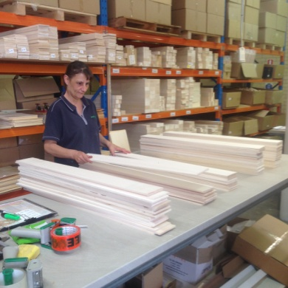  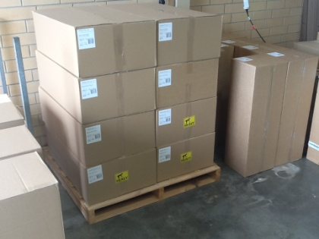 | Picking  - Picking pre-cut items from labeled shelving and bringing to centre table for marking and boxing. Constant standing.  - Shelving requires low level postures to overhead reaching.  - Some items are stored higher, but are accessed infrequently. A step ladder is available for use.  - Fine dexterity and concentration are required for quality control and to pick according to order.  - Orders are placed in boxes or bubble wrapped. Box weights are marked and are under 20kg.  - Moving compete orders from bench to Dispatch a few meters away.  - Sack trucks are used for moving larger orders.  - Trolleys are available for picking if required. Pickers are able to control the bundles according to the weight they feel comfortable lifting. | Doctor Approval  Yes No  Comments:
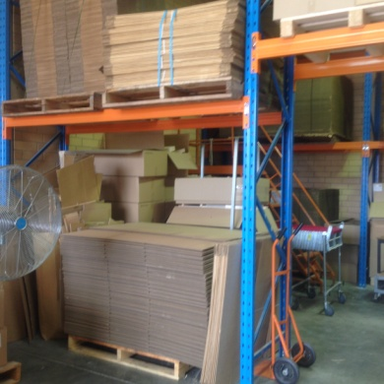  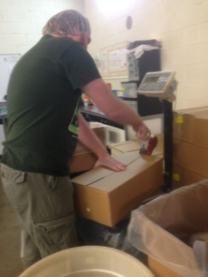 | Boxes  - Folding boxes involves grasping and reaching forward to fold from flat into box shape.  - Flat boxes stored on pallet on the floor, low level postures required to access them when supply is low.  - Taping box joins using power grip on tape gun with dominant hand. | Doctor Approval  Yes No  Comments:
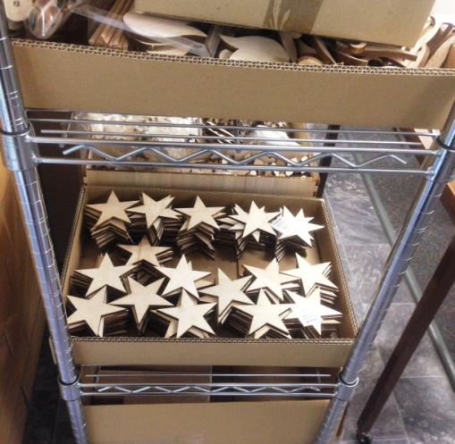 | Laser Cutter  - Made to order personalized items are cut with a laser. Owner operated and all computerized. | Doctor Approval  Yes No  Comments:
Work Capacity Form
Doctor Review (include final comments)

I confirm that in my view, subject to the above comments, the worker is able to perform certain duties detailed in this Early Medical Assessment.
These duties should be reassessed on: |  | Date:

Signature : |  | Date:

Employers Declaration:
I confirm that I/we have reviewed the Doctor’s recommendations and comments. I/we will make suitable changes to make allowances for the Dr’s recommendations.
Signature : |  | Date:

Employees Declaration
My Doctor has discussed their recommendations with me. I have been given the opportunity to participate in this process.
Signature : |  | Date:
For information on completing this form, please contact Business SA on 08 8300 0000.
Disclaimer: This document is published by Business SA with funding from ReturnToWorkSA. All workplaces and circumstances are different and this document should be used as a guide only. It is not diagnostic and should not replace consultation, evaluation, or personal services including examination and an agreed course of action by a licensed practitioner. Business SA and ReturnToWorkSA and their affiliates and their respective agents do not accept any liability for injury, loss or damage arising from the use or reliance on this document. The copyright owner provides permission to reproduce and adapt this document for the purposes indicated and to tailor it (as intended) for individual circumstances. (C) 2016 ReturnToWorkSA

