Early Medical Assessment

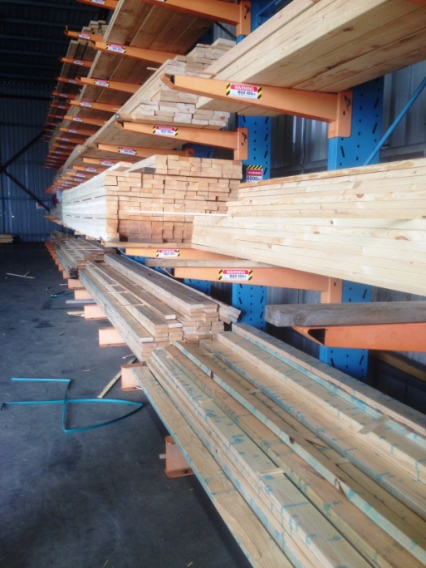

Building Supplies Wholesale

Order Picker

1. Building Supplies Wholesale
2. Order Picker

Dear Doctor: This form will take up to 5 minutes to complete. Please review each task the worker undertakes (both picture and written description) and tick whether or not the worker can complete this task. If modification required, please leave comments. Space at the end of this document is available for final comments and recommendations.

|  |  |  |
| --- | --- | --- |
| L:\RTW Fund Project\Stage Three SAWIC Codes 472801, 473601 & 485601 - 55 templates\Building Supplies Wholesalers\Greenfields\IMG_3897.JPG | **Forklift Driving**   * Forklifts are used to undertake most of the picking tasks. * Climbing in / out of forklift frequently. * Frequent – constant sitting. * Forward reaching and gripping required to use steering wheel and gear stick. * Rotation of neck and spine required for driving and reversing. * Neck extension for placing pallets on high shelving. | Doctor Approval  Yes  No  Comments: |
| L:\RTW Fund Project\Stage Three SAWIC Codes 472801, 473601 & 485601 - 55 templates\Building Supplies Wholesalers\Greenfields\IMG_3901.JPG  L:\RTW Fund Project\Stage Three SAWIC Codes 472801, 473601 & 485601 - 55 templates\Building Supplies Wholesalers\Greenfields\IMG_3903.JPG | **Hand Picking**   * Occasionally an order may be hand picked using a trolley. * Only timber between waist and chest height is hand picked. * Repetitive lifting from chest height to trolley. A 6m timber length weighs approx. 5kg. Twisting and some bending likely. * Pushing trolley (medium force). * Larger timber, infrequently used, can weigh up to 35kg each. Forklift is used to bring the bundle down from the shelves and worker lifts one end on to the prongs, then the other end. Bending and twisting required whilst lifting and grasping. | Doctor Approval  Yes  No  Comments: |
| L:\RTW Fund Project\Stage Three SAWIC Codes 472801, 473601 & 485601 - 55 templates\Building Supplies Wholesalers\Greenfields\IMG_3906.JPG  L:\RTW Fund Project\Stage Three SAWIC Codes 472801, 473601 & 485601\Building Supplies Wholesalers\Jag Timber\wrapping machine (1).JPG | **Strapping and Clipping**   * Strapping bundle (after picking) for delivery. Either undertaken at floor level (low level postures required) or whilst raised on the forklift. * Strapping machine – ratchet like motion required whilst gripping lever to pull strap tight. Power grip required by dominant hand. Fine gripping required by second hand to feed strap into machine. Strap comes on rolls approx 5kg. * Clipping machine requires bilateral hand grip to squeeze handles together to place clip on strap. | Doctor Approval  Yes  No  Comments: |
| L:\RTW Fund Project\Stage Three SAWIC Codes 472801, 473601 & 485601 - 55 templates\Building Supplies Wholesalers\Greenfields\IMG_3913.JPG  L:\RTW Fund Project\Stage Three SAWIC Codes 472801, 473601 & 485601 - 55 templates\Building Supplies Wholesalers\Greenfields\IMG_3912.JPG  L:\RTW Fund Project\Stage Three SAWIC Codes 472801, 473601 & 485601 - 55 templates\Building Supplies Wholesalers\Greenfields\IMG_3922.JPG | **Wrapping**   * Large roll of wrapping on a trolley is used. * Gripping and pulling plastic from roll over length of strapped timber. * Taping plastic with roll of sticky tape requiring bending and reaching. | Doctor Approval  Yes  No  Comments: |
| L:\RTW Fund Project\Stage Three SAWIC Codes 472801, 473601 & 485601 - 55 templates\Building Supplies Wholesalers\Greenfields\IMG_3925.JPG |  |  |
| L:\RTW Fund Project\Stage Three SAWIC Codes 472801, 473601 & 485601 - 55 templates\Building Supplies Wholesalers\Greenfields\images.jpg | **Doors**   * Internal door weighs 12kg, external door weighs approx 45kg. * Pre-wrapped packs need to be split to access the doors in correct order. Tin snips are used to cut strapping and plastic. * Two forklifts are used, sliding unwanted doors onto the prongs of the first one to access desired door. Second forklift used to collect desired door. First forklift replaces unwanted doors. | Doctor Approval  Yes  No  Comments: |

1. Work Capacity Form

**Doctor Review (include final comments)**

|  |
| --- |
|  |
|  |
|  |
|  |
|  |
|  |
|  |
|  |
|  |
|  |

I confirm that in my view, subject to the above comments, the worker is able to perform certain duties detailed in this Early Medical Assessment.

|  |  |  |
| --- | --- | --- |
| These duties should be reassessed on: |  | Date: |

|  |  |  |
| --- | --- | --- |
| Signature : |  | Date: |

**Employers Declaration:**

I confirm that I/we have reviewed the Doctor’s recommendations and comments. I/we will make suitable changes to make allowances for the Dr’s recommendations.

|  |  |  |
| --- | --- | --- |
| Signature : |  | Date: |

**Employees Declaration**

My Doctor has discussed their recommendations with me. I have been given the opportunity to participate in this process.

|  |  |  |
| --- | --- | --- |
| Signature : |  | Date: |

For information on completing this form, please contact Business SA on 08 8300 0000.

***Disclaimer:*** *This document is published by Business SA with funding from ReturnToWorkSA. All workplaces and circumstances are different and this document should be used as a guide only. It is not diagnostic and should not replace consultation, evaluation, or personal services including examination and an agreed course of action by a licensed practitioner. Business SA and ReturnToWorkSA and their affiliates and their respective agents do not accept any liability for injury, loss or damage arising from the use or reliance on this document. The copyright owner provides permission to reproduce and adapt this document for the purposes indicated and to tailor it (as intended) for individual circumstances*. (C) 2016 ReturnToWorkSA