Early Medical Assessment

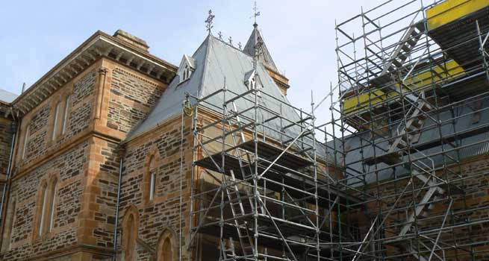

Building Supplies Wholesale
Masonry Restoration Specialist

Building Supplies Wholesale
Masonry Restoration Specialist
Dear Doctor: This form will take up to 5 minutes to complete. Please review each task the worker undertakes (both picture and written description) and tick whether or not the worker can complete this task. If modification required, please leave comments. Space at the end of this document is available for final comments and recommendations.
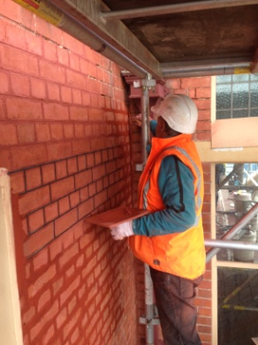  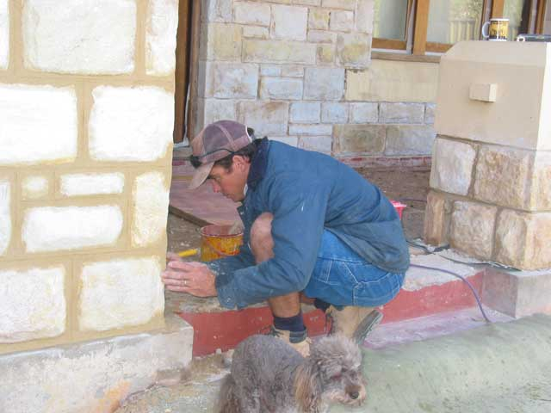  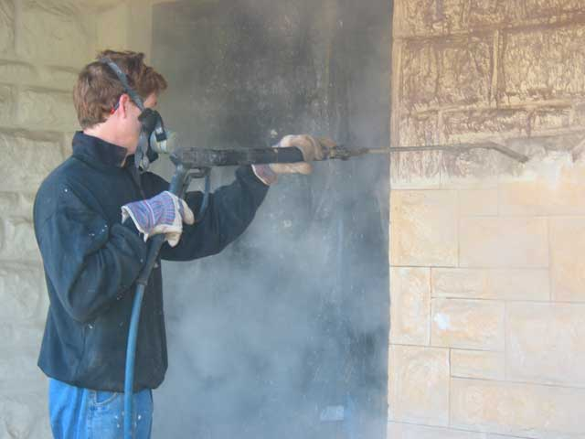 | Daily tasks vary due to differing requests. May consist a variety of-  - Re-pointing masonry structures involving use of tools and sustained forward reach at varying heights.  - Concreting; including mixing and laying concrete.  - Solid plastering work.  - Brick and block laying in walls involving lifting and carrying, low level postures and repetitive gripping.  - Raking joints with hammer.  - Cleaning (warm hot wash or stripping paint) using pressure / steam gun with bilateral grip and sustained upper limb postures. | Doctor Approval  Yes No  Comments:
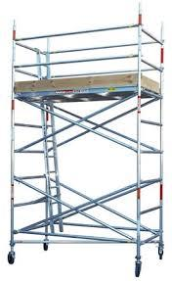 | Assembling small scaffolding  (up to 2m)  - Lifting and carrying pieces of scaffold and putting in place.  - Use of tools to secure scaffolding.  - Working range requiring reaching from ground to overhead height.  - Low level postures and climbing required. | Doctor Approval  Yes No  Comments:
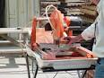  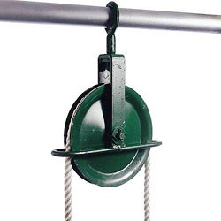 | Stone  - Usually product is delivered to site and moved via truck crane or pallet lifter.  - May need to be cut to size using a grinder or masonry saw requiring gripping and pushing/pulling with dominant hand. Lifting of stone pieces required.  - Occasionally if only a few pieces of stone are needed a ute is used to collect and it is hand loaded/unloaded ie lifting required.  - If a large job with scaffolding a gin wheel is used to raise mortar and stone to the area where it is to be used. Pulling required to use gin wheel. | Doctor Approval  Yes No  Comments:
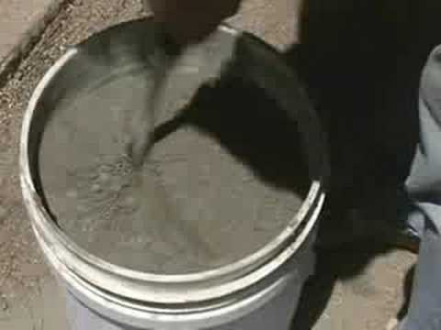  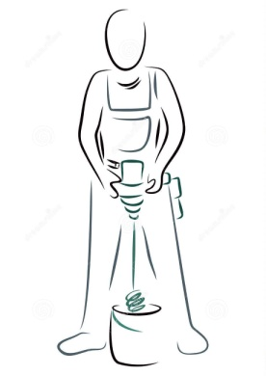 | Preparing Lime Mortars  - Concrete comes in 20kg bags and is mixed in a 10L bucket with a mixing drill (bilateral gripping to hold mixing drill at waist height to mix concrete.) | Doctor Approval  Yes No  Comments:
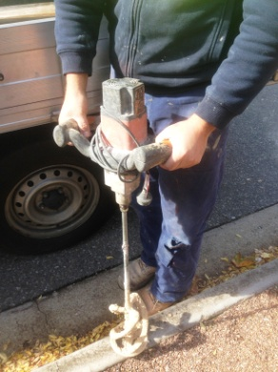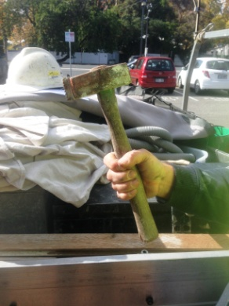  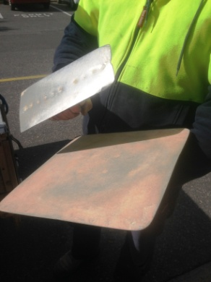 | Tools  - Shovel.  - Mixing drill (as above).  - Hammer (power grip dominant hand).  - Hawk and trowel for plastering. Bilateral task involving fine movements to sweeping movements of arm depending on size of area to be plastered. | Doctor Approval  Yes No  Comments:
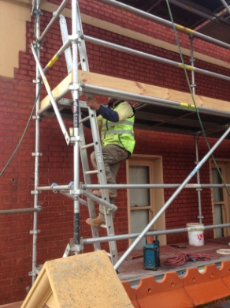  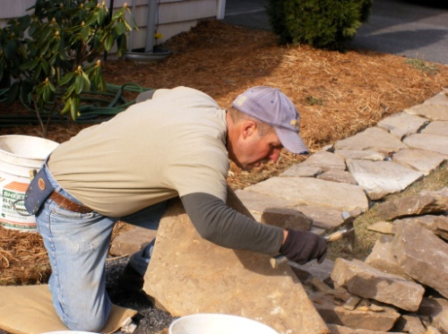  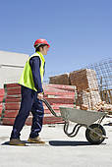 | Physical Requirements  - Constant standing.  - Frequent climbing up scaffolding.  - Sustained or repetitive low level postures.  - Lifting and carrying stone (up to 50kg) but generally if curbing 10-15kg blocks.  - Range of work from floor to overhead height.  - Frequent pushing of a wheelbarrow. | Doctor Approval  Yes No  Comments:
Work Capacity Form
Doctor Review (include final comments)

I confirm that in my view, subject to the above comments, the worker is able to perform certain duties detailed in this Early Medical Assessment.
These duties should be reassessed on: |  | Date:

Signature : |  | Date:

Employers Declaration:
I confirm that I/we have reviewed the Doctor’s recommendations and comments. I/we will make suitable changes to make allowances for the Dr’s recommendations.
Signature : |  | Date:

Employees Declaration
My Doctor has discussed their recommendations with me. I have been given the opportunity to participate in this process.
Signature : |  | Date:
For information on completing this form, please contact Business SA on 08 8300 0000.
Disclaimer: This document is published by Business SA with funding from ReturnToWorkSA. All workplaces and circumstances are different and this document should be used as a guide only. It is not diagnostic and should not replace consultation, evaluation, or personal services including examination and an agreed course of action by a licensed practitioner. Business SA and ReturnToWorkSA and their affiliates and their respective agents do not accept any liability for injury, loss or damage arising from the use or reliance on this document. The copyright owner provides permission to reproduce and adapt this document for the purposes indicated and to tailor it (as intended) for individual circumstances. (C) 2016 ReturnToWorkSA

