Early Medical Assessment

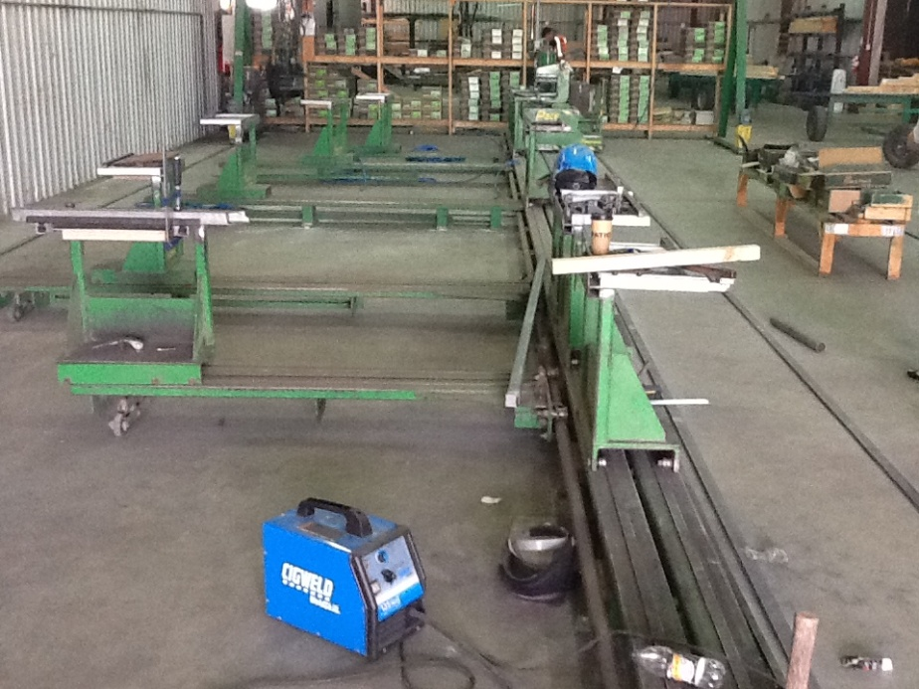

Building Supplies Wholesale
Jig Setter

Building Supplies Wholesale
Jig Setter
Dear Doctor: This form will take up to 5 minutes to complete. Please review each task the worker undertakes (both picture and written description) and tick whether or not the worker can complete this task. If modification required, please leave comments. Space at the end of this document is available for final comments and recommendations.
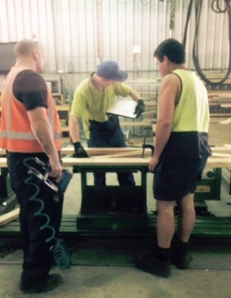  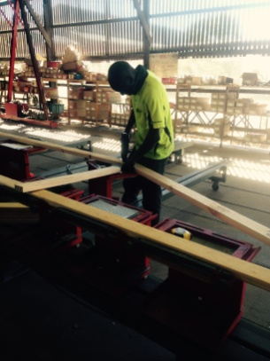  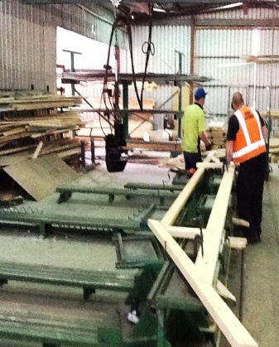 | Setting Up Jig  - Setting up of jig manually using tape measure. Forward reaching and grasping to move jig into position.  - Standing, pushing / pulling, bending, forward reaching, grasping.  - Nail gun used to hold timbers together before pressing. Dominant hand gripping required to hold and use nail gun trigger. Non-dominant hand holds timber in place.  - Press used depends on the shape of truss being made (see below). | Doctor Approval  Yes No  Comments:
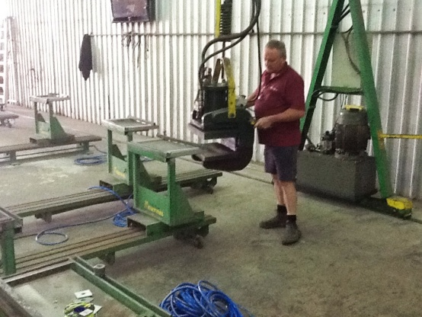 | Gantry Press  - Hydraulic press; walking with press and pushing/pulling it into position.  - Both hands required to move and operate press. | Doctor Approval  Yes No  Comments:
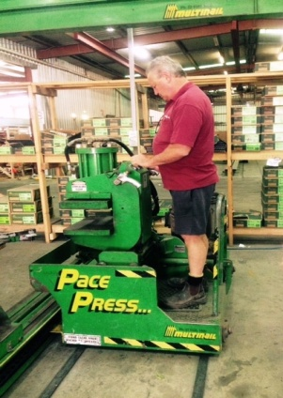 | Pace Press  - Standing to ride hydraulic press.  - Bilateral gripping required to move knobs at waist height to control press. | Doctor Approval  Yes No  Comments:
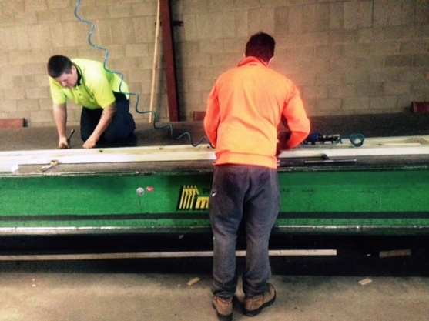 | Table Press  - One worker standing by table press using nail gun and helping to set jig. Constant standing and fine dexterity and force required.  - One worker crouching on the table, using tools to bolt jig in place. Fine dexterity and force required. Constant low level postures and frequent climbing.  - Hydraulic ride on press used, controlled as per “Pace Press”. | Doctor Approval  Yes No  Comments:
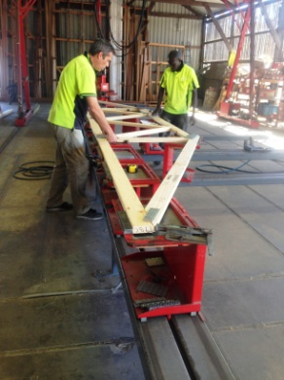  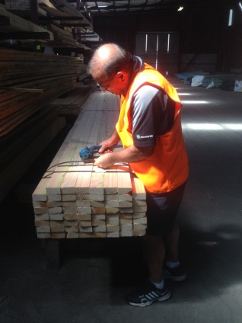  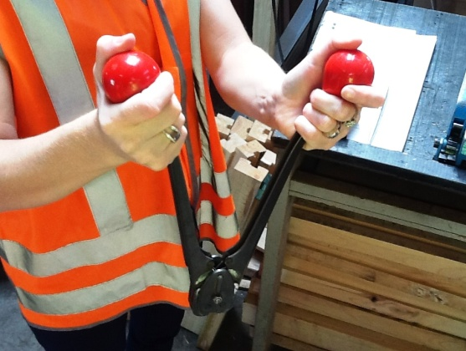  Insert image  and  machine wrapping 1’ | Carrying Trusses  - 2-3 men lift truss and carry it due to its awkward size/shape.  - Place truss on trestles.  - Strapping trusses using strapping machine and clipping machine  - Strapping machine – ratchet like motion required whilst gripping lever to pull strap tight. Power grip required by dominant hand. Fine gripping required by second hand to feed strap into machine;  - Clipping machine - requires bilateral hand grip to squeeze handles together to place clip on strap. | Doctor Approval  Yes No  Comments:
Work Capacity Form
Doctor Review (include final comments)

I confirm that in my view, subject to the above comments, the worker is able to perform certain duties detailed in this Early Medical Assessment.
These duties should be reassessed on: |  | Date:

Signature : |  | Date:

Employers Declaration:
I confirm that I/we have reviewed the Doctor’s recommendations and comments. I/we will make suitable changes to make allowances for the Dr’s recommendations.
Signature : |  | Date:

Employees Declaration
My Doctor has discussed their recommendations with me. I have been given the opportunity to participate in this process.
Signature : |  | Date:
For information on completing this form, please contact Business SA on 08 8300 0000.
Disclaimer: This document is published by Business SA with funding from ReturnToWorkSA. All workplaces and circumstances are different and this document should be used as a guide only. It is not diagnostic and should not replace consultation, evaluation, or personal services including examination and an agreed course of action by a licensed practitioner. Business SA and ReturnToWorkSA and their affiliates and their respective agents do not accept any liability for injury, loss or damage arising from the use or reliance on this document. The copyright owner provides permission to reproduce and adapt this document for the purposes indicated and to tailor it (as intended) for individual circumstances. (C) 2016 ReturnToWorkSA

