Early Medical Assessment

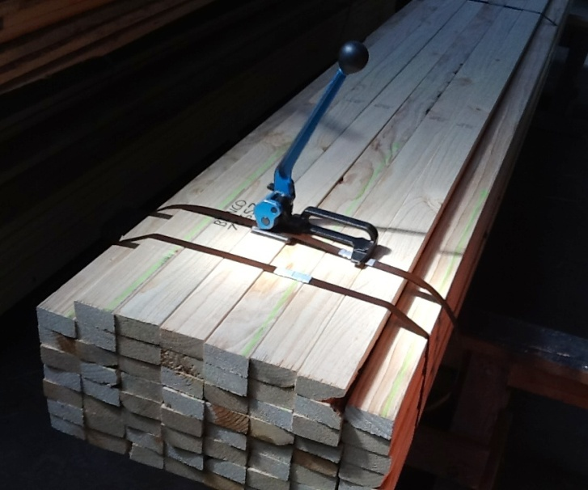

Building Supplies Wholesale
Driver

Building Supplies Wholesale
Driver
Dear Doctor: This form will take up to 5 minutes to complete. Please review each task the worker undertakes (both picture and written description) and tick whether or not the worker can complete this task. If modification required, please leave comments. Space at the end of this document is available for final comments and recommendations.
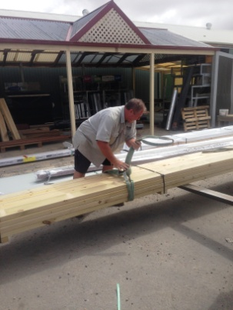 | Loading Truck  - Loading truck using forklift (see below)  - Truck cranes are used when unloading therefore placing slings around load with straps (frequent grasping to secure). Full shoulder movements required and low level postures.  - Tying in load with load binders (ratchet system). Climbing on/off truck and grasping required. | Doctor Approval  Yes No  Comments:
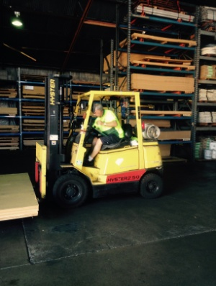 | Forklift Driving  - Use of forklift requiring the driver to  - be able to mount the forklift repetitively  - have unrestricted head and shoulder movement  - demonstrate strength in arms and hands for gripping the gear stick and the steering wheel. | Doctor Approval  Yes No  Comments:
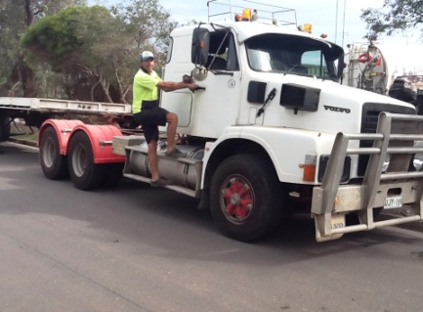 | Driving Truck  - Drivers undertake 8 – 10 deliveries each day  - Constant sitting whilst driving  - Frequent climbing in/out of truck cabin and on/off tray. | Doctor Approval  Yes No  Comments:
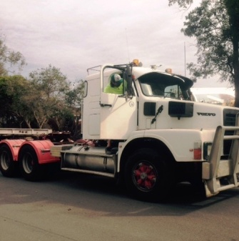  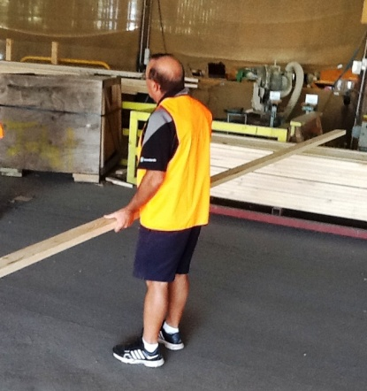  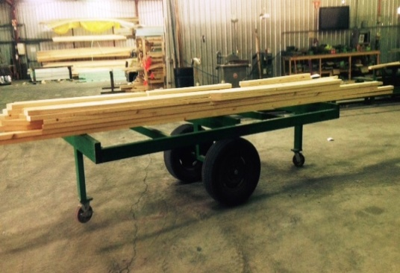 | Unloading Truck  - Controlling of truck crane to lift slings to unload.  - Climbing on/off truck to tie on slings and remove load binders as appropriate.  - Small orders are unloaded by hand requiring climbing onto truck to get timber, lifting and carrying order to customer (circumstances will change at each delivery point). | Doctor Approval  Yes No  Comments:
Work Capacity Form
Doctor Review (include final comments)

I confirm that in my view, subject to the above comments, the worker is able to perform certain duties detailed in this Early Medical Assessment.
These duties should be reassessed on: |  | Date:

Signature : |  | Date:

Employers Declaration:
I confirm that I/we have reviewed the Doctor’s recommendations and comments. I/we will make suitable changes to make allowances for the Dr’s recommendations.
Signature : |  | Date:

Employees Declaration
My Doctor has discussed their recommendations with me. I have been given the opportunity to participate in this process.
Signature : |  | Date:
For information on completing this form, please contact Business SA on 08 8300 0000.
Disclaimer: This document is published by Business SA with funding from ReturnToWorkSA. All workplaces and circumstances are different and this document should be used as a guide only. It is not diagnostic and should not replace consultation, evaluation, or personal services including examination and an agreed course of action by a licensed practitioner. Business SA and ReturnToWorkSA and their affiliates and their respective agents do not accept any liability for injury, loss or damage arising from the use or reliance on this document. The copyright owner provides permission to reproduce and adapt this document for the purposes indicated and to tailor it (as intended) for individual circumstances. (C) 2016 ReturnToWorkSA

