Early Medical Assessment

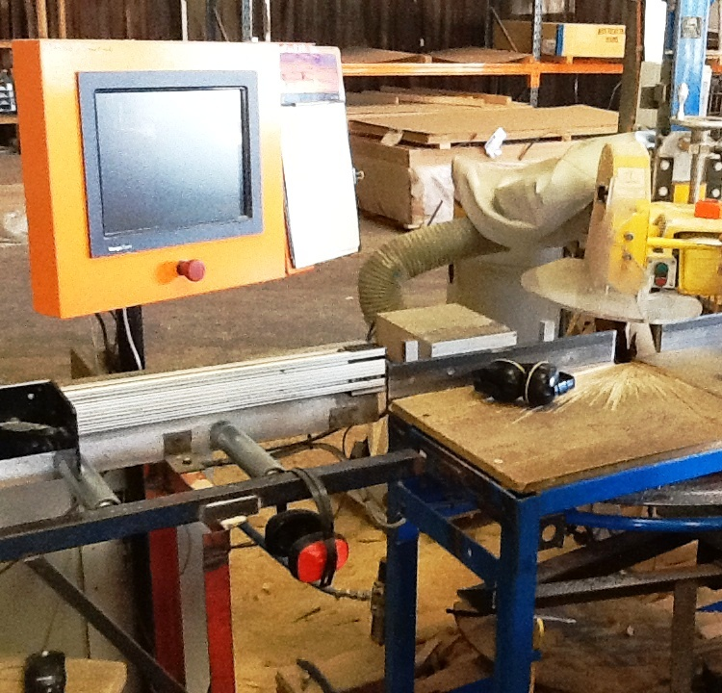

Building Supplies Wholesale
Cutter

Building Supplies Wholesale
Cutter
Dear Doctor: This form will take up to 5 minutes to complete. Please review each task the worker undertakes (both picture and written description) and tick whether or not the worker can complete this task. If modification required, please leave comments. Space at the end of this document is available for final comments and recommendations.
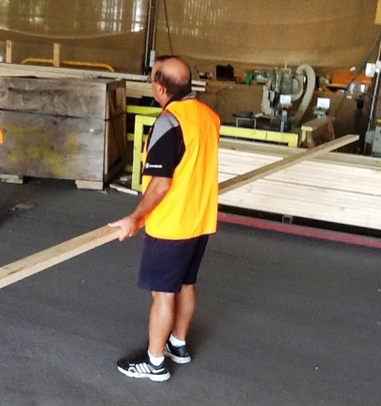  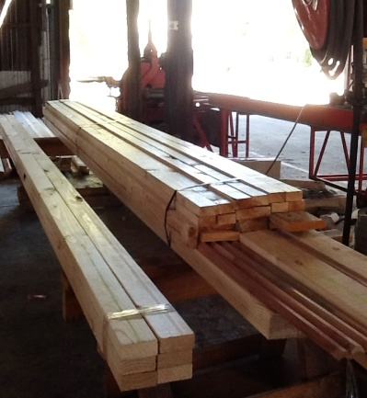  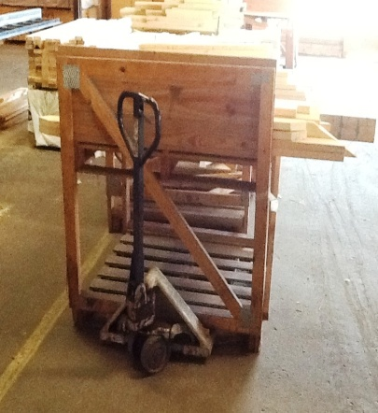 | Picking Timber  - Locating timber required (either on ground or trestles) and moving to cutting area.  - Pushing hand trolley for produce on pallets or carrying lighter loads.  - Timber can be up to 6m in length therefore it must be counterbalanced.  - Walking, lifting, carrying, low level postures, twisting, grasping. | Doctor Approval  Yes No  Comments:
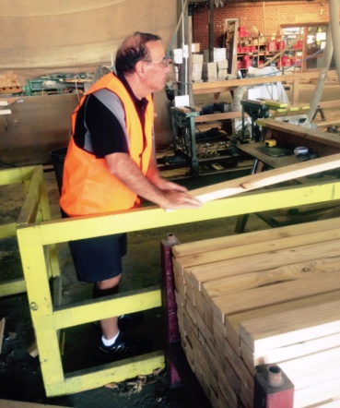  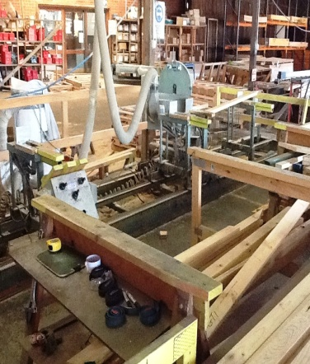  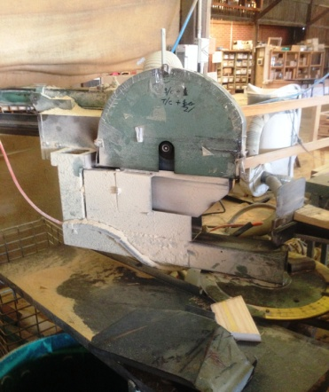 | Manual Saw  - Occurs inside a safety ‘cage’ which only operator is able to access.  - Picking up 2 pieces of timber at a time.  - Manually lining it up with saws, grasping and handling timber.  - Adjusting saw using hand; operating buttons and levers.  - Grasping and lifting required to move cut timber to trestle for pick up by forklift. | Doctor Approval  Yes No  Comments:
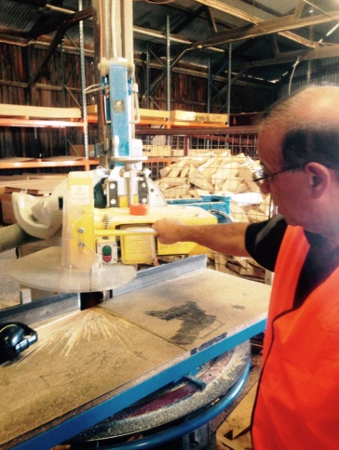  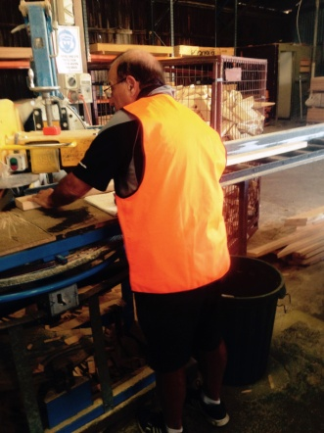 | Computer Design Operated  Saw  - Truss designer sends computerised design to cutter.  - Cutter programs computer using mouse.  - Saw swivels automatically, cutter pulls it out using handle at chest height. Light force required only. | Doctor Approval  Yes No  Comments:
Work Capacity Form
Doctor Review (include final comments)

I confirm that in my view, subject to the above comments, the worker is able to perform certain duties detailed in this Early Medical Assessment.
These duties should be reassessed on: |  | Date:

Signature : |  | Date:

Employers Declaration:
I confirm that I/we have reviewed the Doctor’s recommendations and comments. I/we will make suitable changes to make allowances for the Dr’s recommendations.
Signature : |  | Date:

Employees Declaration
My Doctor has discussed their recommendations with me. I have been given the opportunity to participate in this process.
Signature : |  | Date:
For information on completing this form, please contact Business SA on 08 8300 0000.
Disclaimer: This document is published by Business SA with funding from ReturnToWorkSA. All workplaces and circumstances are different and this document should be used as a guide only. It is not diagnostic and should not replace consultation, evaluation, or personal services including examination and an agreed course of action by a licensed practitioner. Business SA and ReturnToWorkSA and their affiliates and their respective agents do not accept any liability for injury, loss or damage arising from the use or reliance on this document. The copyright owner provides permission to reproduce and adapt this document for the purposes indicated and to tailor it (as intended) for individual circumstances. (C) 2016 ReturnToWorkSA

