Early Medical Assessment

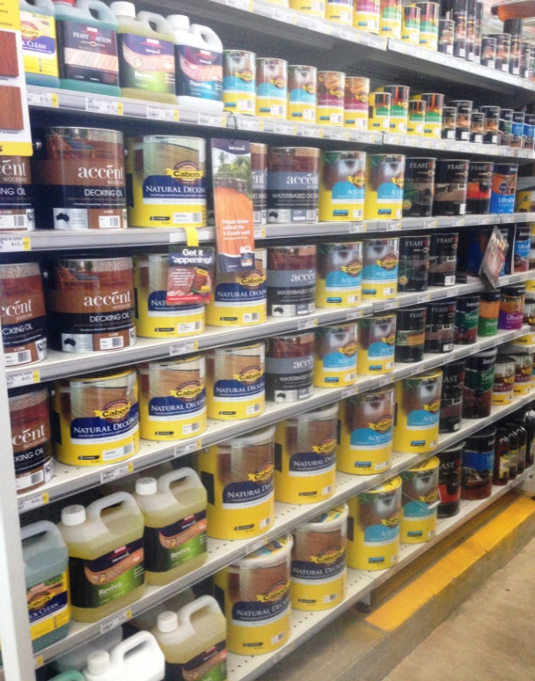

Domestic Appliance Retailing
Customer Service - Paint

Domestic Appliance Retailing
Customer Service - Paint
Dear Doctor: This form will take up to 5 minutes to complete. Please review each task the worker undertakes (both picture and written description) and tick whether or not the worker can complete this task. If modification required, please leave comments. Space at the end of this document is available for final comments and recommendations.
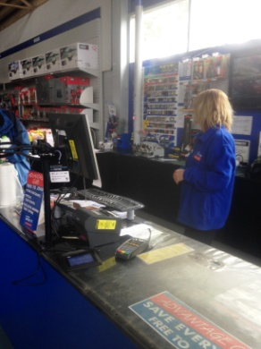 | Customer Service  - Constant standing and walking whilst interacting with customers. | Doctor Approval  Yes No  Comments:
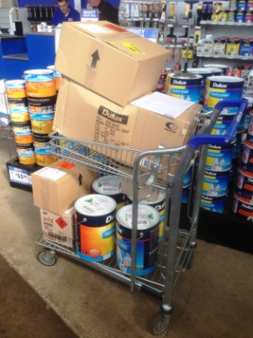  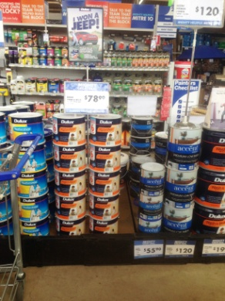  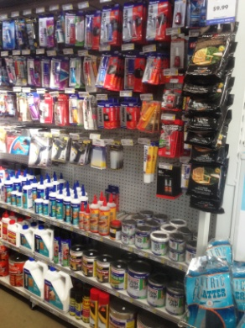 | Shelving Stock  - Collecting stock from “Goods Inwards” by lifting it onto a flatbed trolley and pushing to correct area then lifting and placing on shelving.  - Shelving between floor and overhead height. Light items are located on the higher shelves. Repetitive grasping and reaching to stock shelves. Some low level postures required to access lower shelving.  - Step stool is available to reduce overhead reaching required.  - Paint is stacked from floor level on top of itself using safety rings so they don’t fall. 15L tin of paint and 20L of turps are the largest to be lifted. | Doctor Approval  Yes No  Comments:
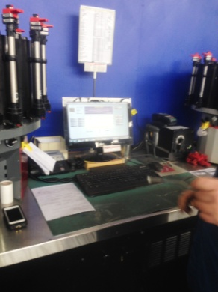  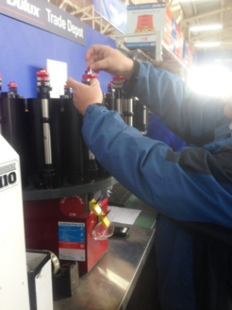  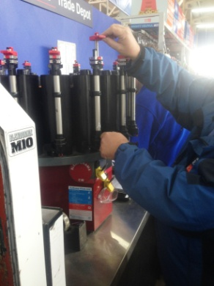  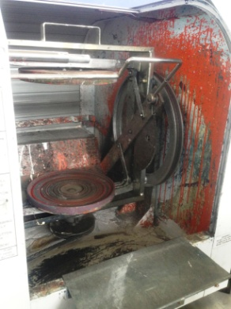 | Mixing Paint  - Customers ask for paint to be mixed to achieve different hues. Formula is looked up on computer on the bench.  - Removing lid by levering it off with small tool. Adding tint by using pincer grip to move valves and measure quantities. Reaching between shoulder and chest height required.  - Replacing lid and lifting tin into shaker. Pulling down on two levers bilaterally to close onto tin. Pulling down safety cover with dominant arm. Turn dial on shaker with left arm.  - Opening safety cover and taking tin out.  - 15L tins don’t fit in the shaker so the tin is placed on a low bench and the paint is mixed manually with a mixing stick. Power grip required and shoulder stirs in rotating motion. | Doctor Approval  Yes No  Comments:
Work Capacity Form
Doctor Review (include final comments)

I confirm that in my view, subject to the above comments, the worker is able to perform certain duties detailed in this Early Medical Assessment.
These duties should be reassessed on: |  | Date:

Signature : |  | Date:

Employers Declaration:
I confirm that I/we have reviewed the Doctor’s recommendations and comments. I/we will make suitable changes to make allowances for the Dr’s recommendations.
Signature : |  | Date:

Employees Declaration
My Doctor has discussed their recommendations with me. I have been given the opportunity to participate in this process.
Signature : |  | Date:
For information on completing this form, please contact Business SA on 08 8300 0000.
Disclaimer: This document is published by Business SA with funding from ReturnToWorkSA. All workplaces and circumstances are different and this document should be used as a guide only. It is not diagnostic and should not replace consultation, evaluation, or personal services including examination and an agreed course of action by a licensed practitioner. Business SA and ReturnToWorkSA and their affiliates and their respective agents do not accept any liability for injury, loss or damage arising from the use or reliance on this document. The copyright owner provides permission to reproduce and adapt this document for the purposes indicated and to tailor it (as intended) for individual circumstances. (C) 2016 ReturnToWorkSA

