Early Medical Assessment

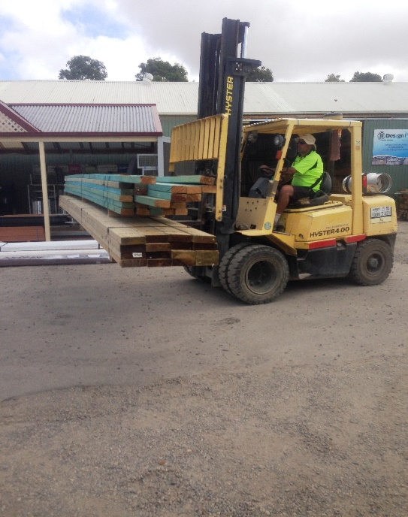

Building Supplies Wholesale
Truck Driver

Building Supplies Wholesale
Truck Driver
Dear Doctor: This form will take up to 5 minutes to complete. Please review each task the worker undertakes (both picture and written description) and tick whether or not the worker can complete this task. If modification required, please leave comments. Space at the end of this document is available for final comments and recommendations.
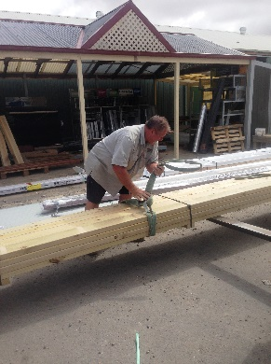  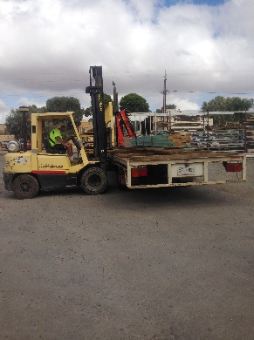  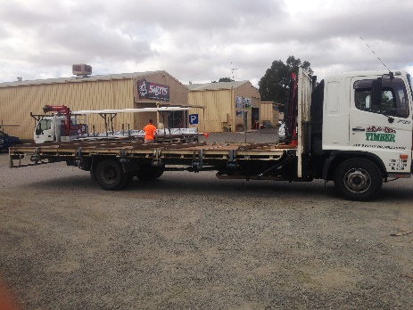 | Loading Truck  - Pre-picked order is located on trestles or ground.  - Placing sling onto load for use with crane. Bending, crouching, bilateral arm/hand used to tie sling.  - Driving forklift to collect order and load onto truck (see below).  - Tying load, climbing on/off truck to tie straps. Bilateral hand use, repetitive grasping. | Doctor Approval  Yes No  Comments:
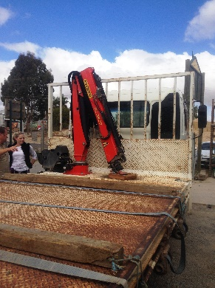 | Unloading Truck  - Truck crane is used for unloading. Controls located at chest height on back tray.  - Climbing onto tray required to hook up sling/load to crane. | Doctor Approval  Yes No  Comments:
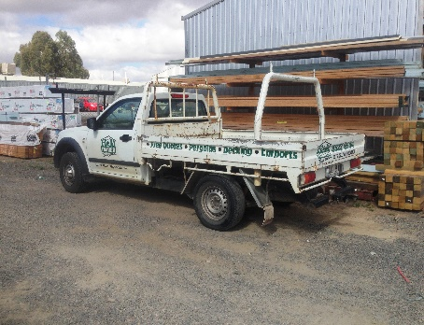  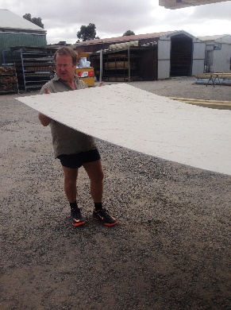  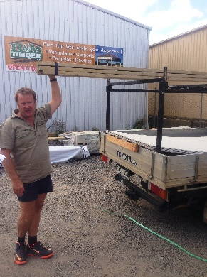 | Ute Deliveries  - Smaller deliveries are undertaken in the utes.  - Hand loading order or loading with the forklift.  - Generally unloading by hand. Second person at delivery location may assist.  - Grasping, lifting, carrying produce required and loading into tray or racks (above head reaching). Loads will vary in weight and size. Bilateral arm use required.  - Sitting to drive to delivery place. | Doctor Approval  Yes No  Comments:
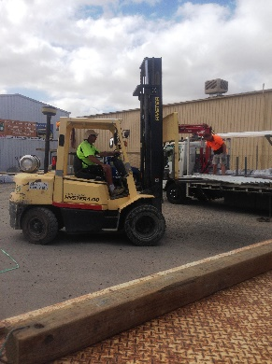 | Forklift Driving  - As required. Driving the forklift requires the ability to  - be able to mount the forklift repetitively;  - have unrestricted head and shoulder movement;  - demonstrate strength in arms and hands for gripping the gear stick and the steering wheel. | Doctor Approval  Yes No  Comments:
Work Capacity Form
Doctor Review (include final comments)

I confirm that in my view, subject to the above comments, the worker is able to perform certain duties detailed in this Early Medical Assessment.
These duties should be reassessed on: |  | Date:

Signature : |  | Date:

Employers Declaration:
I confirm that I/we have reviewed the Doctor’s recommendations and comments. I/we will make suitable changes to make allowances for the Dr’s recommendations.
Signature : |  | Date:

Employees Declaration
My Doctor has discussed their recommendations with me. I have been given the opportunity to participate in this process.
Signature : |  | Date:
For information on completing this form, please contact Business SA on 08 8300 0000.
Disclaimer: This document is published by Business SA with funding from ReturnToWorkSA. All workplaces and circumstances are different and this document should be used as a guide only. It is not diagnostic and should not replace consultation, evaluation, or personal services including examination and an agreed course of action by a licensed practitioner. Business SA and ReturnToWorkSA and their affiliates and their respective agents do not accept any liability for injury, loss or damage arising from the use or reliance on this document. The copyright owner provides permission to reproduce and adapt this document for the purposes indicated and to tailor it (as intended) for individual circumstances. (C) 2016 ReturnToWorkSA

