Early Medical Assessment

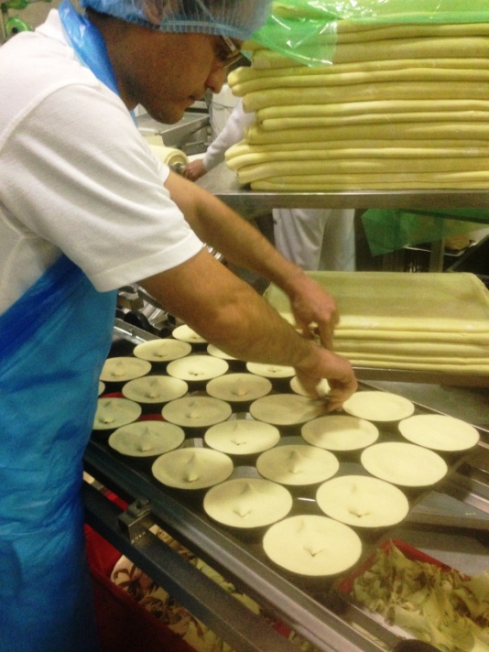

Bread and Cake Retailing
Pie Making

Bread and Cake Retailing
Pie Making
Dear Doctor: This form will take up to 5 minutes to complete. Please review each task the worker undertakes (both picture and written description) and tick whether or not the worker can complete this task. If modification required, please leave comments. Space at the end of this document is available for final comments and recommendations.
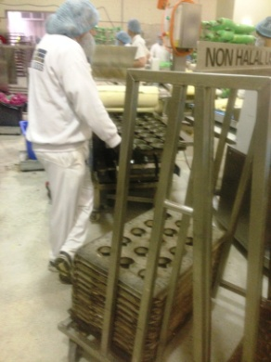  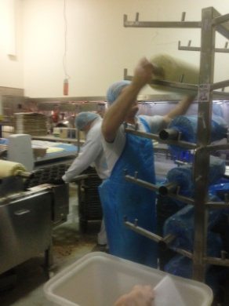  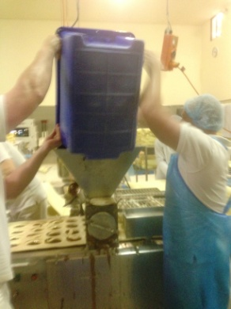  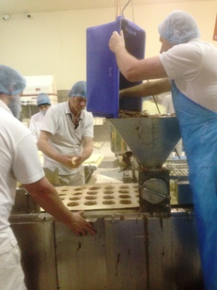 | Start of The Pie Line  - Placing individual trays out on automatic line at bench height. Trays are located on a trolley at the end of the bench. Bilateral reach between head and ankle height required to grasp tray. Bending required, twisting may be involved. Repetitive task.  - Worker obtains roll of pastry (25kg approx) from racking between ankle and overhead height and places it on the machine.  - Two workers lift 30kg tub of meat filling and tip into hopper at approx shoulder height. Meat is scraped out with scraper using dominant hand and second hand to stabilize tub. Step stool raises worker to reduce reaching and awkward postures. | Doctor Approval  Yes No  Comments:
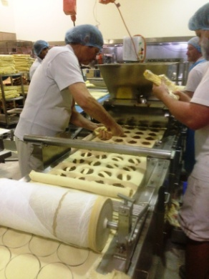 | Filling Pies  - Pastry is automatically indented and filled with meat.  - Two workers pipe in any extra flavours working at bench height. Constant standing with neck flexion  - Piping requires bilateral hand use. One hand squeezes filling out and the other directs the pipe to the individual pies. Some bending / lateral bending may be required depending on method. Constant forward reaching required. | Doctor Approval  Yes No  Comments:
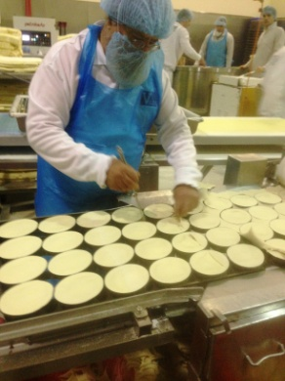  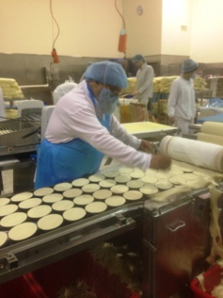 | Waste Pastry  - Standing and using a utensil to poke waste cut offs through into tubs on the ground underneath the line.  - Repetitive forward reaching and twisting. | Doctor Approval  Yes No  Comments:
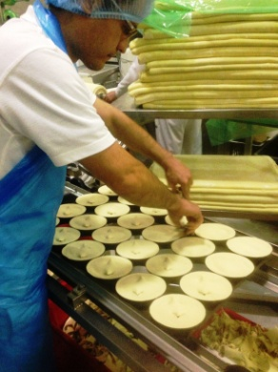 | Cutting Pie Lids  - Each flavor of pie has a different number of cuts on pastry lid (up to 5).  - Holding 2 sets of scissors (one in each hand) and repetitively placing small cuts in pastry lids.  - Constant standing, repetitive forward reaching and fine motor skills for scissor use, some bending to reach pies furthest away. | Doctor Approval  Yes No  Comments:
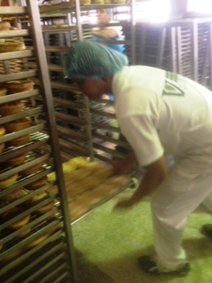 | End of Pie Line  - Lifting tray of pies and sliding into racks (on wheels) between ankle and overhead height. | Doctor Approval  Yes No  Comments:
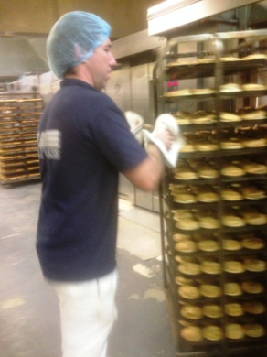  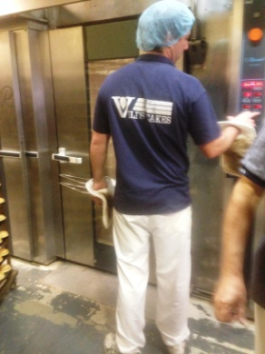 | Baking Pies  - Pushing racks of pies into circulating ovens.  - Occasionally rotating trays during baking process. Bending and reaching to remove tray from one rack and place in another.  - When cooked, pulling rack out of oven and pushing to cooler. | Doctor Approval  Yes No  Comments:
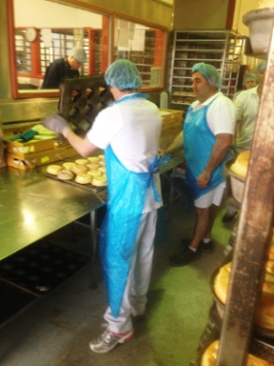  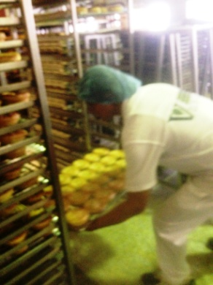 | Tipping Pies  - Once cooled, trays are removed from rack and tipped onto a wire rack. Bilateral holding of wire rack onto tray and tipping over.  - Placing on bench and individually turning pies up the correct way (two hands used).  - Removing any damaged pies and placing in separate tray at back of bench requiring reaching out of close range and forward bending.  - Placing wire rack with pies back into trolley racks between ankle and overhead height .  - Constant standing, repetitive forward reaching, frequent bending, twisting to replace trays in trolley racks. Constant handling of produce. | Doctor Approval  Yes No  Comments:
Work Capacity Form
Doctor Review (include final comments)

I confirm that in my view, subject to the above comments, the worker is able to perform certain duties detailed in this Early Medical Assessment.
These duties should be reassessed on: |  | Date:

Signature : |  | Date:

Employers Declaration:
I confirm that I/we have reviewed the Doctor’s recommendations and comments. I/we will make suitable changes to make allowances for the Dr’s recommendations.
Signature : |  | Date:

Employees Declaration
My Doctor has discussed their recommendations with me. I have been given the opportunity to participate in this process.
Signature : |  | Date:
For information on completing this form, please contact Business SA on 08 8300 0000.
Disclaimer: This document is published by Business SA with funding from ReturnToWorkSA. All workplaces and circumstances are different and this document should be used as a guide only. It is not diagnostic and should not replace consultation, evaluation, or personal services including examination and an agreed course of action by a licensed practitioner. Business SA and ReturnToWorkSA and their affiliates and their respective agents do not accept any liability for injury, loss or damage arising from the use or reliance on this document. The copyright owner provides permission to reproduce and adapt this document for the purposes indicated and to tailor it (as intended) for individual circumstances. (C) 2016 ReturnToWorkSA

