Early Medical Assessment

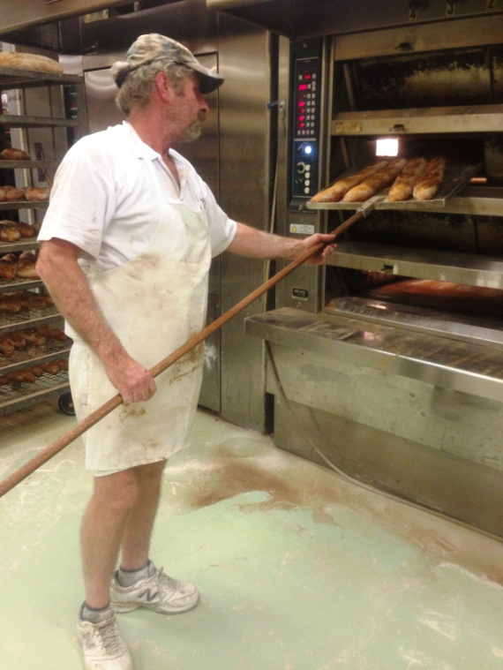

Bread and Cake Retailing
Dough Making

Bread and Cake Retailing
Dough Making
Dear Doctor: This form will take up to 5 minutes to complete. Please review each task the worker undertakes (both picture and written description) and tick whether or not the worker can complete this task. If modification required, please leave comments. Space at the end of this document is available for final comments and recommendations.
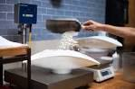  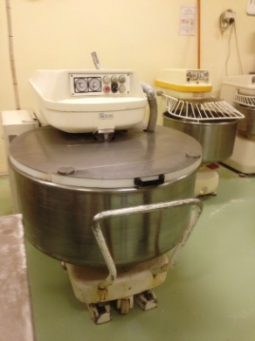 | Making Dough  - Scooping flour out of large bin (power grip with wrist pronation)  - Weighing flour on scales on bench (1000mm)  - Tipping flour (tub) into bread mixer.  - For larger mixers a 25kg bag of flour may be carried and poured into mixer.  - Pulling force required to rip top of bag to allow flour to pour  - Dough is mixed by machine. | Doctor Approval  Yes No  Comments:
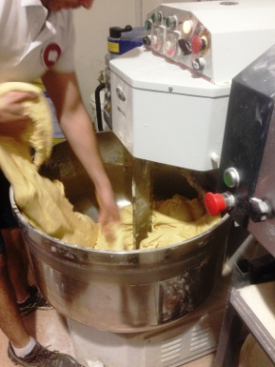  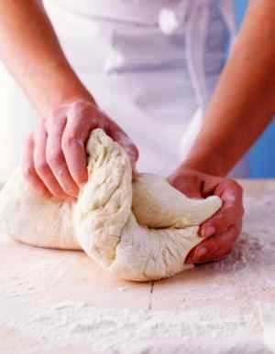 | Kneading and Proofing  - Reaching into mixer bowl and tearing off chunks of dough (10-15kg). Bending and reaching required to access dough in large bowl.  - Kneading dough on bench 1000mm. Bilateral repetitive activity with some force applied to knead.  - Allowing to proof can take hours  - Shaping bread into suitable size/shape by hand and placing on trays  - Bun divider used to make small buns. Flattening bread into circle and placing in divider; pulling down on handle to split dough  - Placing loaf bread into loaf tins  - Decorating bread as required (fine motor) | Doctor Approval  Yes No  Comments:
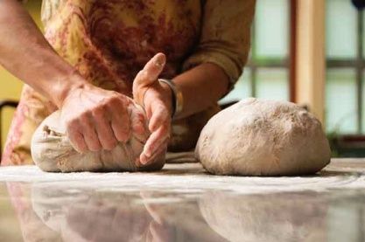  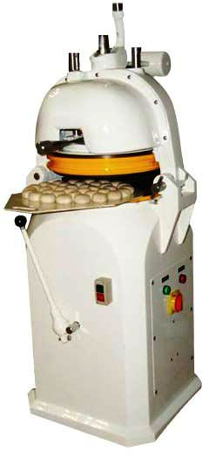 | - Placing trays on rack from ankle to overhead height (reach through full range) and pushing rack into Proofer  - Pulling racks out of proofer for cooking.
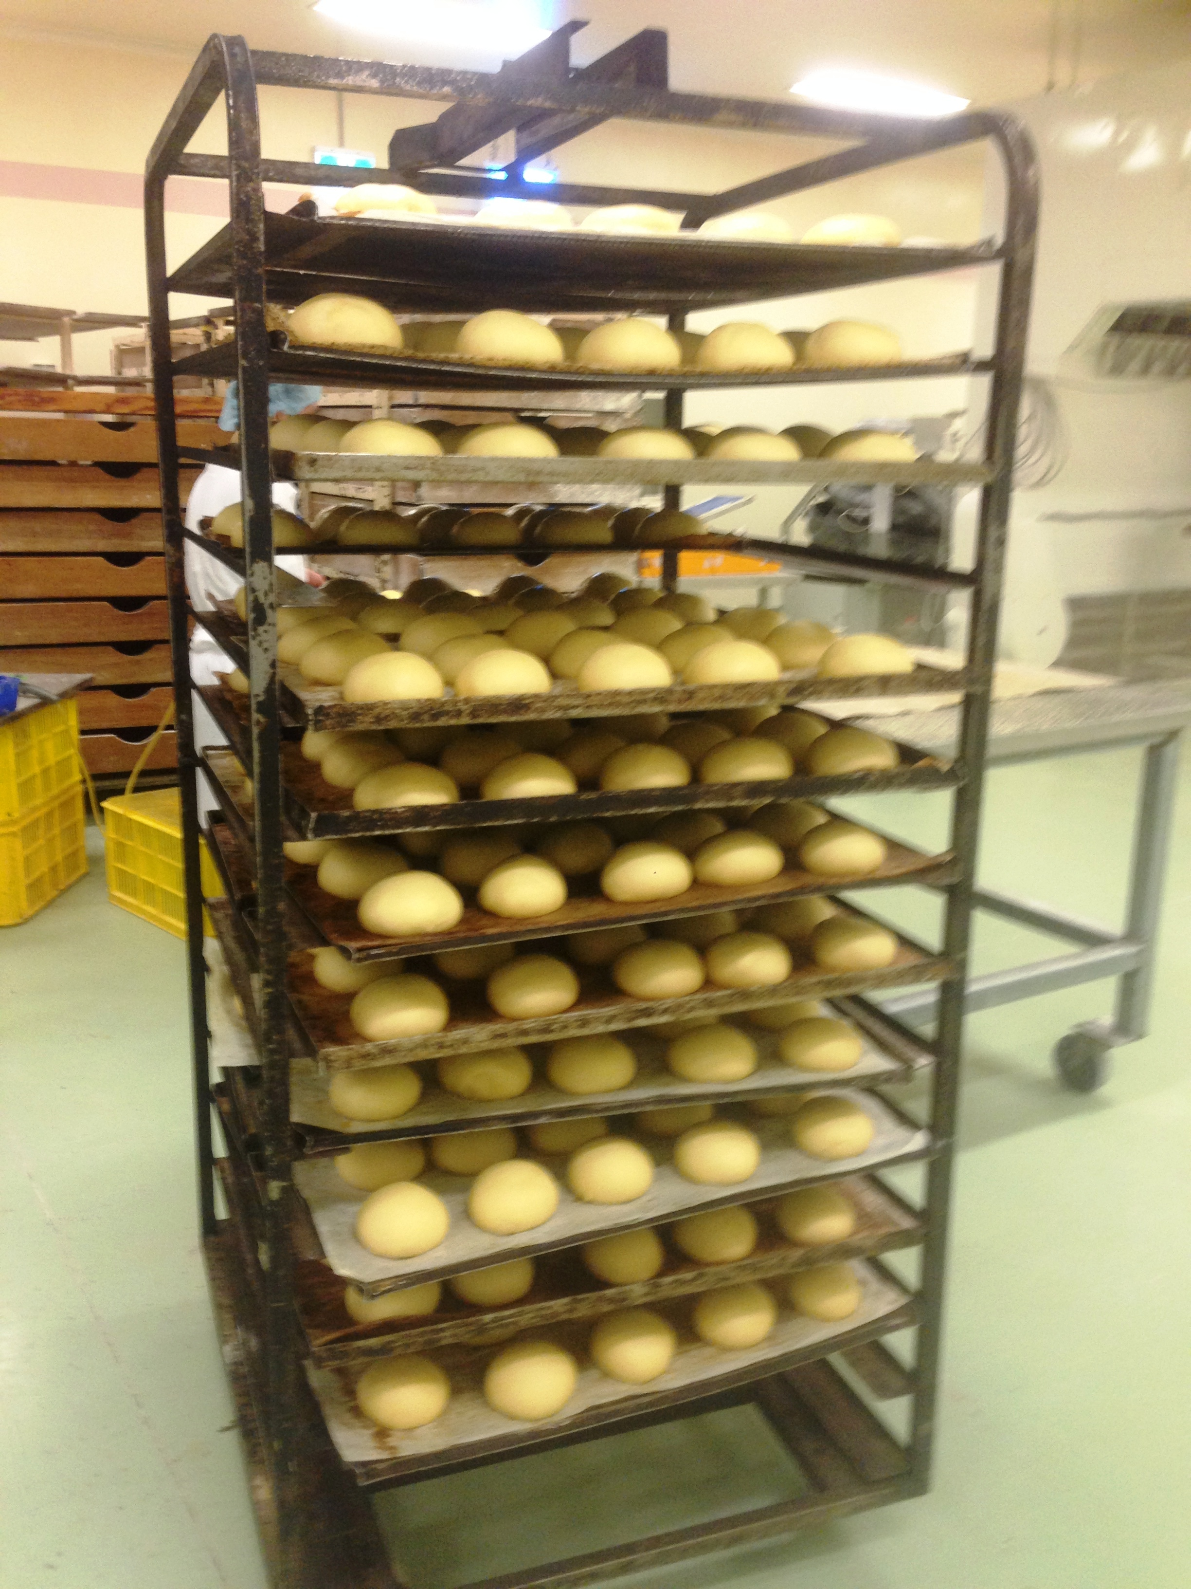  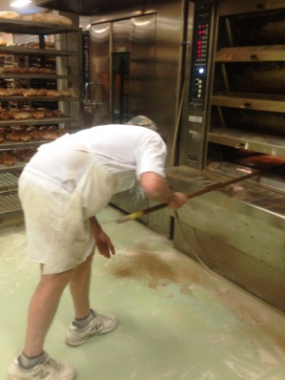  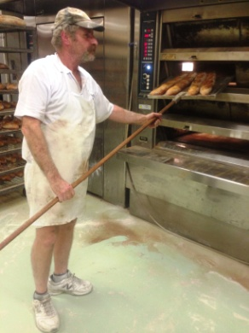 | Baking Bread  - Placing bread in ovens using 2.8m Peel.  - Oven has 4 shelves between approx waist and head height.  - Consistently physical task -  - Repetitive reaching through different levels above waist height.  - Bilateral gripping /holding of Peel whilst moving bread into/out and rotating in oven.  - Lifting of trays from rack (ankle to overhead height).  - Constant standing and walking around baking area.  - Bending to access deep in lower levels of oven. | Doctor Approval  Yes No  Comments:
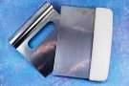  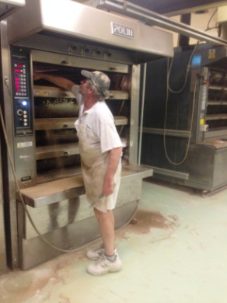 | Cleaning  - Sweeping floor as required  - Cleaning trays with hand held flat edge scraper. Stabilizing tray with one hand and grasping scraper with dominant hand  - Cleaning oven with broom, sweeping out full broom length at each level requiring full bilateral shoulder range of motion. | Doctor Approval  Yes No  Comments:
Work Capacity Form
Doctor Review (include final comments)

I confirm that in my view, subject to the above comments, the worker is able to perform certain duties detailed in this Early Medical Assessment.
These duties should be reassessed on: |  | Date:

Signature : |  | Date:

Employers Declaration:
I confirm that I/we have reviewed the Doctor’s recommendations and comments. I/we will make suitable changes to make allowances for the Dr’s recommendations.
Signature : |  | Date:

Employees Declaration
My Doctor has discussed their recommendations with me. I have been given the opportunity to participate in this process.
Signature : |  | Date:
For information on completing this form, please contact Business SA on 08 8300 0000.
Disclaimer: This document is published by Business SA with funding from ReturnToWorkSA. All workplaces and circumstances are different and this document should be used as a guide only. It is not diagnostic and should not replace consultation, evaluation, or personal services including examination and an agreed course of action by a licensed practitioner. Business SA and ReturnToWorkSA and their affiliates and their respective agents do not accept any liability for injury, loss or damage arising from the use or reliance on this document. The copyright owner provides permission to reproduce and adapt this document for the purposes indicated and to tailor it (as intended) for individual circumstances. (C) 2016 ReturnToWorkSA

