Early Medical Assessment

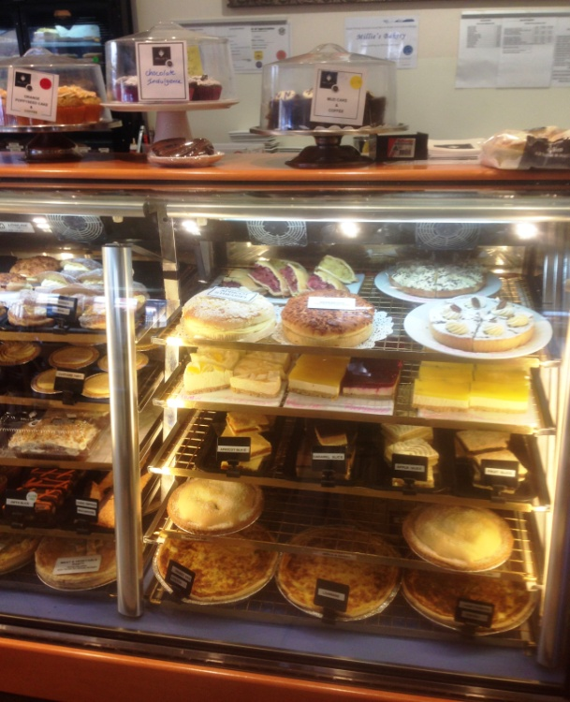

Bread and Cake Retailing
Customer Service – Cafe

Bread and Cake Retailing
Customer Service
Dear Doctor: This form will take up to 5 minutes to complete. Please review each task the worker undertakes (both picture and written description) and tick whether or not the worker can complete this task. If modification required, please leave comments. Space at the end of this document is available for final comments and recommendations.
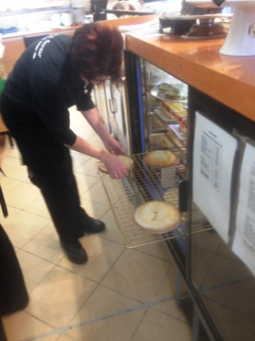  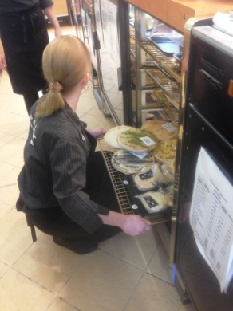  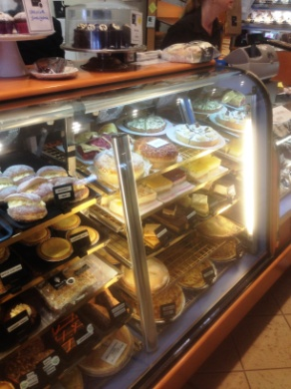 | Display Cabinet  Morning  - Setting up display by collecting product from cool room on trolley. Stored on trolley.  - Repetitive forward reaching and bending to fill display cabinet (under bench height). Pull out shelves reduce the amount of bending into the cabinet.  - Plating up freshly baked cakes using tongs and place in cabinet. Refilling during day as required  - Placing pies in warmer (bench height – 1500mm)  End of day  - Emptying 7 cabinets of plated food and placing on trolley to push to cool room.  - Repetitive forward bending and low level postures to access all product in cabinets to place on trolley  - Cleaning display cabinets (removing pull out wire shelves and wiping bottom, sides and glass) | Doctor Approval  Yes No  Comments:
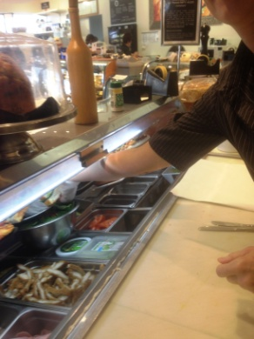  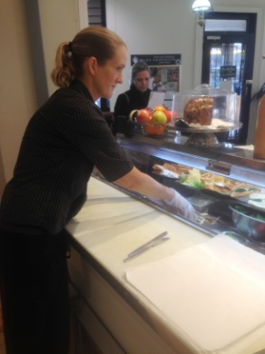  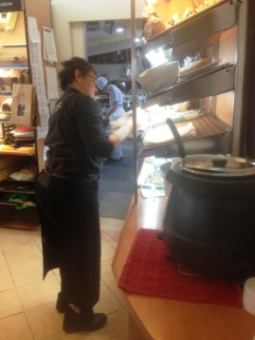 | Sandwich Making  - Each morning two staff pre-make sandwiches  - Making sandwiches as ordered throughout day  - Constant standing behind counter/bench. Bench height 930mm.  - Forward bending to access fillings (700mm deep cabinet)  - Constant use of both hands, knives and tongs  - Extra cold meats kept in cool room nearby on shelving between waist and shoulder height.  - Placing sandwiches on plates or in display cabinet | Doctor Approval  Yes No  Comments:
 | Table Service  - Walking to tables carrying plates and cups as required  - Clearing dishes from plates and carrying to kitchen  - Wiping over tables | Doctor Approval  Yes No  Comments:
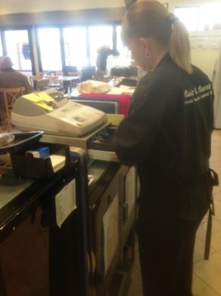  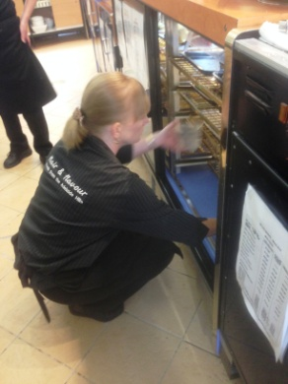  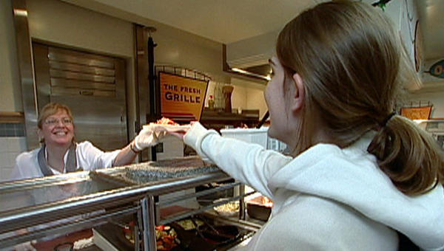 | Customer Service  - Cash handling and use of till  - Serving display cakes and sandwiches, using tongs with dominant hand, holding plate with second hand  - Plating up of ordered items  - Serving of loaves of bread from shelving  - Repetitive reaching over counter  - Bending and squatting to access low cakes shelves | Doctor Approval  Yes No  Comments:
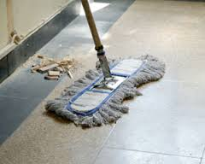 | Cleaning  - Wiping surfaces as required and thoroughly at the end of the day  - Sweeping floors  - Cleaning cabinets and coffee machine at the end of the day | Doctor Approval  Yes No  Comments:
Work Capacity Form
Doctor Review (include final comments)

I confirm that in my view, subject to the above comments, the worker is able to perform certain duties detailed in this Early Medical Assessment.
These duties should be reassessed on: |  | Date:

Signature : |  | Date:

Employers Declaration:
I confirm that I/we have reviewed the Doctor’s recommendations and comments. I/we will make suitable changes to make allowances for the Dr’s recommendations.
Signature : |  | Date:

Employees Declaration
My Doctor has discussed their recommendations with me. I have been given the opportunity to participate in this process.
Signature : |  | Date:
For information on completing this form, please contact Business SA on 08 8300 0000.
Disclaimer: This document is published by Business SA with funding from ReturnToWorkSA. All workplaces and circumstances are different and this document should be used as a guide only. It is not diagnostic and should not replace consultation, evaluation, or personal services including examination and an agreed course of action by a licensed practitioner. Business SA and ReturnToWorkSA and their affiliates and their respective agents do not accept any liability for injury, loss or damage arising from the use or reliance on this document. The copyright owner provides permission to reproduce and adapt this document for the purposes indicated and to tailor it (as intended) for individual circumstances. (C) 2016 ReturnToWorkSA

