Early Medical Assessment

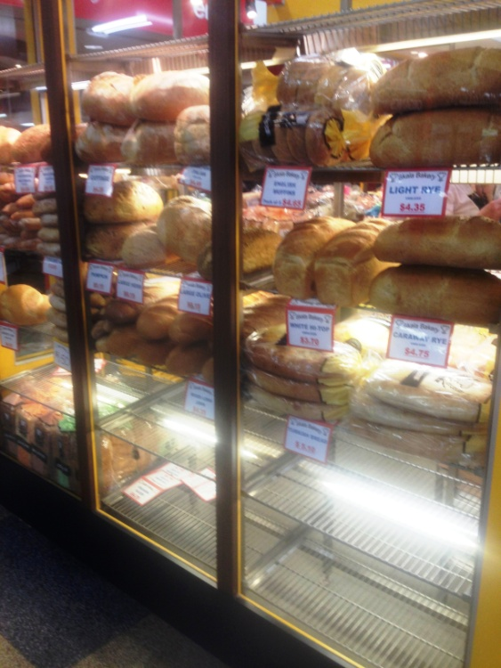

Bread and Cake Retailing
Customer Service – Bread Shop

Bread and Cake Retailing
Customer Service
Dear Doctor: This form will take up to 5 minutes to complete. Please review each task the worker undertakes (both picture and written description) and tick whether or not the worker can complete this task. If modification required, please leave comments. Space at the end of this document is available for final comments and recommendations.
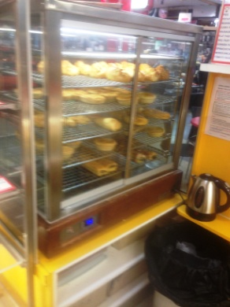  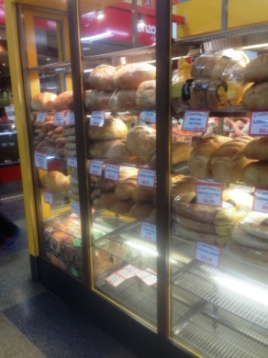  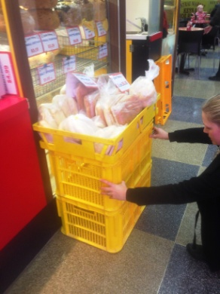  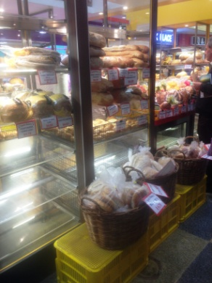 | Deliveries  - Driver brings crates of bread and assists to unpack.  - Placing pies in fridge or pie warmer immediately  - Crates (<10kg) are stacked 3 high. Worker pushes stack into shop over small lip.  - Lifting and placing bread on shelving (as below) requiring repetitive reaching through all ranges. Squatting or bending required for lower shelves and step stool available for upper shelves.  - Placing empty crates outside of shop for driver to remove.  - 50 crates delivered on a busy market day. 20 on a slower day. | Doctor Approval  Yes No  Comments:
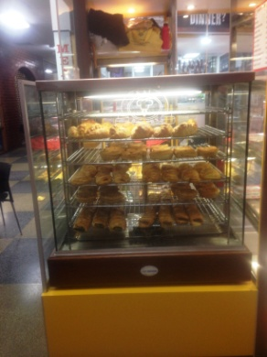  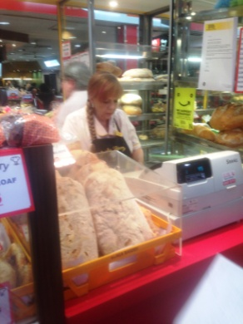  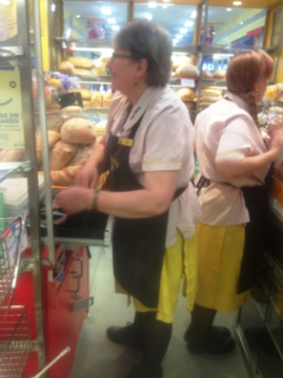 | Serving Customers  - Constant standing and walking whilst assisting customers with their orders  - Shelves  - Lowest 300mm  - Highest 1800mm  - Depth of reach 600mm  - Pie warmer shelving between waist and chest height. Tongs used to handle hot items. Gripping with dominant hand and second hand holding bag.  - “Cash only” operation, one button per item on till for ease of use. Till on 900mm bench.  - Reaching over till to serve customer (1250mm.)  - Repetitive forward reaching to shelves at all heights described. Occasional-frequent squatting/bending to access low shelves, occasional climbing onto step stool to reach upper shelves.  - Constant handling of bread products and money. | Doctor Approval  Yes No  Comments:
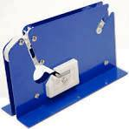  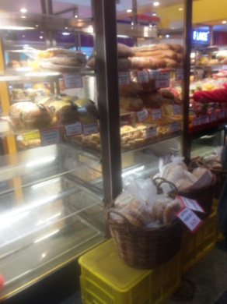 | End of Day Duties  - Bagging rolls and grasping bag to pull through taper to seal. Repetitive gripping and handling of rolls and bags.  - Bagging up left over bread and storing in crate in shop. Delivery driver collects following day and takes to bakery for collection by charity.  - Removing all produce off all shelves and cleaning shelves by wiping over and using duster. Repetitive reaching at full range of heights.  - Sweeping floor.  - Placing bread signs and price tags out for the next day on shelves. Reaching through full range of heights.  - Stock take nightly | Doctor Approval  Yes No  Comments:
Work Capacity Form
Doctor Review (include final comments)

I confirm that in my view, subject to the above comments, the worker is able to perform certain duties detailed in this Early Medical Assessment.
These duties should be reassessed on: |  | Date:

Signature : |  | Date:

Employers Declaration:
I confirm that I/we have reviewed the Doctor’s recommendations and comments. I/we will make suitable changes to make allowances for the Dr’s recommendations.
Signature : |  | Date:

Employees Declaration
My Doctor has discussed their recommendations with me. I have been given the opportunity to participate in this process.
Signature : |  | Date:
For information on completing this form, please contact Business SA on 08 8300 0000.
Disclaimer: This document is published by Business SA with funding from ReturnToWorkSA. All workplaces and circumstances are different and this document should be used as a guide only. It is not diagnostic and should not replace consultation, evaluation, or personal services including examination and an agreed course of action by a licensed practitioner. Business SA and ReturnToWorkSA and their affiliates and their respective agents do not accept any liability for injury, loss or damage arising from the use or reliance on this document. The copyright owner provides permission to reproduce and adapt this document for the purposes indicated and to tailor it (as intended) for individual circumstances. (C) 2016 ReturnToWorkSA

