Early Medical Assessment

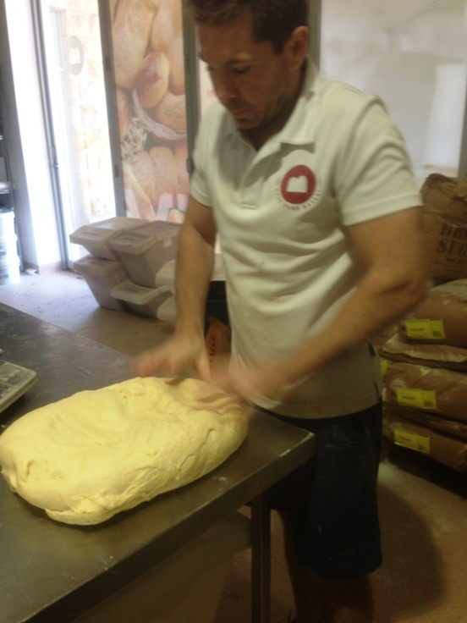

Bread and Cake Retailing
Baker

Bread and Cake Retailing
Baker
Dear Doctor: This form will take up to 5 minutes to complete. Please review each task the worker undertakes (both picture and written description) and tick whether or not the worker can complete this task. If modification required, please leave comments. Space at the end of this document is available for final comments and recommendations.
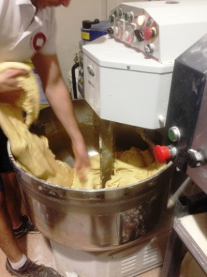  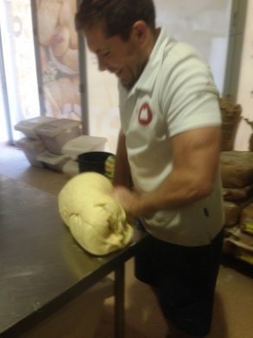  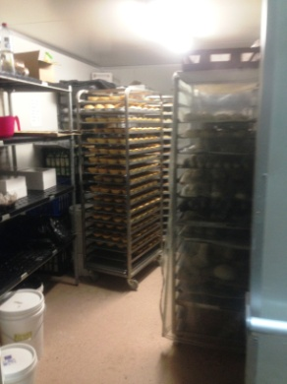  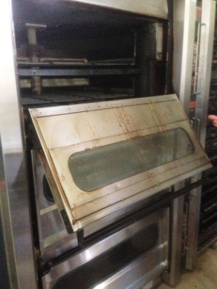 | Baking  - Constant standing and moving whilst baking.  - Bags of flour (white flour 25kg) stacked from floor to head height, lifted and poured into large bowls as required, wholemeal 12.5kg.  - Bread mixed in large automatic mixer (pull down cover for automatic mixing)  - Reaching into bowl to pull apart dough.  - Kneading dough on bench. Bilateral repetitive activity with some force applied to knead.  - Placing dough into pans and onto racks which are pushed into proofer.  - Lifting racks into and out of ovens (3 from floor to 1550mm high)  - Bending required to access low level ingredients and bags of flour as well as reaching into mixing bowl and low ovens. | Doctor Approval  Yes No  Comments:
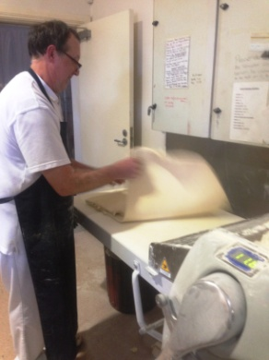  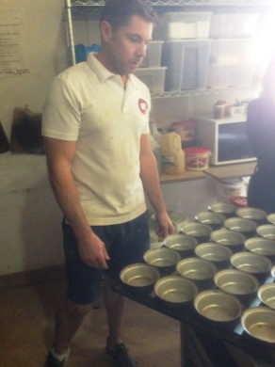  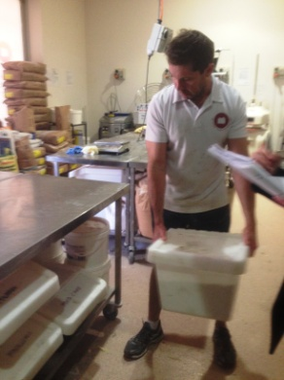  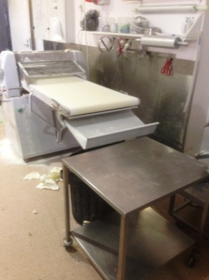 | Pastry  - Constant standing and walking.  - Placing all ingredients into bowl and mixing in automatic mixer. Ingredients stored under bench in tubs.  - Folding pastry into 3 which goes though automatic rollers; repetitive task as pastry is folded many times.  - Lining pie trays with pastry at bench height and placing filling in.  - Placing trays in ovens  - Turning out cooked pies onto rack. Bilateral task with arms spread wide to turn over twice.  - Cooking pie fillings in large pots on stovetop.  - Unpacking some stock from deliveries (not flour) and placing in under bench tubs or coolroom. Bending to access tubs and lift to bench to fill. | Doctor Approval  Yes No  Comments:
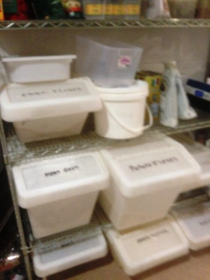 | Stock Rotation  - Moving stock on racks to keep freshest stock at back.  - Pushing racks of bread and pies. | Doctor Approval  Yes No  Comments:
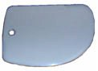  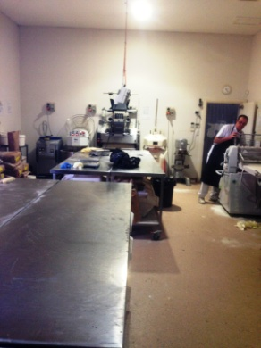 | Cleaning  - Wiping/scraping down benches  - Washing dishes as required in large double sink  - Sweeping and mopping  - Standing, walking, bending, forward reaching, grasping, occasional pushing/pulling. | Doctor Approval  Yes No  Comments:
Work Capacity Form
Doctor Review (include final comments)

I confirm that in my view, subject to the above comments, the worker is able to perform certain duties detailed in this Early Medical Assessment.
These duties should be reassessed on: |  | Date:

Signature : |  | Date:

Employers Declaration:
I confirm that I/we have reviewed the Doctor’s recommendations and comments. I/we will make suitable changes to make allowances for the Dr’s recommendations.
Signature : |  | Date:

Employees Declaration
My Doctor has discussed their recommendations with me. I have been given the opportunity to participate in this process.
Signature : |  | Date:
For information on completing this form, please contact Business SA on 08 8300 0000.
Disclaimer: This document is published by Business SA with funding from ReturnToWorkSA. All workplaces and circumstances are different and this document should be used as a guide only. It is not diagnostic and should not replace consultation, evaluation, or personal services including examination and an agreed course of action by a licensed practitioner. Business SA and ReturnToWorkSA and their affiliates and their respective agents do not accept any liability for injury, loss or damage arising from the use or reliance on this document. The copyright owner provides permission to reproduce and adapt this document for the purposes indicated and to tailor it (as intended) for individual circumstances. (C) 2016 ReturnToWorkSA

