Guide to the Valuation of Liability Transfer Payments
January 2020
Version 2
Contents

Assumption of Outstanding Claims Liabilities 3
Net Premium Position 5
Liability Transfer Payment – Commencing Self-Insurance 6
Liability Transfer Payment – Ceasing self-insurance 8
Example Calculations 10

Assumption of Outstanding Claims Liabilities

On the commencement of self-insurance, an employer becomes liable for all historic and future claims. ReturnToWorkSA will determine if a payment associated with this liability transfer is payable from or to the employer.
An employer considering an application for registration as a self-inured employer should be familiar with the:
- Incidence (transfer) of liability requirements contained within the Return to Work Act 2014 (the Act)
- risks associated with the assumption of claims liabilities on registration as a Self-insured employer
- Process for calculating the value of a liability transfer payment.

Employers insured under the Retro Paid Loss (RPL) scheme should contact the Premium Specialists at ReturnToWorkSA at PremiumSpecialist@rtwsa.com for information on the impact of transition to Self-insurance on its RPL premium calculation.

Feasibility Study
Study considerations | ReturnToWorkSA recommends an employer considering an application to register as a Self-insured employer undertake a feasibility study.  The employer should consider assessing within its feasibility study the:  - risks and benefits of self-insurance  - liabilities the employer will undertake on becoming self-insured  - payment that may be made in connection with the assumption of those liabilities  - Net Premium Position applied to any payment made to an employer to assume outstanding claims  - nature and extent of its claims history, including serious injury claims.  The feasibility study should include incurred but not reported (IBNR) claims and incurred but not enough reported (IBNER) claims.

Valuing the outstanding payments of compensation
Outstanding Claims Liabilities | Outstanding Claims Liabilities (OCL) is the sum of the value of reported claims at the date of valuation; adjusted for inflation, discounting, and an allowance for IBNR and IBNER claims.  An actuary is engaged to value the outstanding claims liabilities.
Approving an Actuary | ReturnToWorkSA has sole discretion to appoint or approve an actuary, for the purpose of estimating the value of outstanding claims liabilities.  Applicants must advise ReturnToWorkSA of their nominated actuary.  ReturnToWorkSA will provide written confirmation of the approval or otherwise to engage the approved actuary.
Costs | The employer is responsible for all costs associated with the valuation, including any costs associated with requests for additional clarification and information relating to the approved actuary’s report.
Valuing Outstanding Claims Liabilities | Actuary reports must comply with ReturnToWorkSA’s Guideline on Self-insured Employer Actuary Reports and Financial Guarantees published on the ReturnToWorkSA website.  ReturnToWorkSA will provide the actuary with the data necessary to undertake the valuation.  The actuary will be required to enter into a confidentiality agreement prior to the provision of any claims data.  A copy of the actuary report must be provided to ReturnToWorkSA.  The information provided by the actuary will be used to determine the amount payable to or by the employer (Liability Transfer Payment).
Peer Review | ReturnToWorkSA may require a peer review of an actuary report, and will be responsible for the cost incurred by its nominated peer review actuary.
Timing | The valuation of OCL will ordinarily commence after the lodgment of an application for registration as a Self-insured employer, or application to amend an existing Self-insured employer registration.  The date of the valuation should be no more than 6 months prior to the date the Board considers the employer’s application.

Net Premium Position
The value of the Liability Transfer Payment (LTP) is subject to a maximum limit, referred to as the Net Premium Position (NPP).

Calculating the NPP
Net Premium Position | The Net Premium Position is the sum of the premium paid by the employer over the last seven financial years (including the current to-date), less the costs paid for claims with an injury date within that period.  NPP is calculated for each company subject to an application, and can be negative or zero, for example:  Company Premium Paid Payments Difference  Company 1 $500,000 $350,000 $150,000  Company 2 $600,000 $250,000 $350,000  Company 3 $325,000 $325,000 $0,000  Total $1,400,000 $925,000 $500,000  The liability transfer payment will include an additional 8% administration component, calculated as 8% of the value of the adjusted outstanding claims liabilities.  The NPP applies to the value of OCL inclusive of the 8% administrative component. (Refer Example Calculations).

Liability Transfer Payment – Commencing Self-Insurance

Prior to the consideration of the employer’s application for self-insurance by ReturnToWorkSA, the value of the LTP is to be agreed.

Liability Transfer Payment
Net Premium Position | The Liability Transfer Payment will be the lesser of the NPP or OCL (Refer Example Calculations). Therefore,  - if OCL > NPP then LTP = NPP  - if OCL < NPP then LTP = OCL  Note: The NPP calculation will be subject to adjustment up to the commencement date of the Self-insured employer registration. Employers should consider the impact of a new financial year commencing when considering the NPP cap.
Interim Liability Transfer Calculation | ReturnToWorkSA will provide the employer with an interim calculation of the LTP, which shall contain:  - the NPP calculation at the date of the interim calculation  - the value of outstanding claims liabilities as at the valuation date  - adjustments from the valuation date to the date of the interim calculation relating to additional likely incurred liabilities (as indicated by the actuary)  - adjustments from the valuation date to the date of the interim calculation relating to claims costs settled; and other specific adjustments ( e.g. recoveries)  - an indicative value of the financial guarantee.
LTP Adjustments | The value of the Liability Transfer Payment will be adjusted by:  - adding likely liabilities incurred between the date of the data extract used for the purpose of the valuation of OCL and the date the employer commences registration as a Self-insured employer (subject to approval)  - deducting payments made on all claims after the date of the data extract used for the purpose of the valuation of OCL and the cancellation of its non-self-insured registration(s) by ReturnToWorkSA (which may be after the date the employer commences registration as a Self-insured employer)  - the value of any adjustment listed in Schedule 3 of the Self-insured Employer Transitional Claims Management Agreement (SIETCMA) executed by the employer and ReturnToWorkSA, e.g. recoveries.  An administration loading of no more than 8% will be applied (after adjustment) to the LTP. The administration component is subject to GST. The OCL component of the payment is not subject to GST.  The LTP including the administration fee is subject to the NPP cap.
Claim Recoveries | The value of a potential claim recovery may be deducted from the value of the liability transfer payment. The employer may claim the difference between amounts recovered that are less than the amount withheld from the liability transfer payment later.  This methodology is used for all applicants for self-insurance and for existing Self-insured employers who are required to bring related bodies corporate into their self-insurance registration under the Act and the Code.
Self-insured Employer Transitional Claims Management Agreement  (SIETCMA) | Prior to consideration of an application for registration as a Self-insured employer, the employer must agree in writing to the terms and conditions of the liability transfer payment, contained within a SIETCMA, and the:  - interim value of the liability transfer payment  - Method for adjusting the liability transfer payment and Net Premium Position to the commencement date of self-insurance.  The Standard SIETCMA is available on request.

Liability Transfer Payment – Ceasing self-insurance

ReturnToWorkSA may undertake the outstanding claims liabilities of a former Self-insured employer.
In determining whether to undertake the outstanding claims liabilities, ReturnToWorkSA will have regard to the solvency of the employer. This includes whether the employer has continued to carry on business in the state and continues to provide adequate provision for dealing with claims and meeting liabilities and responsibilities related to work injuries incurred during its period of registration as a Self-insured employer.

Liability Transfer Payment – Ceasing self-insurance
Run-Off | A former Self-insured employer may seek approval from ReturnToWorkSA to run-off its outstanding claims liabilities.  During the run-off period, the employer retains responsibility for the liabilities relating to claims incurred prior to ceasing to be registered as a Self-insured employer (including liabilities associated with IBNR/IBNER claims).  A run-off period is usually approved for a defined period of time and subject to terms and conditions.
Extension of Delegation | An employer who has been approved to run-off its outstanding claims liabilities shall be provided with a written extension of delegation containing the terms and conditions the employer must comply with during the run-off period.  Terms & conditions generally align with the requirements of registration as a Self-insured employer, e.g. maintenance of resources to administer claims, provision of actuary reports, financial guarantees, EDI data provision etc.
Valuation of Outstanding Claims Liabilities | The outstanding claims liabilities of an employer who is not approved to run-off its self-insured outstanding claims liabilities, or has reached the end of its run-off period will be undertaken by ReturnToWorkSA.  An actuary will be appointed or approved by ReturnToWorkSA to value the employer’s outstanding claims liabilities.
Peer Review | ReturnToWorkSA may require a peer review of any actuary report. ReturnToWorkSA will be responsible for the cost incurred by its nominated peer review actuary.
Calculating the Liability Transfer Payment | The employer will be provided with an interim calculation of the liability transfer payment, inclusive of the 1.5 times scaling factor applied to the value of the outstanding claims liabilities.  The employer will be required to confirm in writing its acceptance or otherwise of the liability transfer payment calculation.
Acknowledge Liability Transfer | On approval of the liability transfer payment by the delegated authority at ReturnToWorkSA, the employer will be issued with a tax invoice.  On payment, the employer will be provided a written acknowledgement confirming the transition of all outstanding claims liabilities associated with claims incurred prior to ceasing to be registered as a Self-insured employer, to ReturnToWorkSA.
Financial Guarantee | ReturnToWorkSA will retain the employer’s financial guarantee until the liability transfer payment has been received and relevant claim files have been returned.

Example Calculations
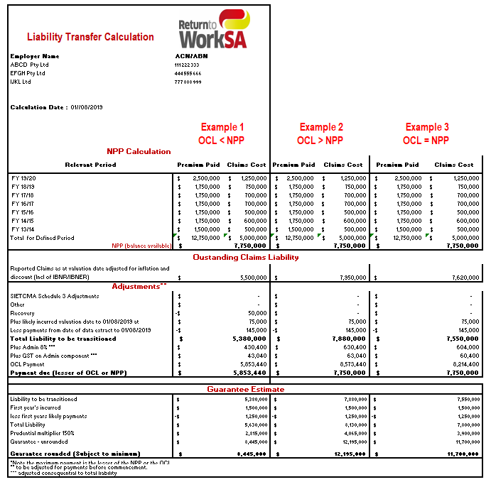

ReturnToWorkSA
13 18 55
info@rtwsa.com
© ReturnToWorkSA 2015

The following free information support services are available:
If you are deaf or have a hearing or speech impairment you can call ReturnToWorkSA on 13 18 55 through the National Relay Service (NRS) www.relayservice.gov.au.
For languages other than English call the Interpreting and Translating Centre on 1800 280 203 and ask for an interpreter to call ReturnToWorkSA on 13 18 55.
For braille, audio or e-text of the information in this brochure call 13 18 55.
ReturnToWorkSA
13 18 55
info@rtwsa.com
© ReturnToWorkSA 2015

