Coordinating workplace return to work
Return to work coordinators are encouraged to arrange a suite of tools and forms to use when needed.
This pack contains the following documents:
- Injury checklist: when a worker is injured, use this step by step guide
- Information for a worker: rights/responsibilities information to explain to workers
- Medical authority: worker’s permission to allow discussion with treating practitioner/s
- Letter to treating doctor: a template to contact the treating doctor
- Work capacity form: to request detailed capacity information from the treating doctor
More templates are available from your agent’s website (e.g. travel reimbursement forms) and ReturnToWorkSA’s website (e.g. recovery/return to work plan, job dictionaries).
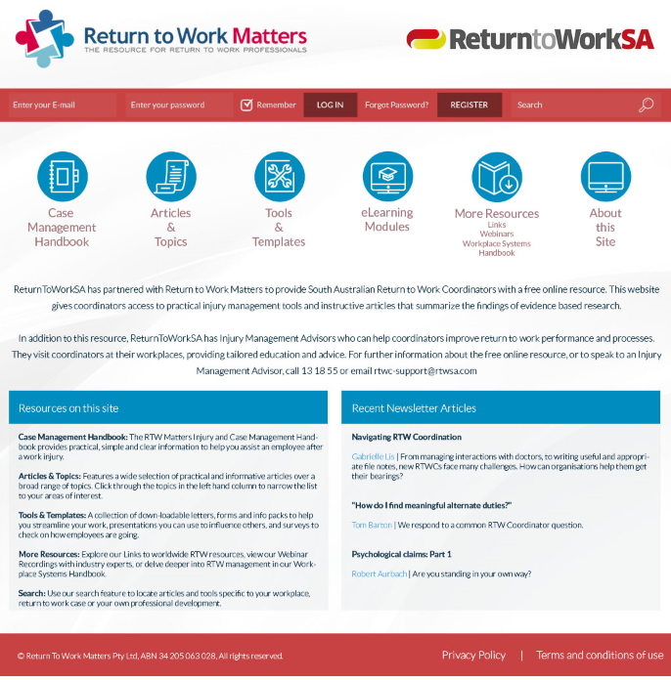
Online tools and resources
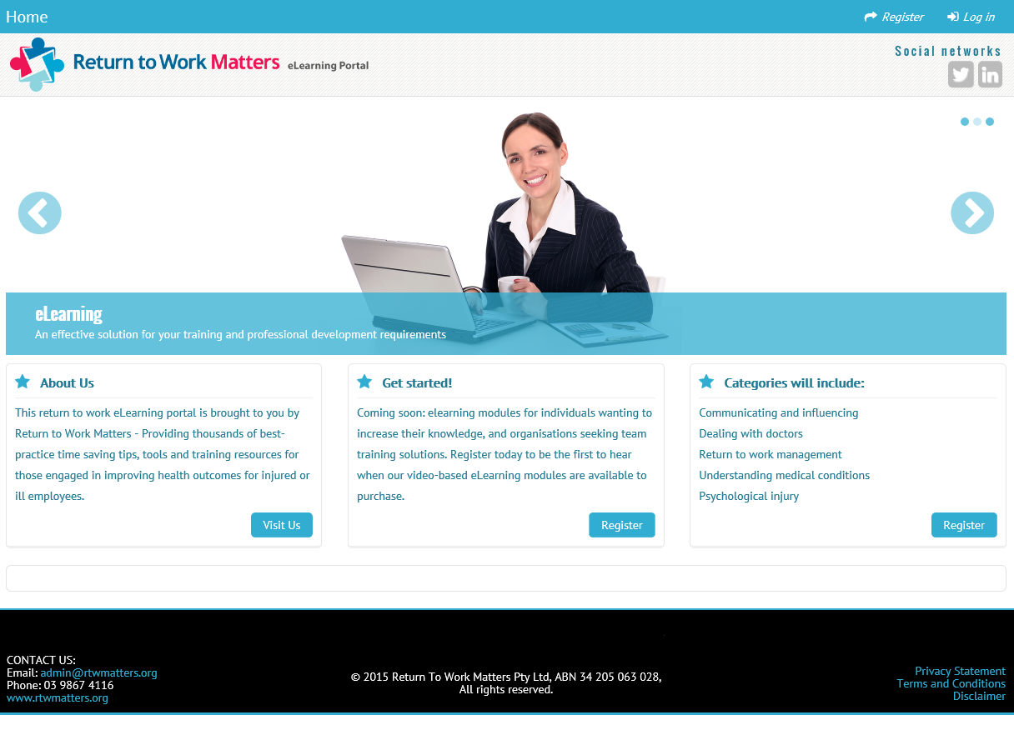
ReturnToWorkSA has partnered with Return to Work Matters to provide South Australian coordinators with free access to online tools and practical resources such as:
- Case management handbook
- Articles about work injury and return to work
- Tools and templates
- Webinars
- Online training modules
Website link: www.rtwmatters.org/sa/

Coordinating recovery/return to work
The employer’s return to work coordinator plays a key role in supporting people with a work injury to remain at or return to work. Together with the person injured, employer, and case manager, coordinators are responsible for developing and implementing return to work solutions.
Recovery and return to work
- Suitable duties (with pre-injury employer)
- Pre-injury role (with pre-injury employer)
- Pre-injury employer new job
- Return to work with new employer
Prepare the workplace
- Management commitment to recovery/return to work outcomes
- Document your reporting/return to work procedures
- Train staff in procedures, roles and responsibilities
Injury occurs
- Provide medical assistance (first aid and/or medical treatment)
- Offer support and identify the worker’s needs
- Obtain a signed medical authority from the worker
13 18 55 – Phone report the claim
- Contact doctor, discuss your role/available suitable duties
- Engage with mobile case manager
- Prevent reoccurrence of the injury
Early face to face support
- Engage mobile case manager, supervisor and worker at the workplace
- Identify and offer suitable duties
- Assist prepare recovery/return to work plan

Monitor and review
- Check how things are going
- Are services working?
- If not, are better services available?
- Review return to work goal

Injury checklist
Insert business logo/letterhead here
Key details
Worker’s full name: | Contact details:
Pre-injury occupation: | Department/Location:
Date of injury: | Nature of injury:
Manager/supervisor name: | Contact details:
Treating doctor’s name: | Contact details:

First contact and claim lodgment process
Senior management advised of injury | Yes No
Accident investigated | Yes No
Corrective actions taken and outcome discussed with worker | Yes No
Initial interview conducted with worker | Yes No
Claim lodged with worker: Phone report claim to claims agent Date: | Yes No NA
Forward Work Capacity Certificate and last 12mths of worker’s pay history to claims agent | Yes No NA
Worker provided with injury pack (travel/chemist form, rights/responsibilities information) | Yes No
Worker asked to sign medical authority (discuss confidentiality) | Yes No
Follow-up activities
Work Capacity Certificate details
Capacity for work discussed and suitable duties identified
Concerns and/or potential barriers to return to work expressed and addressed
Special needs identified (e.g. capacity to drive, interpreter needed)
Contact claims agent and advise of actions taken to date
Establish a confidential file; keep notes of all communication, actions and decisions | Yes No
Letter to doctor sent with a copy of signed medical authority | Yes No
Worker understands the nature of their injury, treatment needs, expected outcome and are happy with their treatment plan and providers involved? | Yes No
Specialist/other treatment providers involved
Prepare recovery/return to work plan and forward to claims agent for approval | Yes No NA

Information for a worker
Insert business logo/letterhead here
Injured at work? It’s important the following things happen:
- Immediately notify your employer (supervisor or manager) and seek necessary first aid treatment
Your employer can assist you with any initial medical treatment for your injury.
- If you need further medical assessment your employer can help you arrange to see a doctor
The doctor will assess you to decide what injury you have suffered and what kind of treatment you need.
They can also issue a Work Capacity Certificate, which you will need to give to your employer.
- Lodging a claim – Call 13 18 55 (Monday – Friday, 8:30am – 5:00pm)
Together with your employer you can lodge a claim by phoning the claims agent, or your employer can call on your behalf. The claims agent will arrange a case manager, who will talk to you and your employer about your injury and claim. They will assist you to receive the right treatment, care and support to help you recover and return to work as soon as possible.
Role of ReturnToWorkSA
Your employer has insurance with ReturnToWorkSA that protects South Australian businesses and their workers in the event of work injury. Support for people who are injured may include:
- Income support to cover your wages for up to two years
- Reasonable and necessary medical treatment and care for up to three years.
Claims for a work injury are managed by an agent (EML or Gallagher Bassett) for ReturnToWorkSA.
Role of the case manager
The case manager is your primary contact and will coordinate the support and services you need to recover from your injury and safely return to work as soon as possible.
If you are unlikely to fully return to work in two weeks, your claims agent may send a case manager to visit your worksite to meet both you and your employer. These face to face worksite visits will occur as soon as possible after your claims agent has been notified of the injury.
They will also help you and your employer to develop and implement a recovery/return to work plan if it is likely that you will be away from work for more than four weeks.
Support from your employer
If your employer has 30 or more staff, they must have a trained return to work coordinator to support you to recover and return to work. Your coordinator can:
- Help you complete a claim (by phone, form and/or any other paperwork)
- Meet with you and your case manager
- Assist you to remain at or return to work
- Keep in contact with you, the claims agent and medical providers
- Take steps to prevent you suffering re-injury or further injury
- Assist with preparing return to work plans
- Monitor the progress of your capacity and return to work.
If your workplace doesn’t have a coordinator, talk to your case manager and see what they can do to help.

Your rights
A person who sustains a work injury can expect:
- Early intervention and appropriate support services
- Income support if you are unable to return to work or to normal working hours
- The support of your employer whilst recovering and returning to work
- Open and transparent communication from all people involved in your claim
- To be able to reasonably request ReturnToWorkSA to review the provision of any service to you under this Act or to investigate any circumstance where it appears their employer is not complying with any requirement of this Act as to their retention, employment or re-employment.
Your responsibilities
A person who sustains a work injury will be expected to:
- Notify your employer of your work injury as soon as possible (within 24 hours if you can)
- Make a claim as soon as possible. The easiest way to do this is to call 13 18 55 Monday to Friday between 8:30am and 5:00pm. The claims agent will advise if a claim form needs to be completed
- Participate in activities that will assist recovery and return to work
- Assist in the development of recovery/return to work plans (if required)
- Comply with any obligations set out in recovery/return to work plans
- Provide current work capacity certificates and recommendations from your doctor
- Meet with your employer and case manager to discuss the recovery/return to work plan
- Return to work as soon as the doctor says you can.
Employer obligations
We expect the employer to support recovery and return to work by:
- Reporting a work injury to their claims agent within five business days of receiving notice of injury
- Participating in the development of recovery/return to work plans
- Complying with any obligations set out in recovery/return to work plans
- Providing suitable duties during recovery/return to work
- Providing suitable employment when fit to return to work, if they cannot return to pre-injury work.

Some recovery and return to work tips:
- Talk to your employer and ask about suitable duties – keep in touch with your supervisor and/or return to work coordinator. You can ask your doctor to call your employer to discuss return to work options.
- Stay active – continue with usual activities as much as possible. Seek advice from your doctor or other treating providers about what activity and exercise is appropriate.
- Stay in touch with your workmates and friends. Continue with regular social activities as much as possible to help your recovery.
- Accept help from family and/or friends – talking about your needs and accepting help is a positive step in recovery.
- Stay positive and focus on what you can do – rather than dwelling on what you can’t.

Need more information? Talk to your return to work coordinator or case manager
If you need to speak in another language, ring the Interpreting and Translating Centre on 1800 280 203 and ask them to contact the claims agent. This interpreting service is available at no cost.
Medical authority
Insert business logo/letterhead here

I, Click here to enter worker’s full name,
Give permission for my treating doctor and/or medical experts, Click here to enter name(s),
To provide my employer’s appointed return to work coordinator, Click here to enter name,
With information relating, and/or relevant, to my work injury, Click here to enter injury or illness details

Worker’s full name:
Worker’s signature:
Date:

***[Delete this note]***
- Explain the purpose of the medical authority to the injured worker
- Obtain written authority to speak with the treating medical provider(s)
- Provide a copy of this authority when sending your initial introduction to the provider(s)
- Identify the way the doctor/physiotherapist would like to communicate with you
- Make sure they are aware of your role to assist and support their patient to recover and return to work
- Remember when asking about what the worker can safely do (capacity) start with the home, then clarify if anything else needs to be considered for work

Letter to treating doctor
Insert business logo/letterhead here

Dear Doctor
Re: Name of patient:
Position:
Business name:
I understand you are the treating doctor for (injured worker’s name).
I am the return to work coordinator and my role includes supporting your patient during this time.
We are committed to assisting their recovery and return to work.
Wherever possible we will provide suitable duties during recovery, including flexibility about hours of work and accommodating any medical restrictions.
I have enclosed a copy of your patient’s signed ‘medical authority’ that enables you to discuss their injury, treatment and capacity with me (should this be needed).
(Only if required) To help us identify suitable duties, we would be grateful if you can complete the enclosed work capacity form to clarify your patient’s capacity for work and any restrictions.
If you require more information, or want to arrange a worksite visit to view their duties, please contact me by phone or email.
I look forward to working with you to assist our worker in their recovery and return to work.
Yours sincerely

(Coordinator name)
Return to work coordinator
(Phone number)
***[Delete this note]***
- Remember doctors are there to help their patient recover
- Help the doctor to understand your role to assist and support their patient to recover and return to work
- Provide a copy of the medical authority when sending your initial introduction
- Engage with the doctor and worker together whenever possible – preferably face to face
- Identify the way the doctor/physiotherapist would like to communicate
- Remember when asking about what the worker can safely do (capacity) start with the home, then clarify if anything else needs to be considered for work
(Email address)
(Date)

Work capacity form
Insert business logo/letterhead here
Patient and employer details
Family name: | Given name(s):
Employer name:
Claim number: | Date of birth:
Capacity to work is affected by the following:
Physical function | Can | Modifications | Cannot | Comments
Sitting | ☐ | ☐ | ☐
Standing/walking | ☐ | ☐ | ☐
Kneeling/squatting | ☐ | ☐ | ☐
Carrying/holding lifting | ☐ | ☐ | ☐
Reaching above shoulder | ☐ | ☐ | ☐
Bending | ☐ | ☐ | ☐
Use of affected body part | ☐ | ☐ | ☐
Neck movement | ☐ | ☐ | ☐
Climbing steps, stairs, ladders | ☐ | ☐ | ☐
Driving | ☐ | ☐ | ☐

Mental health function | Not affected | Partially | Affected | Comments
Attention/concentration | ☐ | ☐ | ☐
Memory (short or long term) | ☐ | ☐ | ☐
Judgment (decision making) | ☐ | ☐ | ☐

Other functional considerations
☐ I have prescribed medication that could impact on your ability to undertake some activities
Details:
Comments (e.g. details of capacity or limitations that will assist in identification of suitable duties)
☐ I would like more information about options available for return to work

I recommend:
☐ A graduated increase in hours over (weeks from) hours a day to your normal hours/ … hours a day
☐ Non-consecutive working days for a period of (days or weeks)

Doctor’s details
Name: | Provider number:
Address:
Email address: | Phone number:
Signed: | Dated:

