# Cleaning work

A guide to deemed workers

# 

# This guide has been produced to help employers and/or workers who may be uncertain about coverage under the *Return to Work Act 2014* (the Act). For further information please call ReturnToWorkSA (RTWSA) on 13 18 55.

# 

# Who is a worker?

The Act provides for the recovery and financial support of workers who suffer a work injury arising from their employment. The Act requires that an employer register with RTWSA and pay an insurance premium based on remuneration paid to workers in their employ (unless they are exempted – see the RTWSA website for information on the small employer registration exemption). Under the Act, ‘worker’ has a broader definition than ‘employee’.

Whether someone is a worker under the Act needs to be considered on a case-by-case basis, from the viewpoint of the ‘worker’-‘employer’ relationship, against the provisions of the Act and well-tested common law principles.

The definition of ‘contract of service’ under the Act includes a contract, arrangement or understanding under which 1 person (the worker) works for another (the principal) in certain types of work i.e. prescribed work or work of a prescribed class - and this includes otherwise independent contractors. In these circumstances the principal is taken to be the ‘employer’ of the ‘worker’.

# Important notes

Whether a worker is engaged to perform work on an ongoing basis or for a short period e.g. for as little as one hour on a given day, or on a casual basis, an obligation exists on the employer to include remuneration paid to any such worker(s) in the calculation of premium payable.

A principal should ensure that an otherwise independent contractor who employs a worker(s) is, at all times when performing work for the principal, registered as an employer with RTWSA. If a contractor (who employs a worker(s)) is not registered, then under section 4(4) of the Act the principal is taken to be the employer of workers employed by the contractor. It is therefore in the principal’s best interests to ensure that any contractors who also employ workers are registered with RTWSA by requesting them to provide a copy of a certificate of registration.

Section 4(4) of the Act – states:

*Where in a prescribed industry or in prescribed circumstances a person (the* ***principal****) contracts with another person (the* ***contractor)*** *for the performance by the contractor of work undertaken by the principal, the principal will, for the purposes of this Act, be taken to be the employer of workers employed by the contractor.*

Regulation 5(8) of the *Return to Work Regulations 2015* (the Regulations) states:

*For the purposes of section 4(4) of the Act, a prescribed circumstance is where a person (the principal) contracts with another person (the contractor) who is not registered as an employer under the Act.*

# 

# Cleaning work

The Regulations identify cleaning work as prescribed work and is defined as the work of cleaning any building or part of a building (including the windows and surrounds of the building) by regulation 5 of the Regulations. Accordingly, a contract of service will be taken to exist (i.e. the cleaner will be taken to be a ‘worker ‘under the Act) if all of the following conditions are met:

* The work carried out by the worker has to be for the purpose of the trade or business of the principal (employer) e.g. office/carpet cleaning for a cleaning company.

This would also include the situation where a doctor subcontracts directly with an office cleaner to clean his/her surgery. Whilst the cleaning does not directly relate to the trade or business of a doctor, the work is for the purpose of the trade or business.

* The work is performed personally by the worker (whether or not the worker supplies tools, plant or equipment).
* The worker does not employ any other person to carry out any part of the work. This relates to all the work required by the contract. Take, for example, a contract to clean a multi-storey office. The person engaged to do that work employs another to do the upper floors and performs personally the work on the lower floors. In these circumstances, this requirement is not met as he/she has employed another person to carry out part of the work.
* The value of materials for 2025:

1. cleaning work (excluding window cleaning) supplied or reasonably expected to be supplied does not exceed $160 (indexed) or does not exceed $160 per month, or
2. window cleaning, supplied or reasonably expected to supply is less than $80 (indexed) or does not exceed $80 per month.

Materials include detergents, floor polish, window cleaning solutions and other consumables. It does not include brooms, mops, buckets, polishing machines or other tools of trade. If all of the above conditions are satisfied the person is **taken to be a worker**.

# 

# **Cleaning work – Who is covered?**

# *This is to be used as a guide only. For confirmation, please contact ReturnToWorkSA.*

To determine if a contractor who is in the cleaning industry is a worker of the principal, the following questions should be asked:

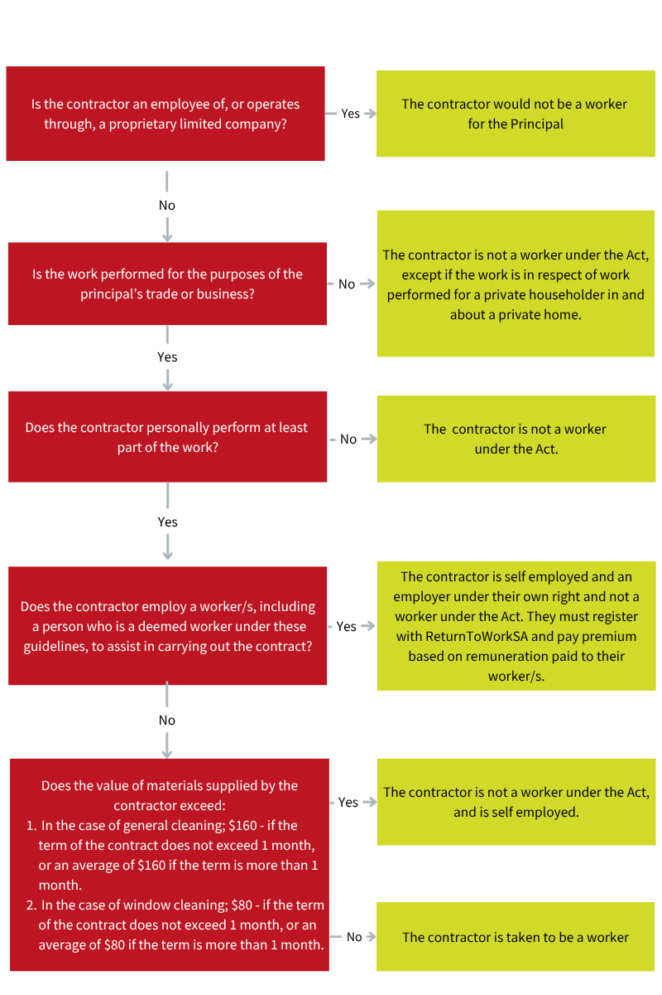

Disclaimer

The information produced by ReturnToWorkSA in this publication is correct at the time of printing and is provided as general information only and not as legal advice. In utilising general information about workplace health and safety and work injury management, the specific issues relevant to your workplace should always be considered and advice obtained. This publication is not intended as a substitute for the requirements of the *Return to Work Act 2014* or the *Work Health and Safety Act 2012.*

30 May 2025