Building work (other than wall or floor tiling)
A guide to deemed workers

This guide has been produced to help employers and/or workers who may be uncertain about coverage under the Return to Work Act 2014 (the Act). For further information please call ReturnToWorkSA (RTWSA) on 13 18 55.

Who is a worker?
The Act provides for the recovery and financial support of workers who suffer a work injury arising from their employment. The Act requires that an employer register with RTWSA and pay an insurance premium based on remuneration paid to workers in their employ (unless they are exempted – see the RTWSA website for information on the small employer registration exemption). Under the Act, ‘worker’ has a broader definition than ‘employee’.

Whether someone is a worker under the Act needs to be considered on a case-by-case basis, from the viewpoint of the ‘worker’-‘employer’ relationship, against the provisions of the Act and well-tested common law principles.

The definition of ‘contract of service’ under the Act includes a contract, arrangement or understanding under which 1 person (the worker) works for another (the principal) in certain types of work i.e. prescribed work or work of a prescribed class - and this includes otherwise independent contractors. In these circumstances the principal is taken to be the ‘employer’ of the ‘worker’.

Under this provision and subject to meeting particular criteria, persons performing building work (other than wall or floor tiling work) can be a worker.

Important notes
Whether a worker is engaged to perform work on an ongoing basis or for a short period e.g. for as little as one hour on a given day, or on a casual basis, an obligation exists on the employer to include remuneration paid to any such worker(s) in the calculation of premium payable.

A principal should ensure that an otherwise independent contractor who employs a worker(s) is, at all times when performing work for the principal, registered as an employer with RTWSA. If a contractor (who employs a worker(s)) is not registered, then under section 4(4) of the Act the principal is taken to be the employer of workers employed by the contractor. It is therefore in the principal’s best interests to ensure that any contractors who also employ workers are registered with RTWSA by requesting them to provide a copy of a certificate of registration.

Section 4(4) of the Act – states:
Where in a prescribed industry or in prescribed circumstances a person (the principal) contracts with another person (the contractor) for the performance by the contractor of work undertaken by the principal, the principal will, for the purposes of this Act, be taken to be the employer of workers employed by the contractor.

Regulation 5 (8) of the Return to Work Regulations 2015 (the Regulations) states:
For the purposes of section 4(4) of the Act, a prescribed circumstance is where a person (the principal) contracts with another person (the contractor) who is not registered as an employer under the Act.

How the Act relates specifically to building work (other than wall or floor tiling work)
Depending on specific circumstances, a person performing building work may be treated as a ‘worker’ under the Act on the basis of the definition described above and the Regulations which prescribe the work or classes of work referred to above. Regulation 5 extends the definition of ‘contract of service’ to persons performing building work (other than wall or floor tiling work).

Regulation 5 defines ‘building work’ as having the same meaning as in the Building Work Contractors Act 1995. Accordingly, ‘building work’ means:

- the whole or part of the work of constructing, erecting, underpinning, altering, repairing, improving, adding to or demolishing a building; or
- the whole or part of the work of excavating or filling of a site for the above work; or
- the on-site construction, alteration, repair or improvement of a swimming pool or spa; or
- paving; or
- fencing (excluding post and wire fencing); or
- the installation, maintenance, repair and removal of insulation.

Persons engaged in performing ‘building work’ described above (other than wall or floor tiling work) are taken to be working under a contract of service and have the corresponding status of a ‘worker’ where the following conditions are all fulfilled.

The work performed under a contract, arrangement or understanding:

- is performed by 1 person (worker) in the course of or for the trade or business of the other party to the contract, arrangement or understanding (employer) eg, carpentry work for a builder. This would also include the situation where a hotel owner contracts directly with a builder to renovate his/her hotel and the builder meets the other requirements set out below. Whilst the renovations do not directly relate to the operation of a hotel, the work is for the purpose of the trade or business of the hotel owner.

- is performed personally by the worker (whether or not the worker supplies tools, plant or equipment)

- the worker does not employ any other person to carry out any part of the work. This relates to all the work required for the contract. For example: The contract is to lay a foundation. There are various stages to complete that contract and if the worker employs another to assist in any part of the work, say digging a trench, then the worker does not fulfil this requirement, having employed another to carry out part of the work.

- the value of any ‘materials’ supplied or expected to be supplied by the worker does not exceed 4 per cent of the amount payable to the worker under the contract, arrangement or understanding, or $155 in 2024 (indexed)* whichever is the greater. ‘Material’ includes timber, bricks, paint, mortar, nails. It does not include plant, equipment or tools of the trade.

- the worker does not own or lease any item of plant or equipment, or any tool for work purposes which exceeds the yearly index adjusted amount*.
The value of any tool, plant or equipment referred to is the price that at the time of entering into the contract, arrangement or understanding the worker would reasonably be expected to pay for an equivalent, new tool or item of plant or equipment.
A vehicle which is primarily used by the worker to transport the worker and any tools, plant or equipment to a worksite is not to be taken to be used for work purposes i.e. is excluded from being considered a tool, plant or equipment for the purpose of these provisions.

* Refer to information on page 4.

A flowchart incorporating a range of questions is provided on page 3 to assist in relating ‘building work’ to the operation of the Act.

Building work flowchart

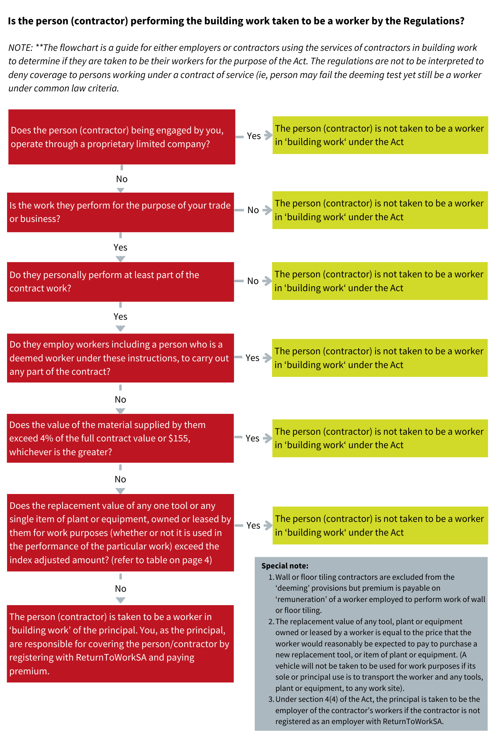

Replacement value of any tool or plant or equipment
Regulation 5(1)(a)(v) of the Return to Work Regulations 2015 states the value of any one tool, or any single item of plant or equipment, owned or leased by the worker for work purposes (whether or not it is used in the performance of the particular work) does not exceed $24,421*.
*This amount is indexed and adjusted annually.

The table sets out the indexed amounts for the replacement value of any tool or plant or equipment from 2019 to 2024.

Year | Amount
2024 | $24,421
2023 | $23,059
2022 | $21,266
2021 | $20,746
2020 | $20,530
2019 | $20,154

Disclaimer
The information produced by ReturnToWorkSA in this publication is correct at the time of printing and is provided as general information only and not as legal advice. In utilising general information about workplace health and safety and work injury management, the specific issues relevant to your workplace should always be considered and advice obtained. This publication is not intended as a substitute for the requirements of the Return to Work Act 2014 or the Work Health and Safety Act 2012.

