Early Medical Assessment

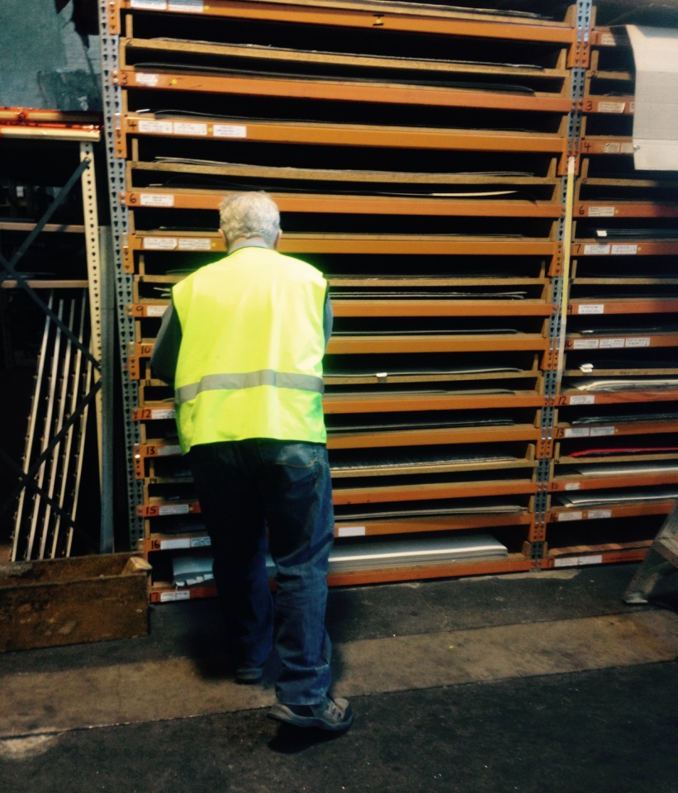

Building Supplies Wholesale
Laminate Handler

Building Supplies Wholesale
Laminate Handler
Dear Doctor: This form will take up to 5 minutes to complete. Please review each task the worker undertakes (both picture and written description) and tick whether or not the worker can complete this task. If modification required, please leave comments. Space at the end of this document is available for final comments and recommendations.
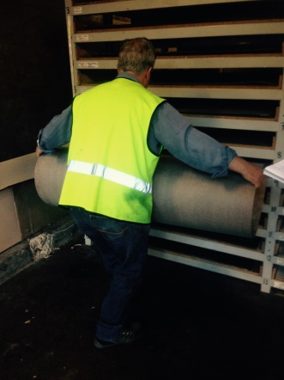 | Handling Laminate Sheets  - Laminate sheets are 4100mm long and lightweight. They are brittle so must be handled carefully.  - Accessing sheets from racking floor to overhead height. Pulling sheet out and rolling it to carry to cutting stand.  - Gripping and bilateral shoulder flexion/abduction and rotation required. | Doctor Approval  Yes No  Comments:
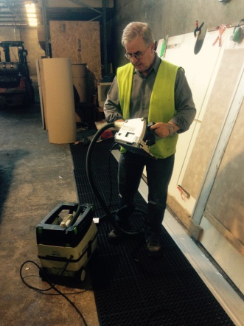 | Cutting Laminate Sheets  - Cutting stand is on an angle.  - Worker lays laminate on board (bending and twisting) and places metal bar to keep in place. Clamp is used to hold metal bar. Gripping required to use clamp with above shoulder height reach.  - Portable saw (approx 7kg) used from knee height. Placing saw against board and pushing it up sheet to above head height, requiring bending, gripping and reaching. | Doctor Approval  Yes No  Comments:
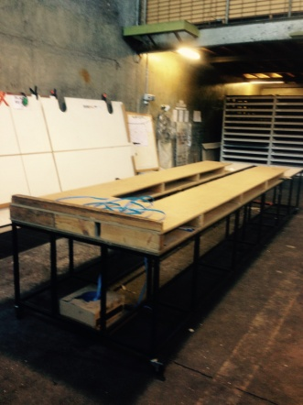 | Rolling Laminate Sheets  - Placing sheet from cutting stand to rolling table.  - Walking into cut out in rolling table and forward reaching and gripping to roll laminate up and sticking so it stays in a roll. | Doctor Approval  Yes No  Comments:
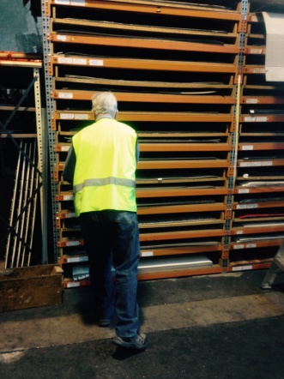 | Shelving Laminate Sheets  - Forklifts are used to place laminate sheets into racking.  - Worker drives forklift up to racking then climbs out to move the laminate. Pulling and pushing forces required to slide sheets from pallet on forklift to racks. Some twisting necessary.  - For higher shelves, ladder may be used therefore climbing involved. For lower shelves, adoption of low level postures.  - Driving the forklift requires the driver to  - be able to mount the forklift ;  - have unrestricted head and shoulder movement;  - demonstrate strength in arms and hands for gripping the gear stick and the steering wheel. | Doctor Approval  Yes No  Comments:
Work Capacity Form
Doctor Review (include final comments)

I confirm that in my view, subject to the above comments, the worker is able to perform certain duties detailed in this Early Medical Assessment.
These duties should be reassessed on: |  | Date:

Signature : |  | Date:

Employers Declaration:
I confirm that I/we have reviewed the Doctor’s recommendations and comments. I/we will make suitable changes to make allowances for the Dr’s recommendations.
Signature : |  | Date:

Employees Declaration
My Doctor has discussed their recommendations with me. I have been given the opportunity to participate in this process.
Signature : |  | Date:
For information on completing this form, please contact Business SA on 08 8300 0000.
Disclaimer: This document is published by Business SA with funding from ReturnToWorkSA. All workplaces and circumstances are different and this document should be used as a guide only. It is not diagnostic and should not replace consultation, evaluation, or personal services including examination and an agreed course of action by a licensed practitioner. Business SA and ReturnToWorkSA and their affiliates and their respective agents do not accept any liability for injury, loss or damage arising from the use or reliance on this document. The copyright owner provides permission to reproduce and adapt this document for the purposes indicated and to tailor it (as intended) for individual circumstances. (C) 2016 ReturnToWorkSA

