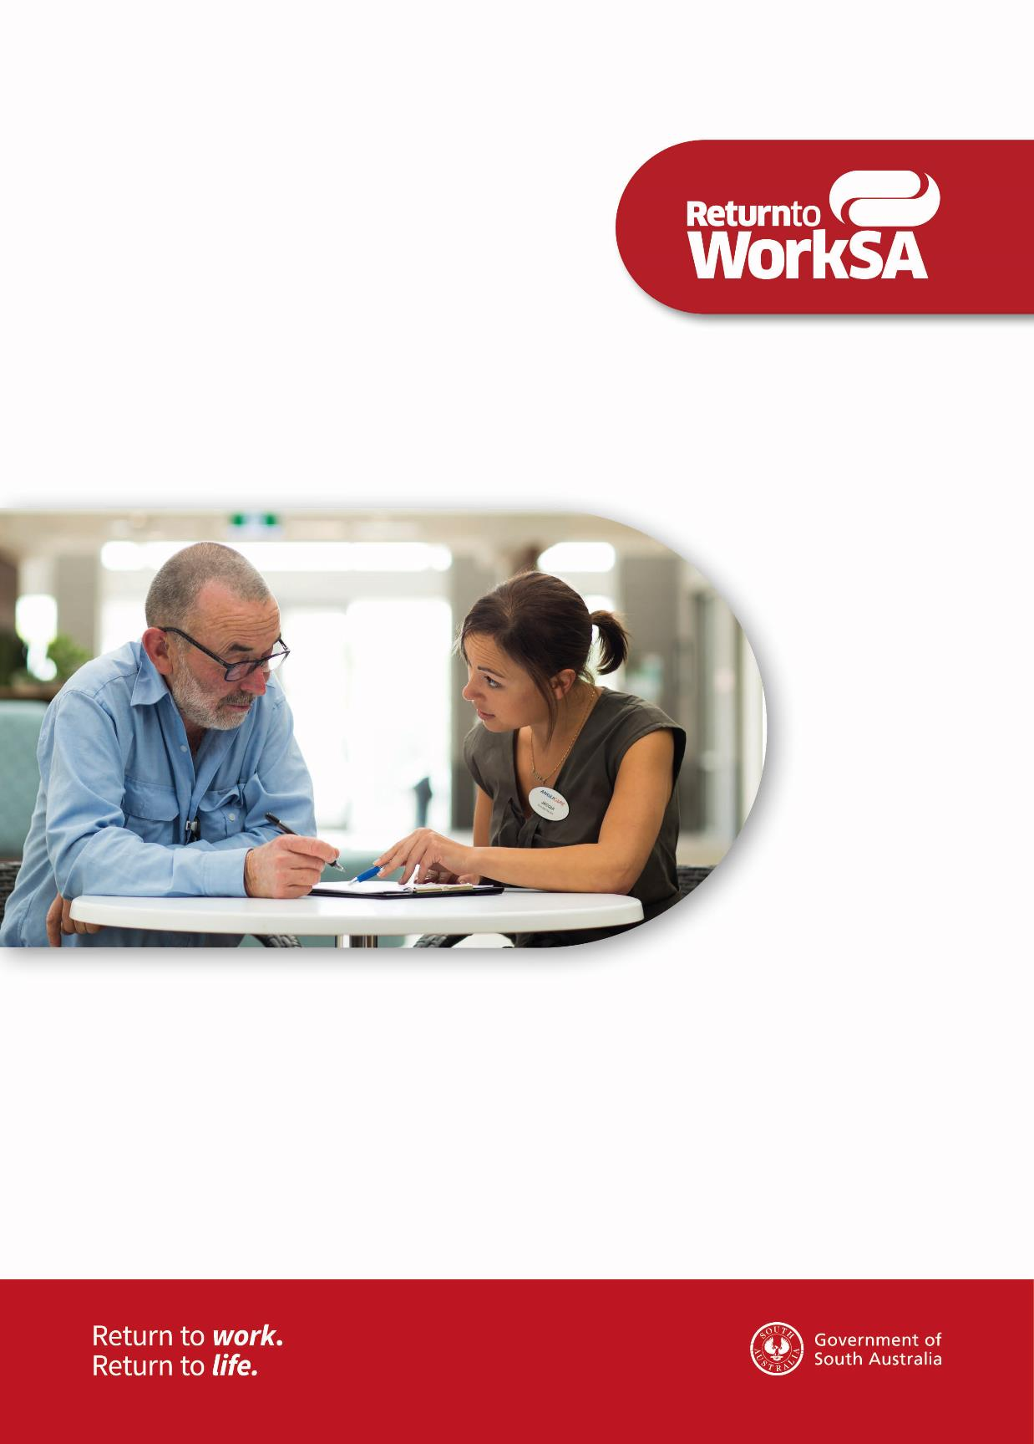
Managing psychiatric injuries
A guide for return to work coordinators

Contents

Introduction 3
Mental illness 3
Psychiatric injury arising from employment 4
What do psychiatric injuries look like? 4
Some common psychiatric diagnoses 5
Depression 5
Anxiety disorders 5
Post-traumatic stress disorder (PTSD) 5
Adjustment disorders 5
Pain disorders 6
Treatment strategies 6
Assisting in recovery and return to work 6
Prepare a recovery and return to work plan 7
Prevention of psychiatric injuries 8
Early identification – what to look for, what to do 8
Early indicators 8
Approach, assess and assist 9
When should the person injured seek professional help? 9
Further information 9
Helpful contacts 9
Helpful websites 10
Additional assistance 10

Introduction
This guide has been designed to help a return to work coordinator (coordinator) prepare, manage and assist a person with a psychiatric injury. The coordinator role and functions are critical to supporting positive recovery and return to work outcomes.
As with a physical injury, it is not always the best thing for a person with a psychiatric injury to stay at home until they are completely recovered. Being isolated from colleagues and friends, and not taking part in work may even worsen their condition.
This guide provides an overview of the impact of psychiatric injuries and information to support recovery and return to work. It also provides information to identify suitable duties and advice to help understand psychiatric injury claims arising from work.
There is considerable evidence that early workplace intervention will significantly improve sustainable return to work outcomes, prevent the development of serious problems and decrease costs. The prospect for successful recovery and return to work is therefore greatest when the support starts as soon as possible after an injury occurs. A coordinator can assist by providing early assistance, practical support to the person injured and help improve their wellbeing.
Effective communication with all parties involved is essential. The coordinator needs to be able to liaise with medical providers as well as managers, direct supervisors, co-workers and other external parties (e.g. case managers, return to work specialists). Strong communication skills and knowledge about specific injuries, as well as suitable duties and the workplace, are all vital.

Mental illness
Mental illness can affect up to one in five Australians and a leading cost to employers and the community through productivity loss, reduced work performance and absenteeism. There are a number of programs to help employers assist employees with mental illness, including beyondblue, the Black Dog Institute, Mental Health First Aid, and Applied Suicide Intervention Skills Training (ASIST).
Workplace management can take action to improve the impact of, and recovery from, a mental illness. Many employers have recognised they can assist by implementing proactive prevention measures and early intervention strategies, such as wellness programs and access to confidential employee assistance programs (EAP). Some employers also provide training to managers and staff to assist and enable people with mental illness to continue working.
This guide is specifically focused on assisting coordinators to help manage psychiatric injuries arising from employment.

If you have any questions about the guide contact
ReturnToWorkSA on 13 18 55 or email coordinators@rtwsa.com.

Psychiatric injury arising from employment
Section 7 of the Return to Work Act 2014 states “This Act applies to an injury if (and only if) it arises from employment” and further “the psychiatric injury arises out of or in the course of employment and the employment was the significant contributing cause of the injury”.
Section 7 (4) (a) to (d) sets out four exclusionary factors:
- reasonable action taken in a reasonable manner by the employer to transfer, demote, discipline, counsel, retrench or dismiss the worker or a decision of the employer not to renew or extend a contract of service;
- a decision of the employer, based on reasonable grounds, not to award or provide a promotion, transfer or benefit in connection with the worker’s employment;
- reasonable administrative action taken in a reasonable manner by the employer in connection with the worker’s employment
- reasonable action taken in a reasonable manner under the Act affecting the worker.
Where evidence indicates that a psychiatric injury arises wholly or predominantly from one or more of the exclusionary factors as set out above, the psychiatric injury will not be a work injury for the purposes of the Act.
It is the case manager’s role to determine whether a psychiatric injury arises from employment. It is important all available factual evidence is provided to enable the case manager to make an informed, evidence-based decision.
The process required to determine a claim should not impact or delay a coordinator (or employer) from implementing assistance and support for recovery and return to work.
The term ‘psychiatric injury’ covers a variety of diagnoses, and includes a number of conditions including depression and anxiety disorders.

Work-related psychiatric injuries include: ‘primary’ injuries, directly linked to work-related activity, for example being subject to an armed hold-up, physical trauma or violence at work. In addition there are psychiatric injuries that can be diagnosed as a result of arising from complications from a work-related physical injury – for example pain conditions or depression.
Psychiatric injures can adversely affect a person’s ability to function, including work, and may also involve close interaction with work related issues/co-workers which may impact recovery and return to work. The coordinator role is in an excellent position to assist implement and monitor strategies to address such issues and/or barriers.
The following background information will help you to better understand clinical symptoms, treatment of specific disorders and likely impact within the workplace.

What do psychiatric injuries look like?
A psychiatric injury is a diagnosable mental illness that significantly and adversely affects a person’s functioning (thinking, emotional state and behaviour). It can disrupt their ability to work and carry out other daily activities and to engage in satisfying personal relationships.
Unlike a physical injury, a psychiatric injury is not necessarily easy to recognise or understand. Sometimes people with a psychiatric injury may not initially disclose it as they are worried that their injury may provoke unnecessary concern by co-workers, or they perceive that their managers or co-workers may have discriminatory ideas regarding psychiatric illness.
“Psychiatric injuries are real and treatable”

Some common psychiatric diagnoses

Depression
Feeling sadness, at a loss, or feeling ‘down in the dumps’ does not necessarily equate to a diagnosis of depression. Depression describes a collective of symptoms that generally last for longer than two weeks and significantly affect a person’s ability to undertake usual daily activities, including work, and participate in relationships with others, including co-workers.
Depression impacts an individual’s thoughts, behaviour, physical activity and emotions. Symptoms of depression can vary considerably from individual to individual. Being engaged and aware of the people in the workplace will increase a coordinator’s ability to notice a change in a person.
Symptoms can include strong feelings of sadness, loss of joy and happiness, feelings of despair, lack of energy, changes to sleep patterns (not being able to sleep to being exhausted and sleeping too much), loss of pleasure, difficulty in concentrating or comprehending instructions, change in diet (eating more or eating less), difficulty in making decisions and intrusive thoughts about death.
Additional information can be found on these websites:
beyondblue: www.beyondblue.org.au
Black Dog Institute: blackdoginstitute.org.au

Anxiety disorders
All humans experience short-term anxiety at times, for example being late for an appointment, having to give a presentation, meeting new people, nearing an important time frame. An anxiety disorder is a medical condition that is long lasting, more severe and interferes with a person’s ability to undertake day to day activities and integration with others, including at work.
Anxiety disorders encompass a number of conditions, including panic attacks and general protracted anxiety, panic disorder, agoraphobia and social phobia. Anxiety disorders also include post-traumatic stress disorder (PTSD), which is described in more detail later.

Symptoms of anxiety disorders can include persistent and excessive worry, decreased concentration, apprehension, tiredness, irritability and apprehension and interference to carry out activities and participate in day to day life.
Untreated and not recognised anxiety disorders can be associated with poor attendance at work, difficulty in following instructions, difficulty in undertaking work activities and interacting with colleagues. Anxiety disorders can also arise from physical difficulties, including chronic pain.
Additional information can be found at:
beyondblue: http://www.beyondblue.org.au
SANE Australia: www.sane.org

Post-traumatic stress disorder (PTSD)
This describes a specific set of symptoms which may follow exposure to one or a number of events that the individual perceives as traumatic. Many people who experience a ‘traumatic event’ will not develop a psychiatric condition.
Symptoms of anxiety may occur immediately following a person’s exposure or may occur over the following days/weeks/months or even years and can include hyper-vigilance, anxiety, problems with concentration, nightmares and avoidance of feared situations.
The best outcome depends on how quickly the person is diagnosed and receives appropriate treatment.
Additional information can be found at:
beyondblue: www.beyondblue.org.au
SANE Australia: www.sane.org

Adjustment disorders
This is generally a diagnosis and a short term response that a person can experience in adjusting to, or coping with, a specific source of stress – for example a loss, event or major life change. Adjustment disorder can include anxiety and or depressed mood, anger and the extent of distress and impact on work and life activities can vary significantly between individuals.

Normally the difficulties resolve themselves once the mental trigger(s) ceases. However, if the cause is chronic and unresolved, adjustment disorders can last for months.
Symptoms can include decreased concentration, social withdrawal, low motivation and low energy levels, behavioural changes.
Additional information can be found at:
beyondblue: www.beyondblue.org.au
SANE Australia: sane.org

Pain disorders
People who have significant pain problems arising from a physical injury may receive a psychiatric diagnosis of a somatic symptoms disorder with predominant pain (formerly described as somatoform pain disorder). There are a number of pain disorders and diagnosis and treatment is specific to the individual’s response. Unfortunately there is some variability in the diagnosis with “pain disorder” also being used.
Symptoms can include fear of pain aggravation and associated avoidance of physical activities, fear of undertaking certain tasks, poor postures and deconditioning.

Treatment strategies
As a coordinator you are not a medical expert. However it is important for coordinators to be aware of how the treatment of psychiatric illness is managed by medical providers.
Medical providers include general practitioners (often the family doctor), psychiatrists, psychologists and other professional and mental health clinicians.
Medical treatment can include specific psychological interventions such as cognitive behavioural therapy and medication. Cognitive behavioural therapy is treatment applied to both pain-related psychological difficulties and other work-related psychiatric injuries. It involves structured techniques to become aware of, and change, unhelpful thought and behaviour patterns, and offers techniques and education to help manage symptoms. Cognitive behavioural therapy seeks to assist a person to reduce unhelpful behaviours (such as avoiding exercise when in pain) and increase helpful behaviours such as returning to previously enjoyable social activities.
Whilst medical treatment is crucial for psychiatric illness the management of workplace related issues, support, and providing suitable duties can greatly assist recovery and return to work.
The coordinator can contribute to recovery and assist medical management by providing workplace related assistance. This includes maintaining regular contact and providing direct support to the injured person, ensuring medical providers are aware of the workplace supports available, including potential suitable duties when return to work is appropriate. A coordinator is well-placed to facilitate effective communication and to ensure the recommendations of treating medical providers are actioned.

Assisting recovery and return to work
In consultation with the treating medical providers, a coordinator may need to facilitate workplace adjustments to accommodate the injured person’s recovery and support return to work. A coordinator should also enlist the support of the injured person’s manager and/or supervisor to consider:
- flexible working options
- varied start and finish times
- working part-time
- offering a variety of tasks
- offering a quieter location in which to work
- sharing responsibilities or tasks.
- To assist the person injured with concentration and memory issues you could consider:
- asking how they would prefer instructions, verbally, writing, via diagrams etc.
- allowing extra time to undertake tasks
- allowing short breaks more frequently
- providing a diary to manage deadlines
- ensuring there is a support person available for them to speak with.
To assist the person injured with planning tasks you could consider:
- developing a written plan with them that features achievable tasks
- providing a checklist of tasks that need completion
- regularly reviewing any expected deadlines.
To assist the person injured with managing emotions you could consider:
- providing a ‘buddy’ who they trust in the workplace
- maintaining regular contact with them and providing appropriate and sensitive support and assistance
- allowing them to take short regular breaks
- ensuring they have ready access to medical providers if needed.
Remember: psychiatric injuries are the same as any other injury – they may take a while to heal, just as other injuries do.

These suggestions are not exhaustive. As the coordinator the best thing you can do is to engage and include the person injured, and their medical providers as needed, to understand what arrangements they would like made in the workplace to support them.
Try to work out adjustments that are reasonable to both the employer and the injured person that will be approved by the treatment providers. It is important to ensure that the workplace is safe and supportive for everyone, not just the person injured. The employer has a duty of care to take any actions to prevent risk of harm to all its employees.

Prepare a recovery and return to work plan
Establishing rapport, trust and good working relationships is crucial. There is considerable evidence that the quality of the relationship is a predictor of success when managing psychiatric injuries. If absence from the workplace has occurred for an extended time, the coordinator should maintain contact with both the person injured and their medical providers.
A coordinator assists to prepare a recovery/return to work plan, individually tailored to address needs, including:
- realistic goals agreed to and owned by all parties
- steps to achieve those goals
- each person’s role in the plan
- the relevant permissions for communication
- strategies to manage each step of the return to work
- review periods.
When return to work occurs, provide support by listening to concerns and where appropriate address them. A person with an injury may lack confidence and are likely to have some apprehension. It is important to be sensitive to their feelings, provide reassurance where appropriate. If they undertake modified duties, ensure co-workers are supportive. Try to find an on-site ‘buddy’ and be aware that reactions by co-workers can strongly impact return to work outcomes, either positively or negatively.

Prevention of psychiatric injuries
The following strategies will help your workplace to effectively manage risk factors. With the support of the leadership team:
- promote a strong safety culture and trust
- promote work-life balance between the demands of work, family and personal life
- implement prevention, education and support, such as wellness programs, to lessen the impact of adverse situations and improve resilience and coping strategies
- provide positive and responsive communication and feedback channels
- define clear policies and procedures for work health and safety, such as:
- bullying and harassment, change management and performance management
- grievance and/or conflict resolution
- managing work-related and non-work related psychiatric injury and illness
- recovery and return to work processes and identifying suitable duties
- ensure all policies and procedures are reviewed regularly and all employees are aware of them through induction and training
- regularly review your workplace with employees to identify potential psychological health risk factors.

Ensure employees have confidential access to employer supported EAP programs. Studies have shown that problems within the workplace, such as management style, heavy workload, poor work-life balance, workplace harassment and poor job matching, can contribute to negative stress and symptoms of distress.
Important points:
- support the person injured and maintain contact
- provide contact details for medical support services
- leave it to the professional clinicians to assist the person to find a solution
- only make promises you can keep and never trivialise the person’s experience.
Never blame or judge and never tell someone to ‘cheer up’ or ‘snap out of it’. This is possibly the worst thing you can say to them. It shows a lack of understanding of what they are experiencing. It is the equivalent of telling someone with a badly broken leg to ‘heal themselves’.
The stigma surrounding psychiatric illness continues to be common in our society, caused by fear, discrimination, prejudice and lack of appropriate information. This fear can be reduced by educating staff and eliminating myths. You can obtain affirmative posters to place around the workplace from organisations such as beyondblue and RU ok?
Remember, you are not a medical provider.

Early identification – what to look for, what to do

Early indicators
Prevention is the most effective management tool. This should include a risk identification assessment and a management plan, including referral to treatment to assist recovery and return to work.
There may be some early indicators of difficulties that could lead to psychiatric illness. These may include a person who:
- is regularly late to work and is frequently absent
- has decreased productivity despite working the same or longer hours
- displays reduced quality in their work
- misses job deadlines
- has concentration and memory problems
- looks tired, fatigued, unhappy and is easily brought to tears
- is irritable and easily provoked
- withdraws from social functions, conversations, meetings and/or the lunchroom
- has frequent toilet breaks and may spend excessive time there
- loses interest in previously liked work activities and work in general.

Approach, assess and assist
Engaging in non-judgmental communication is one of the most effective ways to approach a work colleague who may be suffering from a psychiatric illness. Do not ignore the signs. A caring, open approach by the person’s manager/supervisor has been shown to be effective.
A coordinator can also assist the person by making helpful and practical suggestions e.g. seeing their doctor or visiting your EAP provider. Remember that confidentiality is important, it is not appropriate to discuss their issues with others unless they have given permission to do so.

When should the person injured seek professional help?
They may not want to do this straight away but if and when they expresses a need or desire to seek professional help, which may include the services of an EAP, then they should be encouraged and supported to do so.

Further information
Employers and workers can contact their claims agent to obtain further information and assistance such as the mobile case manager role who can meet face-to-face with workers and employers at the workplace when needed.
If you have any questions about your role as a coordinator or the role of your employer in the return to work process, visit our website www.rtwsa.com. This outlines employer responsibilities, the benefits of appointing a coordinator, the expectations and obligations an employer has to appropriately support their coordinator.
ReturnToWorkSA provides a range of services to help coordinators and employers. Our Workplace Advisory Services team can provide face-to-face support, guidance and education for coordinators and employers to assist recovery and return to work outcomes.
To help reduce work injuries, SafeWork SA has produced information to provide employers with practical information to develop and implement WHS policies and procedures for the workplace. The information can be downloaded from safework.sa.gov.au.

Helpful contacts
For more information about psychological illness, please refer to the contact details below.
Where to call for help

Service | Phone number
Emergency services | 000
Lifeline | 13 11 14
beyondblue | 1300 22 4636
SANE Australia | 1800 187 263
ReturnToWorkSA | 13 18 55
ASIST | 1300 738 382

Helpful websites
SafeWork SA: www.safework.sa.gov.au
beyondblue: www.beyondblue.org
RU Ok? : www.ruok.org.au
Stop Bullying SA: www.stopbullyingsa.com.au
ReturnToWorkSA: www.rtwsa.com
Life Line www.lifeline.org.au
ASIST: www.livingworks.com.au

Additional assistance
beyondblue: the national depression initiative
beyondblue is a not-for-profit organisation that addresses issues associated with depression, anxiety and related substance misuse disorders in Australia. Their website offers a range of resources and fact sheets for employers, managers, families and the community. They also provide a workplace training program for managers and employees. beyondblue also has a 24 hour/7 day week phone contact and an online chat facility available from 3pm to 10am (AEST) 7 days a week.
Black Dog Institute
The institute is a not-for-profit organisation specialises in mood disorders including depression and bipolar disorder. It provides education and training, and clinical assistance for health professionals, conducts research and has a community oriented range of resources. The institute is based at the Prince of Wales Hospital in Sydney and is affiliated with the University of New South Wales.
SANE Australia
A national charity that undertakes campaigns, education and research which helps to provide a better life for people affected by mental illness. The organisation offers an online and telephone helpline, online fact sheets, print and multimedia resources, with specific information for employers, managers, co-workers and employees with mental illness. Workplace education and training are also available.

The following free information support services are available:
If you are deaf or have a hearing or speech impairment you can call ReturnToWorkSA through the National Relay Service (NRS):
- TTY users can phone 13 36 77 and ask for 13 18 55.
- Speak & Listen (speech-to-speech) users can phone 1300 555 727 and ask for 13 18 55.
- Internet Relay users connect to NRS on www.relayservice.com and ask for 13 18 55.
For languages other than English call the Interpreting and Translating Centre on 1800 280 203 and ask for an interpreter to call ReturnToWorkSA on 13 18 55. For Braille, audio or e-text call 13 18 55.

ReturnToWorkSA
13 18 55
info@rtwsa.com
© ReturnToWorkSA 2015

